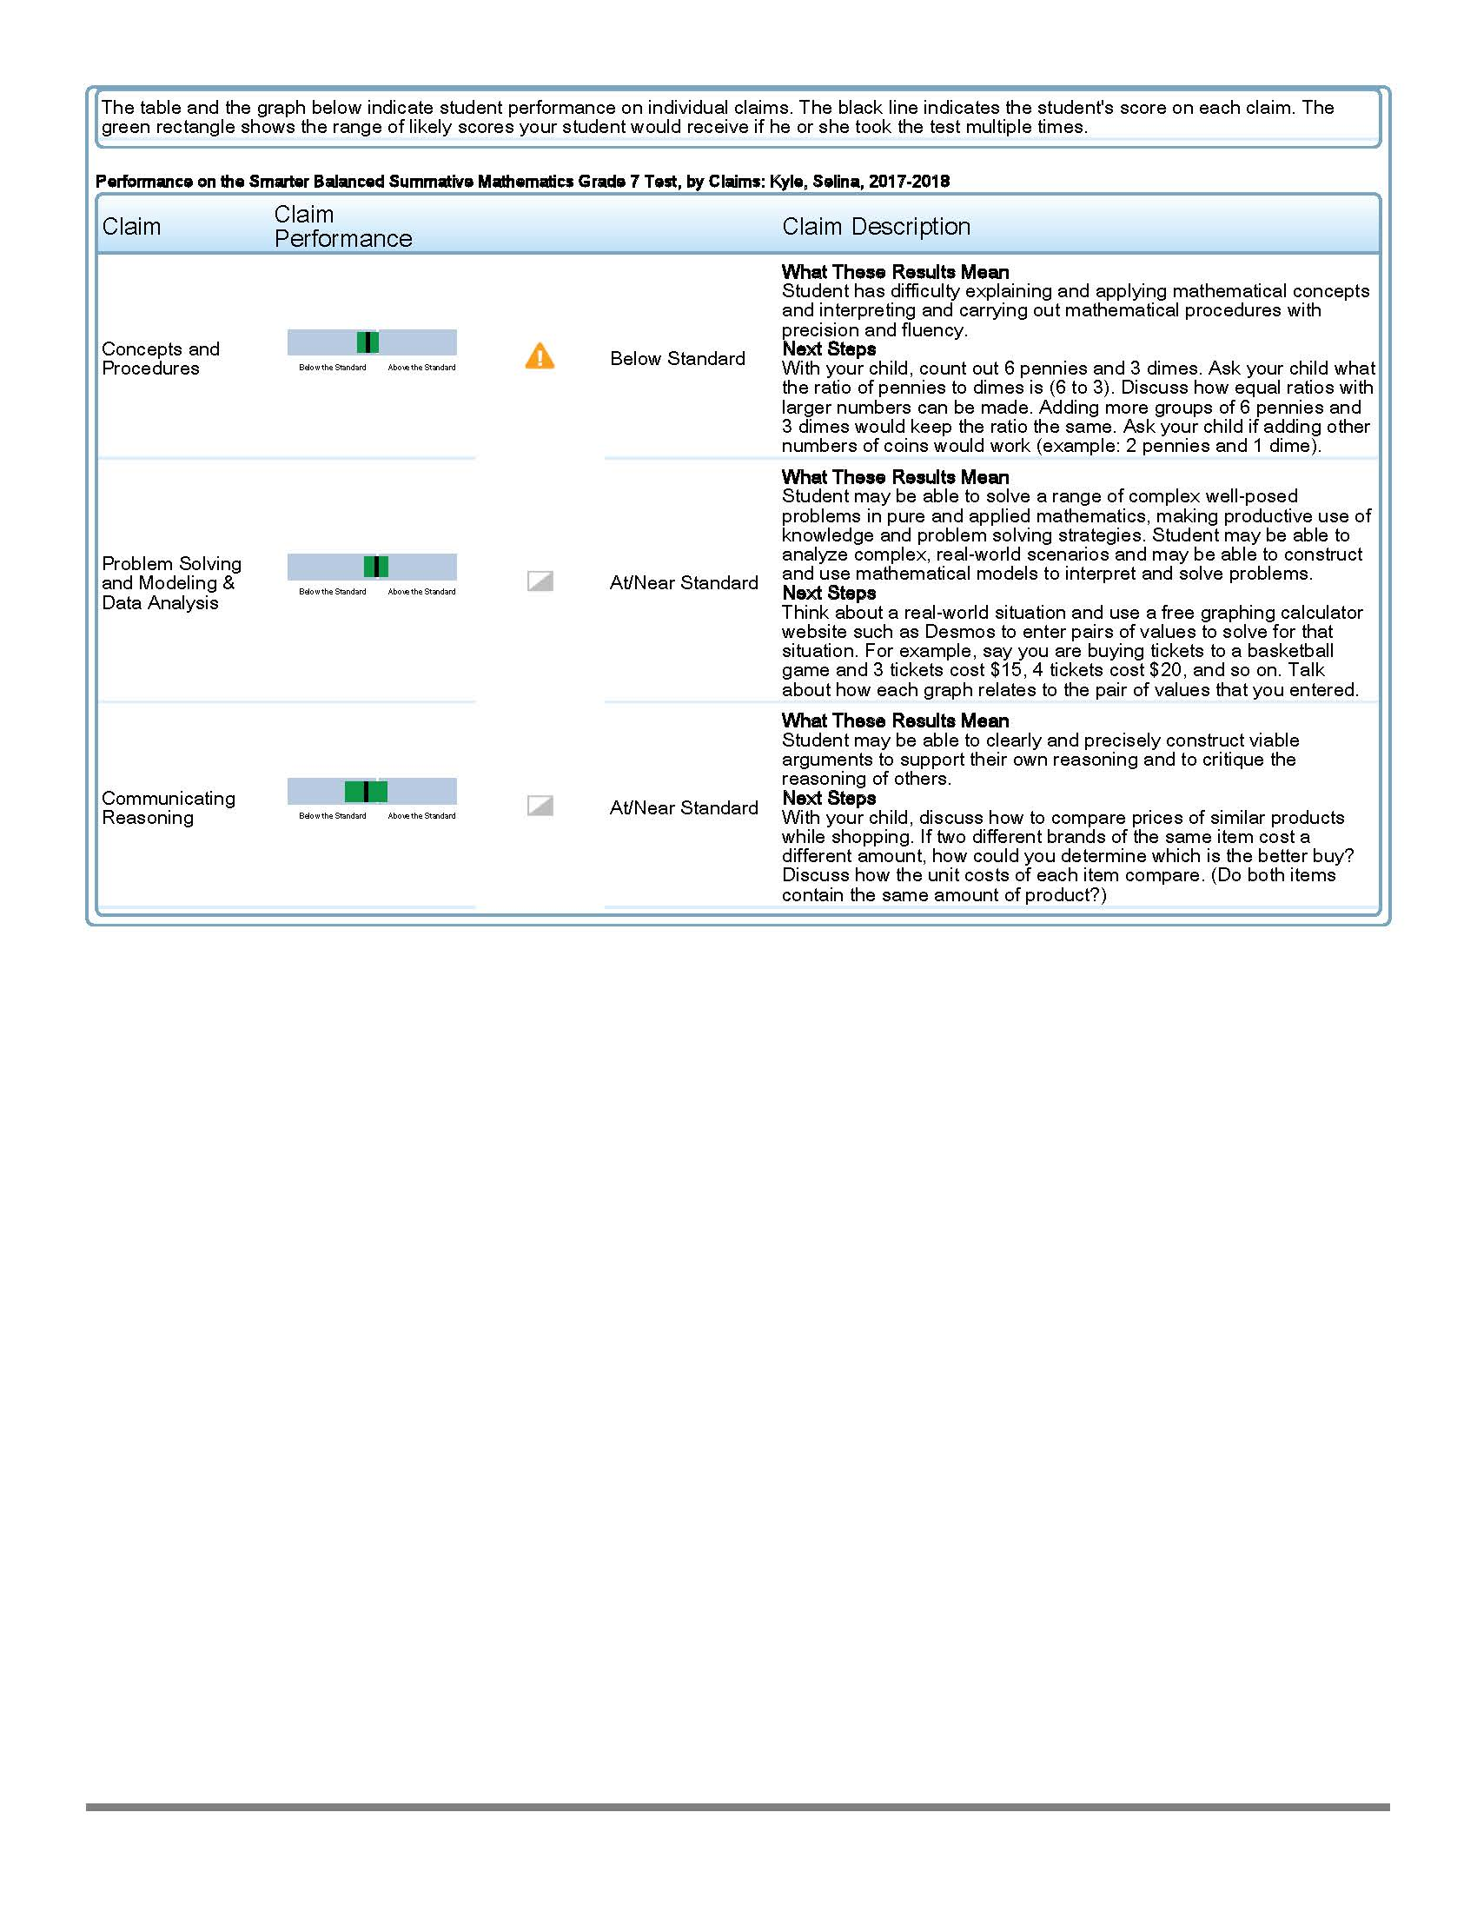
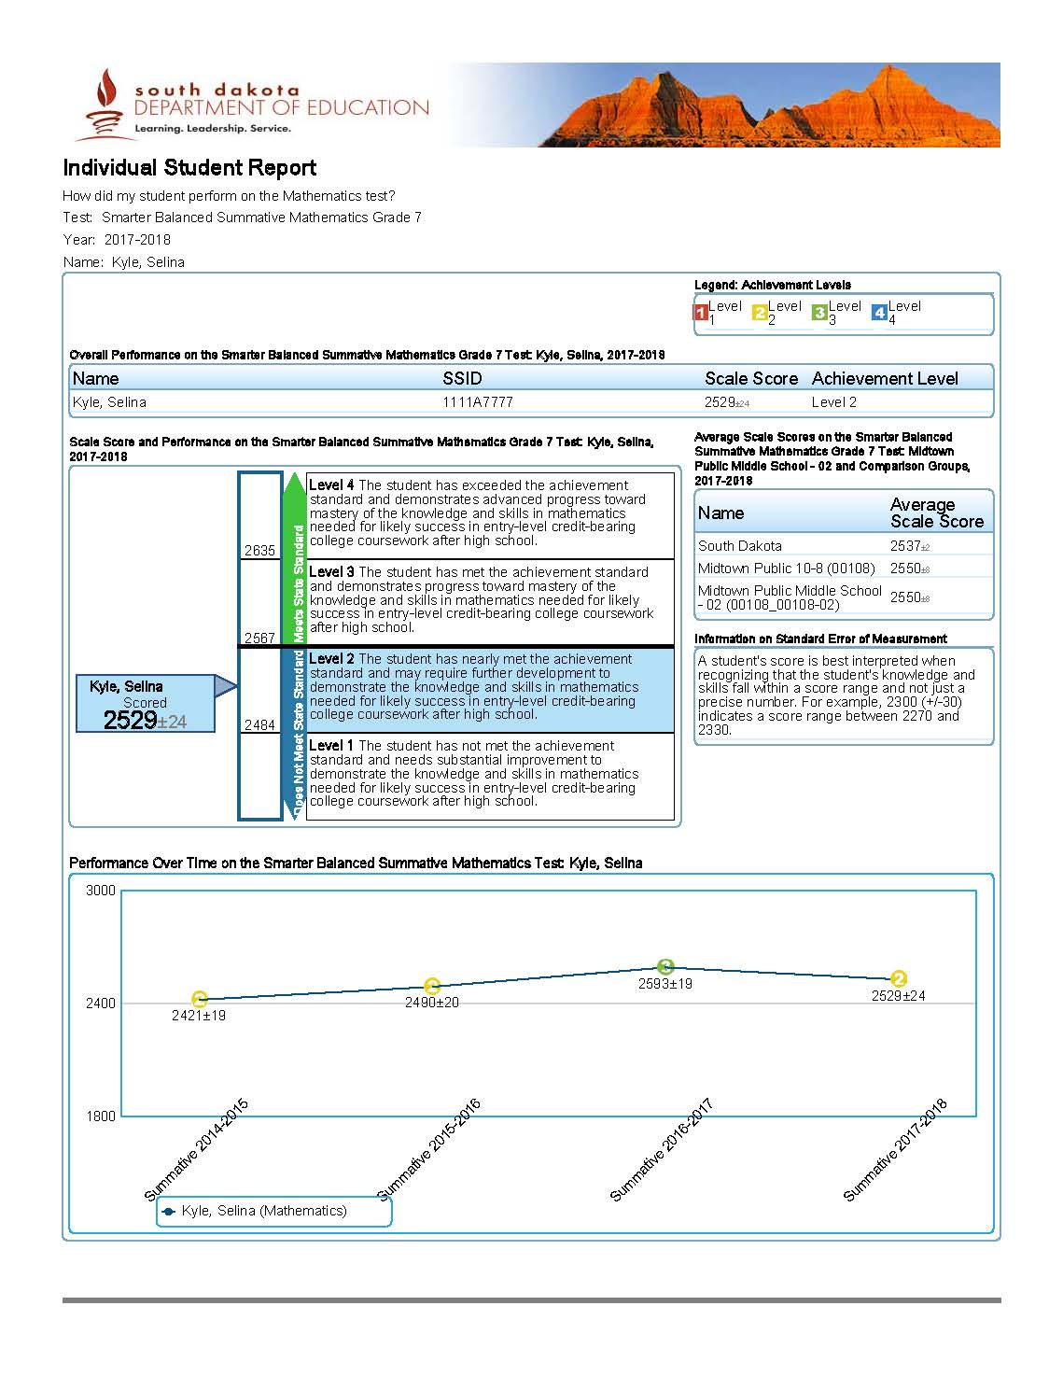
Summative Math Detailed ISR (Individual Student Report)

Longitudinal Legend

Test Name, Subject, & Grade Level

Student Name, SSID#, Scale Score, & Achievement Level

Student Name, SSID#, Scale Score, & Achievement Level
Student Name, SSID#, Scale Score, & Achievement Level

Scale Score (2000-3000) with standard error

Average State, School, and District scores for assessed grade and subject

Achievement Level: Level 3 and 4 are considered performing at or above proficiency

Score details

Average State, School, and District scores for assessed grade and subject.
Longitudinal Trends:
Visual representation for student’s performance over time

Claim Description: Indicates student performance on groups of assessment items that measured similar skills

Performance Per Claim: Student performance descriptors and achievement ranges based on each claim

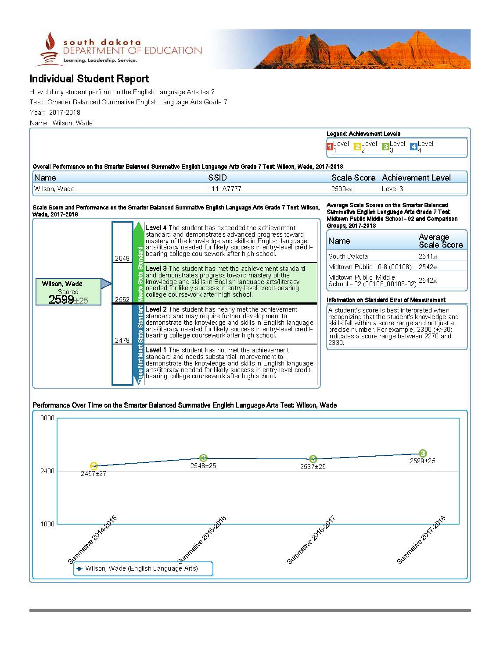
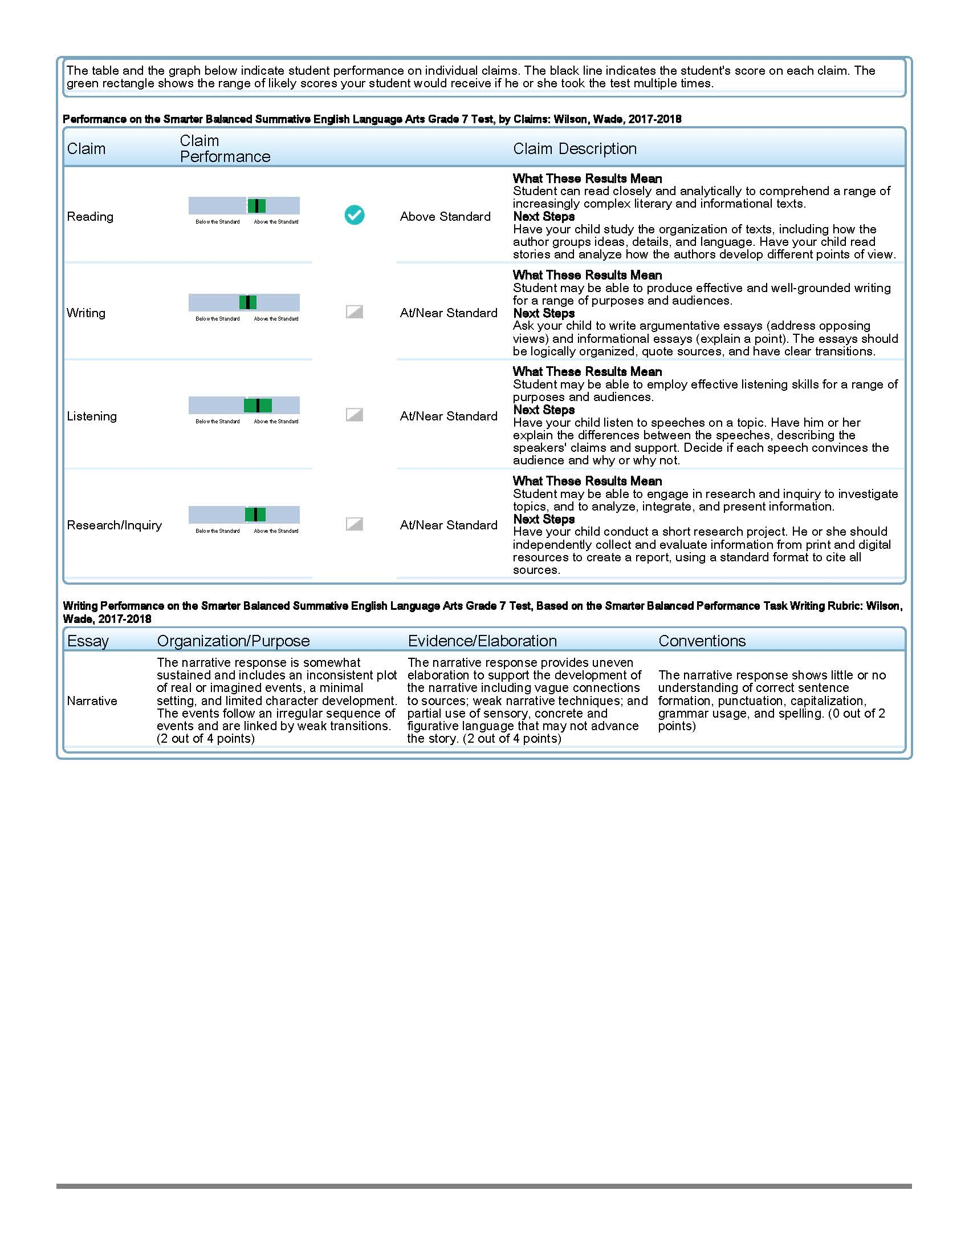
Summative ELA Detailed ISR (Individual Student Report)
Test Name, Subject, & Grade Level

Longitudinal Legend

Student Name, SSID#, Scale Score, & Achievement Level

Scale Score (2000-3000) with standard error

Average State, School, and District scores for assessed grade and subject
Achievement Level: Level 3 and 4 are considered performing at or above proficiency

Score details

Longitudinal Trends: Visual representation for student’s performance over time

Performance Per Claim: Student performance descriptors and achievement ranges based on each claim
Claim Description: Indicates student performance on groups of assessment items that measured similar skills

Writing Performance Task Explanation: The information states the type of essay and student’s performance for each of the writing characteristics assessed
Key Terms
- Achievement Level - There are 4 levels indicating progress toward meeting the expectation of content mastery and college and career readiness.
- Average Scale Score - provides data about the average performance of students in the school and district for the tested grade and subject.
- Claims - are groups of test questions that measure similar skills.
- Claims Performance - describes student performance as “below standard”, at/near standard”, or “above standard”.
- ELA is the English Language Arts/Literacy assessment and includes reading, listening & speaking, writing and research/inquiry skills.
- Mathematics is the Mathematics assessment and includes concepts & procedures, problem solving, and communicating reasoning.
- Scale Score is the score assigned to the student based on his/her results on the Smarter Balanced assessment.
- Scores range from 2000 to 3000.
- Standard Error of Measurement indicates the range of possible scores if a student took the same test a number of times.

Scale Score Sample
A score of 2473±10 is the student’s scale score with standard error of measurement – if the student took the test 10 times, he/she would likely get a score between 2463 and 2483 each time the test was taken.

*NOTE: The Smarter Balanced assessment includes two components: 1) The Computer Adaptive Test is given online and adapts to each student’s ability. 2) The Performance Task is a collection of questions and activities connected to a single theme or situation. Students write short essays for ELA and solve multi-step problems on one topic for math.

Achievement Level Descriptors

Level 4 The student has exceeded the achievement standard and demonstrates advanced progress toward mastery of the knowledge and skills in English language arts/literacy or mathematics needed for likely success in future coursework.

Level 3 The student has met the achievement standard and demonstrates progress toward mastery of the knowledge and skills in English language arts/literacy or mathematics needed for likely success in future coursework.

Level 2 The student has nearly met the achievement standard and may require further development to demonstrate the knowledge and skills in English language arts/literacy or mathematics needed for likely success in future coursework.

Level 1 The student has not met the achievement standard and needs substantial improvement to demonstrate the knowledge and skills in English language arts/literacy or mathematics needed for likely success in future coursework.

Claims

English Language Arts (ELA) | Math
Reading | Concepts and Procedures
Listening & Speaking | Problem Solving
Writing | Communicating Reasoning
Research | Modeling and Data Analysis

Claims Performance Levels Key
Below Standard At/Near Standard Above Standard
Average State, School, and District scores for assessed grade and subject.

