How to Create, Edit, or Delete a User in TIDE

- Go to TIDE login by clicking this box found at the Smarter Balanced Assessment Portal under either District or Test Administrators
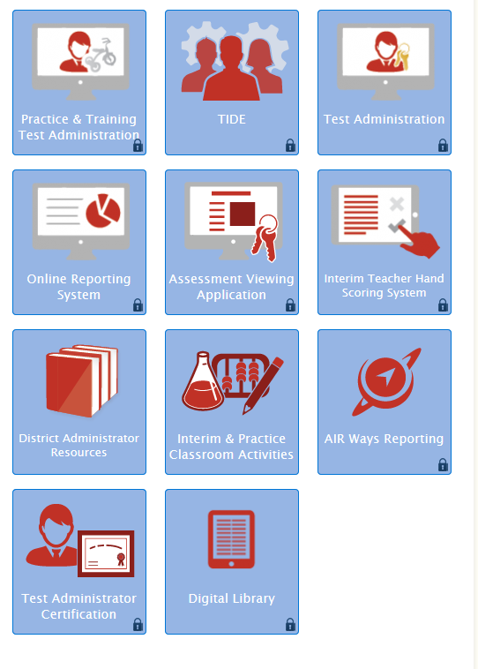

- The following screen should appear
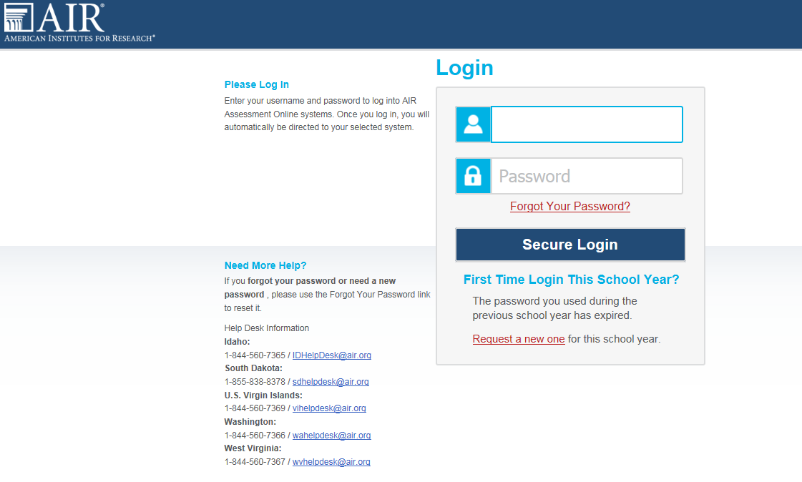
If you have an account but haven’t logged into it yet this year, then you will need to follow the directions below the login screen here:

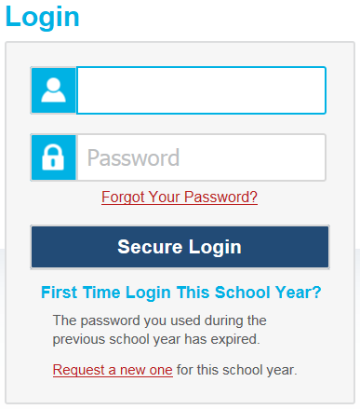

If you have already reset it this school year and just forgot your password, then click the “Forgot Your Password?” link to reset it and create another new one

- If you have more than 1 user account you will see a screen like this each time you log into the system:
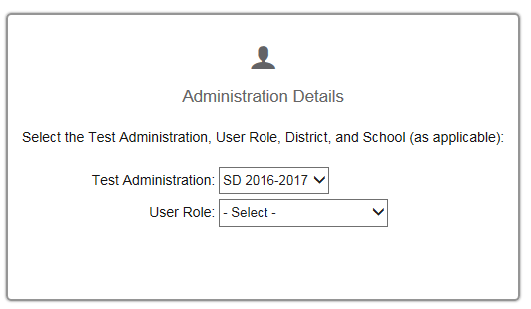

The next screen you see will look like this:

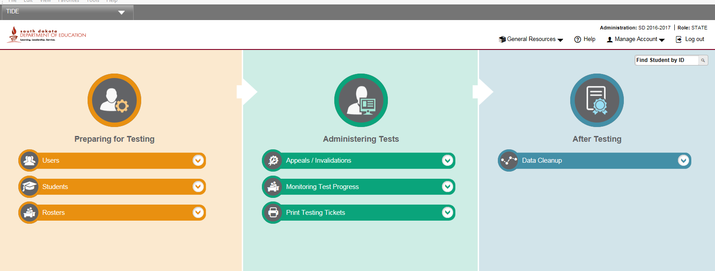

- User Accounts are under the first “Preparing for Testing” section
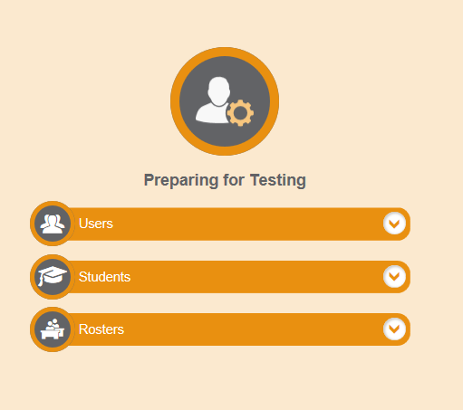
Clicking the “Users” drop box should reveal this:
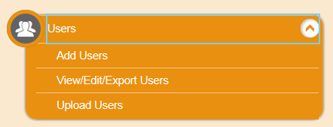
- Add Users
Click the “Add Users” tab and see a screen similar to this:
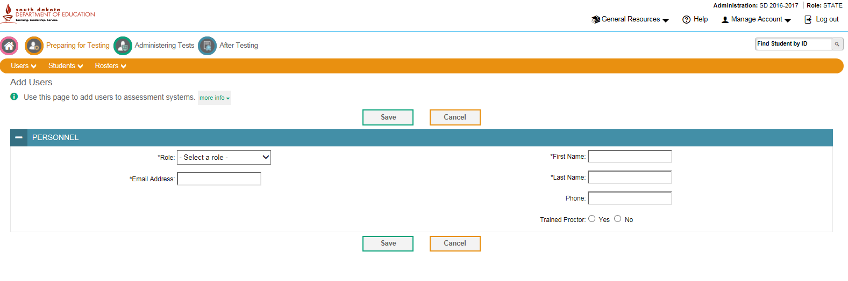
Select a role from the drop box, then fill in all of the required information. Clicking save will create the account and an auto-generated email from AIR will be sent to the person with their login information. If they do not receive it they should check spam folders in case it was sent there.
- View/Edit/Export Users

Click the “View/Edit/Export User tab and see a screen similar to this:
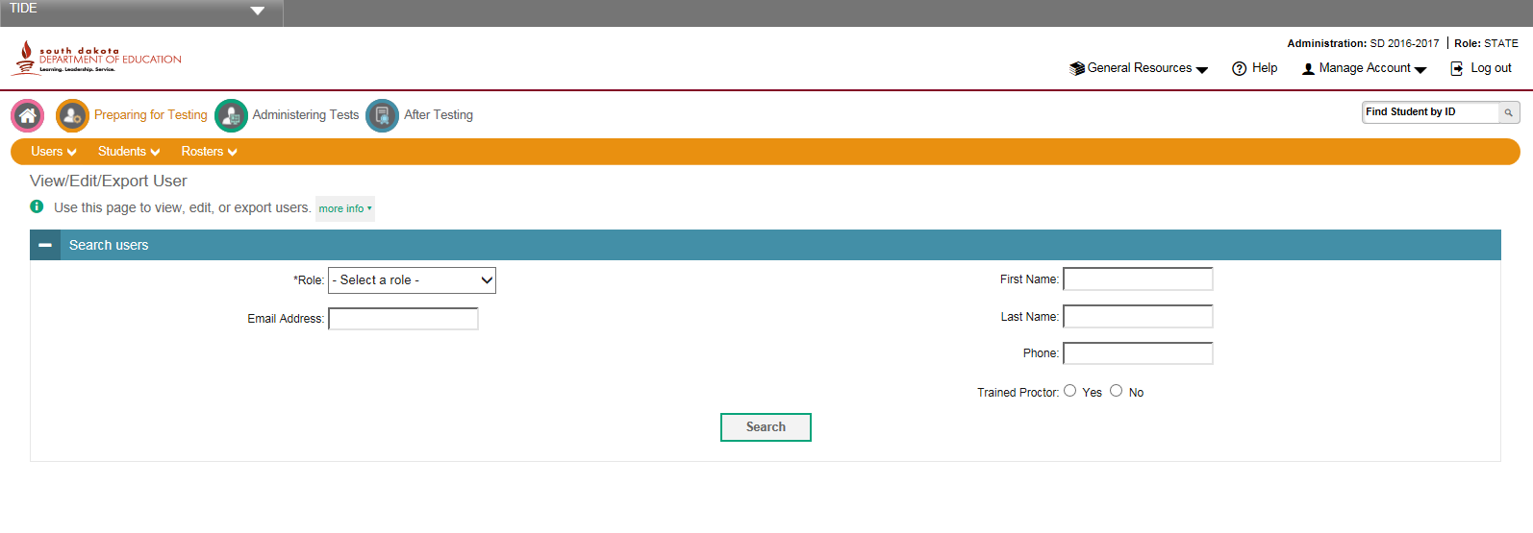
Select a role from the drop box, then fill in one or all of the boxes. It is searchable with just one box filled. Users at the same account level as you are not searchable.
Once you find the account you need to edit, click the “Edit”  button found in their row. Everything but email can be changed.

Deleting an account is done by clicking the box on the far left of the row to be deleted, then clicking the garbage can icon that goes live when the box is clicked.

Clicking this icon  allows the selected account information to be exported to an Excel or CSV file
Be sure to click save when you are finished making changes

- Upload Users
To upload users, one must first download the template for either CSV or Excel
Fill in all necessary information, save it, then upload it and follow all screen prompts

