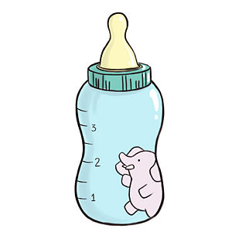
For Parents: Feeding Your Baby Infant Formula? Tell Us More!
This Photo by Unknown Author is licensed under CC BY-ND

As your child care provider, we want to make sure we are meeting your baby’s needs. Please share how you know when your baby is hungry and what you feed your baby.

___________________________ _________________________________________________________________
Today’s Date: Baby’s Name (first and last):

___________________________ _________________________________________________________________
Baby’s Birth Date: Parent’s Name (first and last):

What signs does your baby give you to tell you that he or she is hungry?

- Opens and closed mouth
- Tries to bring food to his or her mouth
- Cries
- Sucks hands and other objects
- Reaches or points to food
- Makes sucking noises and motions

- Roots or turns his or her head and opens his or her mouth
- Other: _____________________________________________________________________

Child Care Providers, please fill out the following:

At our child care site, we offer ____________________ type of iron-fortified infant formula.

What infant formula would you like us to serve your baby? Please answer below.
- Please give my baby the infant formula you have at the child care site.
- I will provide breastmilk. Please do not give my baby the infant formula you have at the child care site.
- My baby has a disability and needs a special infant formula.
Thank you for letting us know! We will be reaching out to you for more information about your baby’s disability.
- My baby does not have a disability, but I want to provide different infant formula than the one you have at the child care site. Please do not give my baby the infant formula you have at the child care site.
Thank you for letting us know! Since we participate in the Child and Adult Care Food Program (CACFP), the infant formula served in our site and the one you provide must be iron-fortified. To know if a formula is iron-fortified, look for
“Infant Formula with Iron,” or a similar statement on the front of the formula package. It must also be purchased in the United States.

Parent’s Signature: _____________________________________________________________

