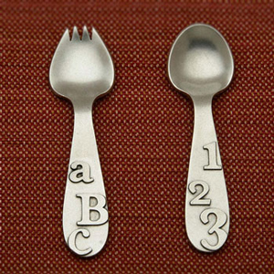
For Parents: What Is Your Baby Eating? Let Us Know!
This Photo by Unknown Author is licensed under CC BY

____________________ ____________________________________________________
Today’s Date: Baby’s Name (first and last):

____________________ ____________________________________________________
Baby’s Birth Date: Parent’s Name (first and last):

Is your baby eating solid foods? Yes No

What texture(s) of food do you give to your baby?
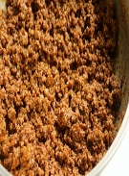
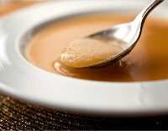
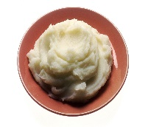
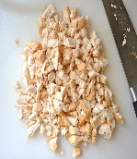
This Photo by Unknown Author is licensed under CC BY-SA-NC
This Photo by Unknown Author is licensed under CC BY-SA-NC
This Photo by Unknown Author is licensed under CC BY-NC

This Photo by Unknown Author is licensed under CC BY-SA

pureed mashed ground finely chopped

Which of these foods have you served to your baby?

Grains:
crackers

iron-fortified infant cereal (check all that apply)
barley cereal oat cereal
wheat cereal rice cereal

ready-to-eat cereal (such as whole-grain o-shaped cereal)

pieces of bread/toast

pieces of pita bread

pieces of soft tortilla

Meats and Meat Alternates (Protein Foods and Dairy):

beans beef pork chicken cottage cheese

eggs fish turkey cheese yogurt shellfish

Vegetables:

broccoli butternut squash cauliflower corn spinach peas

carrots sweet potatoes tomatoes green beans other: _________

Fruits:

apples apricot bananas blueberries mangos

peaches pears prunes strawberries other: _______________

What else does your baby eat?
__________________________________________________________________________________________________________________________________________________________________________________________________________________________________________________________________________________________________________________________________________________________________________________________________________________________________________________________________________________________________________________________________________________________________________________________________________________________________________________________________________________________________________________________________________________________________________________________________

Parent’s Signature: _____________________________________________________________

