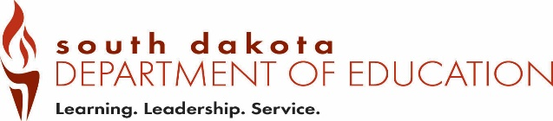
Date Received by SD DOE:
Form SA1 01-2019)
Office of Educator Certification Suicide Awareness and Prevention Training
Type all information or use blue or black ink. Provider Request Form

Part 1 – Applicant Information

Last Name | First Name | Name of Organization
Phone Number | Email Address
Website
Part 2 – Suicide Awareness and Prevention Training Provider Request.
Answer all questions.

According to SDCL 13-42-71, the South Dakota Board of Education Standards shall promulgate rules to include a minimum of one hour of suicide awareness and prevention training as a requirement that an applicant must meet in order to be issued an initial certificate and a renewal certificate as a teacher, administrator, or other education professional. The board shall, after consultation with suicide prevention or counseling experts, identify evidence-based resources that will fulfill the suicide awareness and prevention training requirement and shall make the list of the resources available to school districts.

The South Dakota Board of Education Standards has approved the following guidelines regarding this training:

- Must be evidence-based;
- Include information on youth suicide risk indicators; and
- Include appropriate educator responses and referral sources

Complete the following questions:

Name of Training:

Type of Training:
☐ Online
☐ In-Person

If this is in-person training, describe the specific credentials or minimum requirements of the trainer demonstrating knowledge of the subject area:

Is there a cost associated with this Training?
☐ No
☐ Yes
If yes, what is the cost and describe what the cost covers:

Does the educator completing the training receive a certification of completion?
☐ Yes
☐ No
If no, how will proof of completion be provided?

The SDDOE must be able to view the training or receive a syllabus or documentation of the training to determine the training meets the guidelines of the South Dakota Board of Education Standards. How will this access be provided?

Part 3 – Attestation.
Upload to the application or Email completed form to certification@state.sd.us

I understand that I am applying to be a provider for the Suicide Awareness and Prevention Training require of the South Dakota Department of Education (SDDOE). I hereby attest that the information I have provided is true, and accurate to the best of my knowledge.

Applicant Signature | Date

Save the completed form as a PDF and upload to the application OR Email to certification@state.sd.us

