Finding and Printing Individual Student 2018 SBAC and SDSA Scores in SDAP

Step 1: Log into South Dakota Assessment Portal (SDAP) found here: https://sdap.emetric.net/
Step 2: Click the “Reporting” link 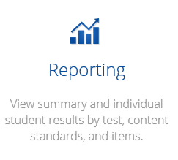
Step 3: Click the first box 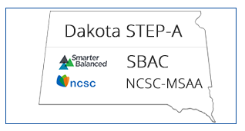
Do not click this box as this is for the no longer used Dakota Step test 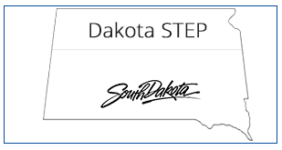

Step 4: Since SBAC is the default choice in the drop-down box at the top, to print SDSA select
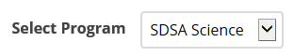
Step 5: To print individual student reports for SBAC select .
Select the year and grade, and school if necessary, then select .
To print individual student reports for SDSA select then .

Step 6: Click “Student View” along the banner on top right of the student names

Step 7: Click “Download” and the following box should appear
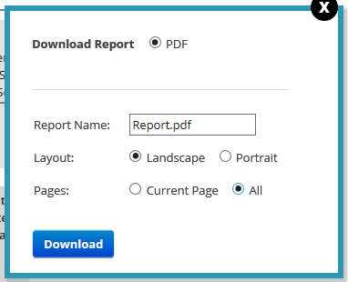
Step 8: Make sure “All” is selected under pages if you are wanting to print each student in that grade, then click download. All individual student reports for that grade should now be downloaded.

Step 9: You can select “Open” to open all of the reports in Adobe Reader or “Save” to save them to a file

Step 10: If you chose to “Open” them, you can then select the print icon in Adobe Reader. This will print all of the individual student reports in that file. If you chose to “Save” them, you can print them later by opening in Adobe Reader and selecting the print icon.

These instructions are only for individual student reports. Other reports are available in the system based on the options you choose.

