(More detailed instructions can be found in the “Authoring Manual” under Help in the SDAP)
SDAP Help Sheet for Creating Items
https://sdap.emetric.net/Portal/ (works best in Google Chrome, Firefox, and Internet Explorer 11)

- Click on on the Welcome screen once you have logged into the system.
- Click on the drop box by “Item Banks” and click on “Classroom Program” if that is not the default for your account. All of the item banks in the system you have access to should now be visible.
- Click on. Create a name for your item bank. You can also choose to align it with a specific subject/standard, as well as choose to share it with others now, or come back to this area to share it later.
- Click on
- Click on
- Choose the standard(s) for which you plan to write the question on the right of the screen from the section labeled “South Dakota Standards”
- Click on
- A window will appear with these template choices:
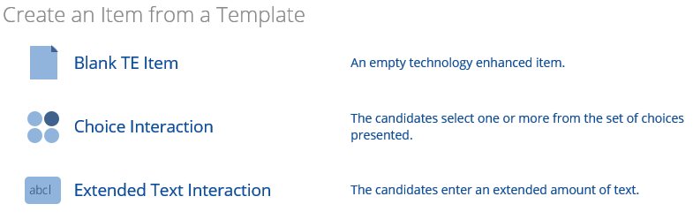
- Choose question type: Blank TE Item, Choice Interaction, or Extended Text Interaction

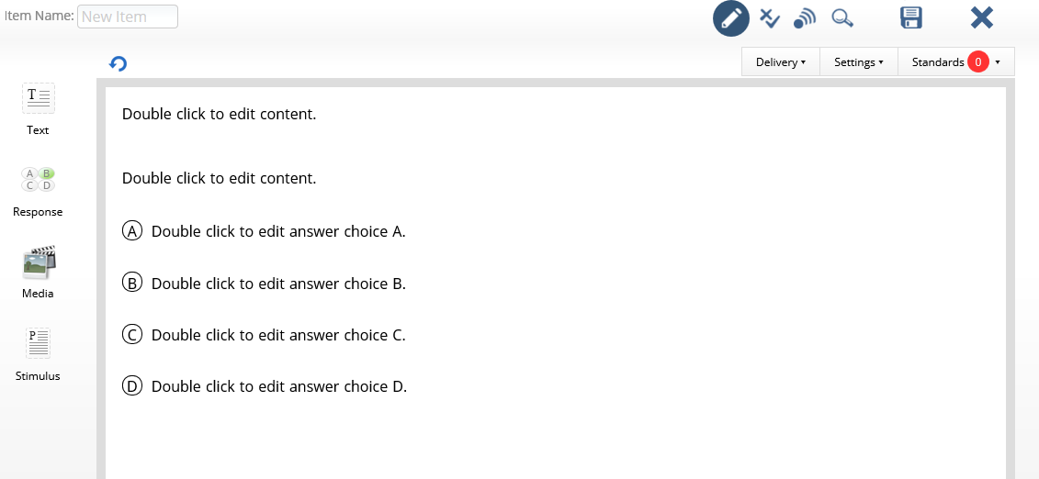
- Select the content you want to add by selecting it from the left menu.
- Choose “Edit” to make the item to your liking. (Directions for each widget are available in the Widgets help guide)
- Items must be aligned to a standard to be saved
- Select “Scoring Mode” to enter the scoring rubric (more information is available on pg. 9 of the Authoring manual)
- Save the item to your item bank
- Pages 6-11 of the Authoring manual has more detailed instructions

