The following steps will be using two different programs within the eMetric site.
- Administration-– Used to create Classes and Students, and to schedule tests to a class
- Authoring-– Used to create Tests and Test questions
- In the upper left-hand corner of every textbox is a small icon indicating the program you must be in to continue with the steps.
- To move from one program to another, click on the  at the top of the screen. Then choose the needed program.
SDAP Help Sheet for Teachers to Create New Tests
https://sdap.emetric.net/Portal/ (works best in Google Chrome, Firefox, and Internet Explorer 11)

Continue to Step 3 on the back
Forms (The Collection of Items)
Make sure you are working under “Item Banks for Classroom Program”
– Click on
If you do not default to your personal item bank, choose it before continuing
- Click “Create Form”
- Select a content area for this form
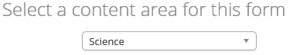
- Click “Use this Content Area” 
- Name your form, select a content area and add an optional description.
- Choose which standards you want to use to make your form. Then choose the content area for the form.
- The Content Area must correspond to the subject in drop box in Administration.
- All forms MUST include Directions, which show up for the students.
- Add references if necessary by clicking “Click here to edit references”.
- Add sessions or sections by clicking the “Add Session” or “Add Section” buttons.
- Delete a session, if necessary, by clicking the “Delete Session” button. The current active session will be deleted.
- Name the session by typing in the space provided
- Name the section by typing in the space provided
- Add items to each section by clicking the “Add Items” button. A menu of available items will be displayed. Click an item to add it to the form. You can pick different available item banks to look for questions that match the standards you have chosen
- Indicate whether a section is repeatable by checking the “Repeatable” box. If a section is repeatable, students will be able to revisit items in that session at any time. If it is not repeatable, students will not be able to revisit items in the section once they have completed the section.
- Click “Save Form”
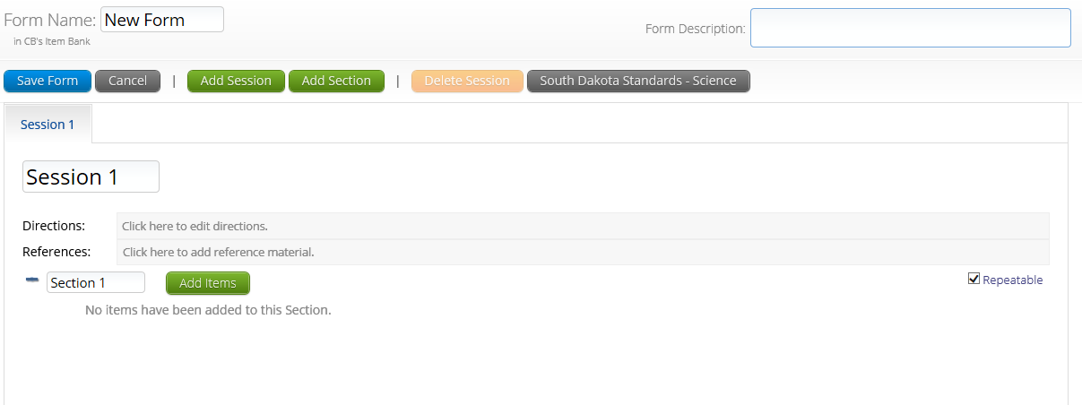
More detail is found on p. 13-14 of Authoring manual

Items (optional step)
Step 2
Step 1
Classes (Class Management) – Click on
- Choose your content area in the middle of the screen.
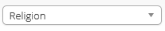
- This must match the Content Area of the test in Step 2 #3 and Step 4 #1.
- Choose “Course Level” for a class by subject, and “Grade Level” for a class by grade
- Click “Create New Class”
- Create a unique class name.
- Choose the Content Area. (Remember the Content Area you choose for Step 1).
- Ctrl-Click, Shift-Click, or click and drag to select the students you want in your class.
- Click “Add >>”
- Click “Save”
**You may create your Form and Test, Steps 2 and 3, before you create your Class, Step 1.
**Items is an optional feature that allows you to create your own test questions. You may bypass this step**
Item Bank – must be created in appropriate program
Items (Test Questions) – Click on
- Click “Create an Item.”
- There are 3 general question types available

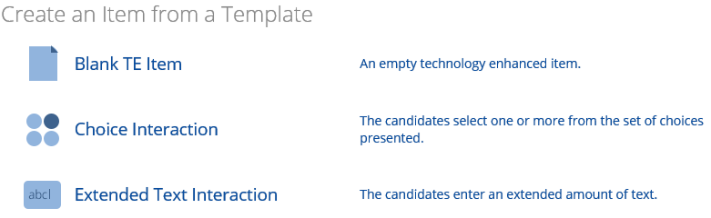
5 Basic steps to follow for all question types:
1: Edit an item using template provided, align standards
2: Score an item using the rubric creator
3: Check accessibility for all students
4: Preview
5: Save and close the item

More is found on p. 6-11 of Authoring manual

Step 4
Step 3
Tests (The Collection of Forms) – Click on
- Click “Create Test.”
- Name the test something similar to the name of your form.
- Include an optional description of your test.
- Click “Add Form” to add a form to the test

- Options: explained on p. 16 of Authoring manual
- Set the “Test Type” for the test.
- Standard-student responses are stored. Once test is submitted, they cannot log in again.
- Allow multiple student attempts-used for benchmark testing. All student attempts are stored and submitted for reporting, and students can take the test multiple times using the same user name and password.
- Create a single username and password to be used for all students-Practice test format. No responses will be stored.
- Click “Save Test” to save the test or “Cancel” to delete the test and any changes made.

Test Sessions (Schedule a test) – Click on
- Use the dropdown menus to filter the list of content areas, programs, and available tests to match the ones you have been using
- Under all Test Types select password type
- Click “Schedule New Test Session” 
- Select the classes and forms you with to schedule by clicking to highlight the desired classes and forms.
- Indicate the Start Date, End Date, Start Time, End Time and Time Zone.
- Click “Schedule”.
- Find all the students’ usernames and passwords by clicking “View Details/Student Logins”.
- To print student logins, click the area above the information that says “Print test login (Avery label 5160)”

View all State Standards
Attach Form(s) to Test
Create the test layout
Create and access test questions
Groupings of test items
Site Cert

iTester Home
Home
Manage your classes
List of students
Schedule a test
Test Security Agreements
Help Guide for Administration

Additional Information
** For students to take your test, iTester3 client must be downloaded on the students’ computers.**
Directions to Download iTester3
- Technology coordinator or administrator must log into SDAP.
- Click “Administration”
- Click on the link found in the middle of the screen corresponding to the type of computers your students have.
- Follow the directions to download.
- Either download iTester3 on all computers manually (recommended) or download on your network and push out to all computers.
** Students will click on the iTester icon found on the desktop to log in to take the test.

Reporting – Used to view data (Dakota Step, End of Course, Benchmark, Formative).

Home
Help Guide for Authoring

