How to Print Individual Student Reports for 2018 SDSA

Chrome is the preferred browser

STEP 1: Log into the Nextera Administration Center found here
https://sd.nextera.questarai.com/admin/Accounts/Login

STEP 2: Click on the “REPORTS” tab. If you do not see the “REPORTS” tab, then your account is below the
minimum permission level.

STEP 3: Select “Reports” from the drop-down window
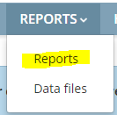
STEP 4: Under “Report Level” select “Classroom”. This is the only level that has Individual Student Reports. The
other levels are non-functional.

STEP 5: Select “Individual student report (ISR)” under “Report Type”. It is the only option available.

STEP 6: If you have a district level account, you will need to select the school, subject of “Science”, grade, and
class. Then click “Create report”. If you have a school level account, then you can only select the subject of
“Science”, grade, and class. Then click “Create report”

STEP 7: If nothing happens, check to make sure your pop-up blocker will allow pop-ups from Nextera and isn’t
working to prevent the reports window from appearing. Once they do appear, click the icon circled below
for the options to export the file. 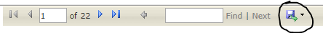

STEP 8: Select the option you want for exporting the reports.
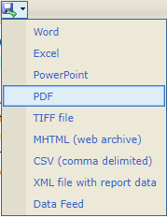
If possible, select PDF so they appear like they do on the screen.
Selecting “Word” spreads the reports out over 2 pages so they are more difficult to read. The other
options are not recommended. Select the download location if necessary.

STEP 9: Open in program you selected for file type. You should be able to print the entire class as it is one file.
This is the only grouping available to print individual student reports.

