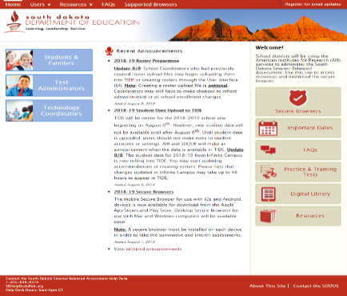
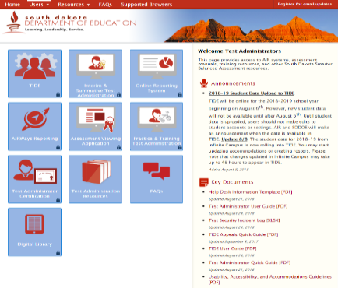
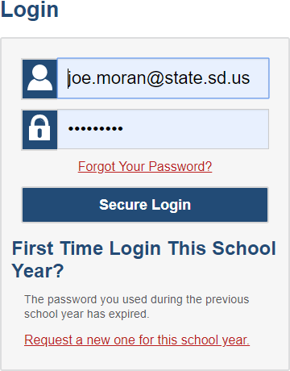
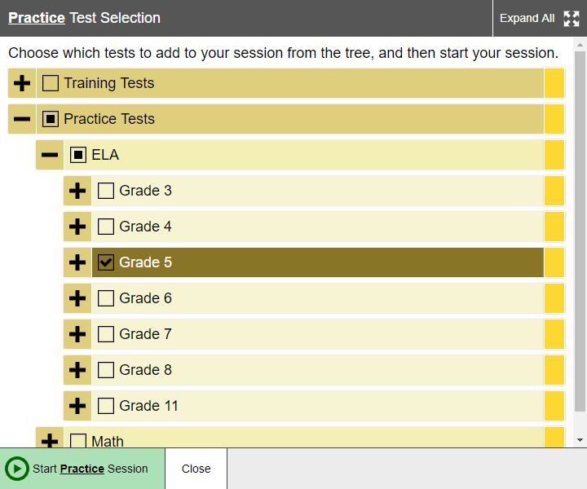
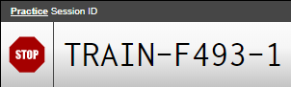
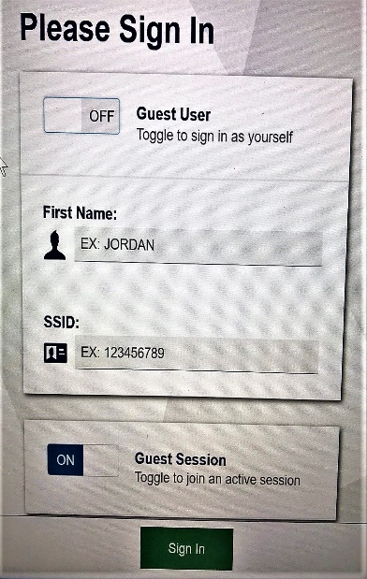
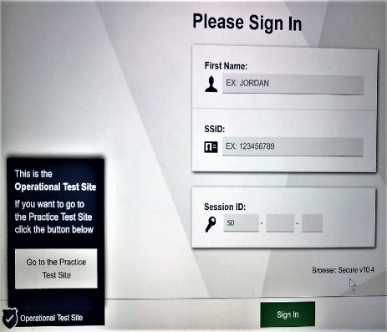
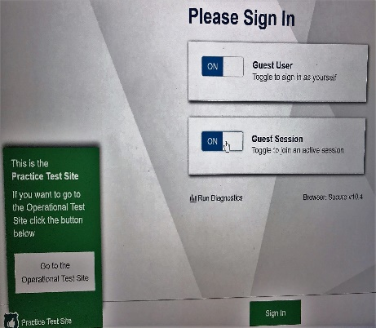
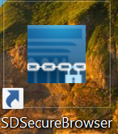
Purpose: To assist users in setting up a LIVE practice assessment session, which may aid in (a) ensuring students and educators are system fluent and (b) student supports, tools, and accommodations are functioning properly.
Educator: Access SBAC Assessment Portal
Educator: Set up Appropriate Practice/Training Assessment Sessions
Exact same process as administering a summative or interim assessment: except a different administration program card.
Provide students with the Session ID.
Open the Secure Browser
Note: Same Secure Browser that you use for interim and summative assessments.
(Depends on district operating systems and preferences)
Student: Log on using the SBAC Secure Browser
Select the Practice Test Site
Click the switch to change GUEST setting off.
Log on

