Preference Survey – FFAVORS Transfer Request
To find the survey:
- Log into iCAN System
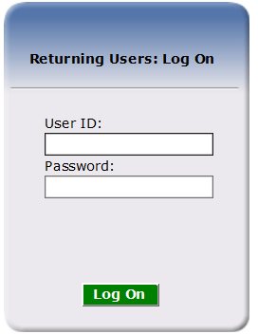
- Click the Food Distribution tile (if available)
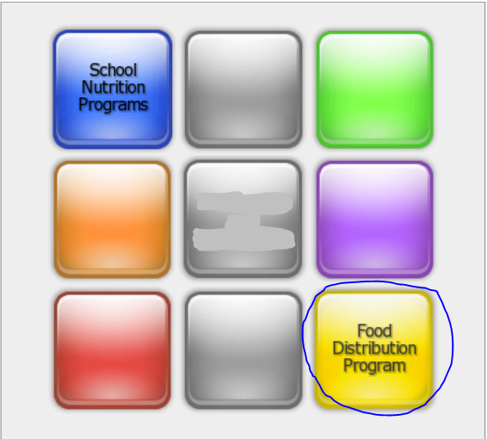

  - OR Agencies at the top of the screen
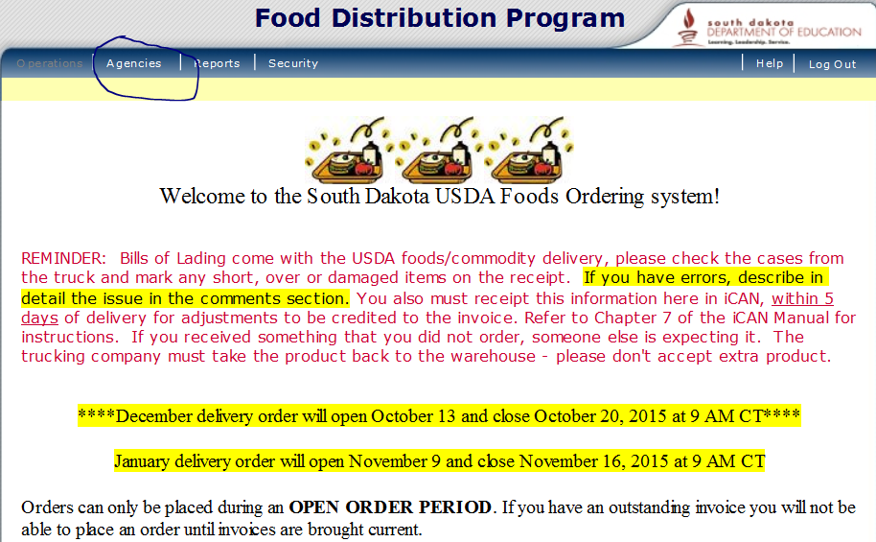

- Click Surveys
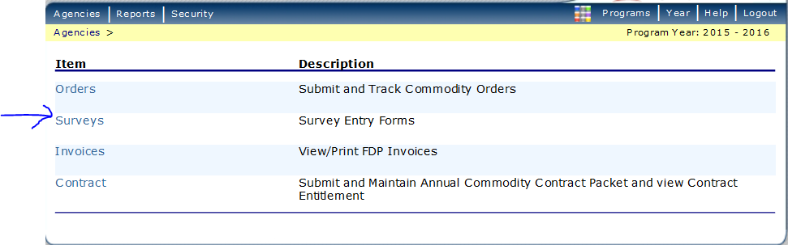

- Click Continue
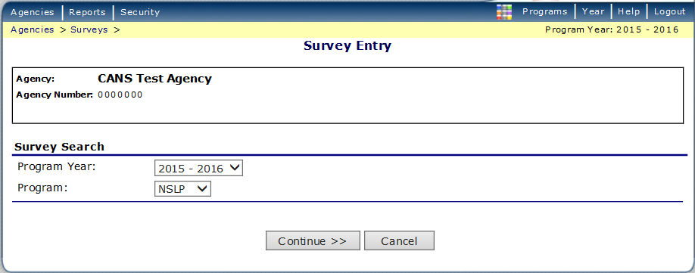

- Click on the number “109” 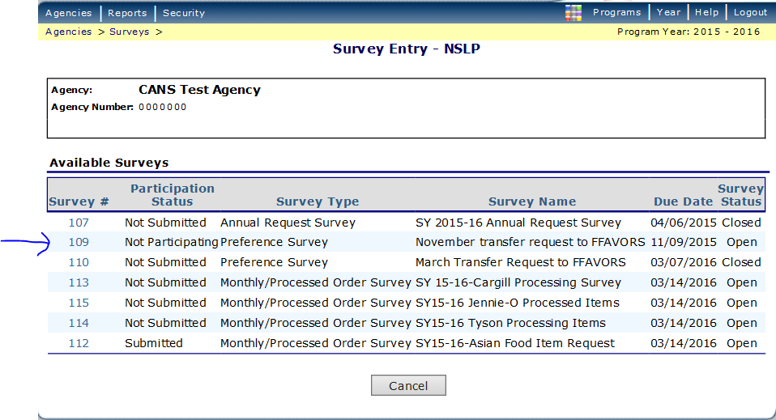

- In the Anticipated Usage column, fill in the dollar amount you would like transferred to DoD.
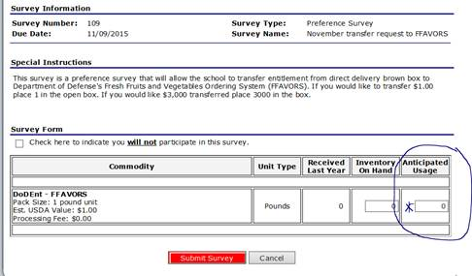

- Click Submit Survey
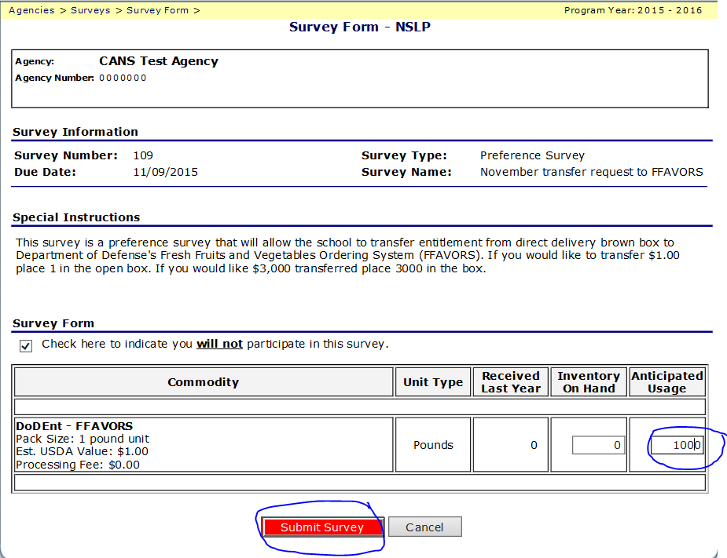

- Click Finished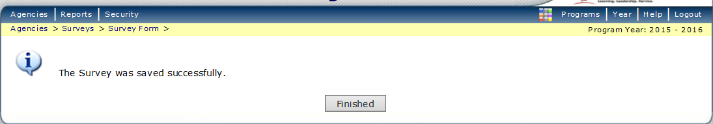

- Participation Status column will now show Submitted