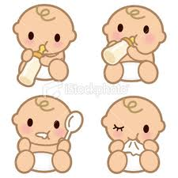
This Photo by Unknown Author is licensed under CC BY
For Parents: Have You Already Started Giving Your Baby Solid Foods? Please Let Us Know!
Please complete this handout and give it to your child care provider.

___________________________ _________________________________________________________________
Today’s Date: Baby’s Name (first and last):

___________________________ _________________________________________________________________
Baby’s Birth Date: Parent’s Name (first and last):

What foods have you given to your baby? ___________________________________________
_____________________________________________________________________________

Has your baby had an allergic reaction to any foods? __________________________________
_____________________________________________________________________________

Did your baby’s health care provider tell you that your baby has a food allergy or intolerance? Note, we may need a medical statement from a recognized medical authority to accommodate this.

Yes No * If yes, which foods should we not serve to your baby in child care?
________________________________________________________

If your baby has a reaction to food, who should we call? Relationship: ____________________

Name: _____________________________ Phone Number: ___________________________

If your baby has a reaction to a food at child care, what medication does your health care provider want us to give it to him or her? ___________________________________________
_____________________________________________________________________________
Are there foods your family does not eat due to religious reasons? Yes No
- If yes, which foods does your family not eat? ___________________________________

Is there anything else we should know about what or how your baby eats? ________________
_____________________________________________________________________________

Parent’s Signature: _____________________________________________________________

