For Parents: Varying Your Baby’s Veggies

Giving your baby a variety of vegetables is a great way to introduce different flavors and nutrients into your baby’s diet. You can start by giving your baby thinner pureed vegetables. Introduce thicker and lumpier vegetables as he or she gets older. This includes mashed, ground, and finely chopped foods.

What Face Does Your Baby Make When Trying These Foods?
Circle the face that looks like the face your baby made when trying the new food.

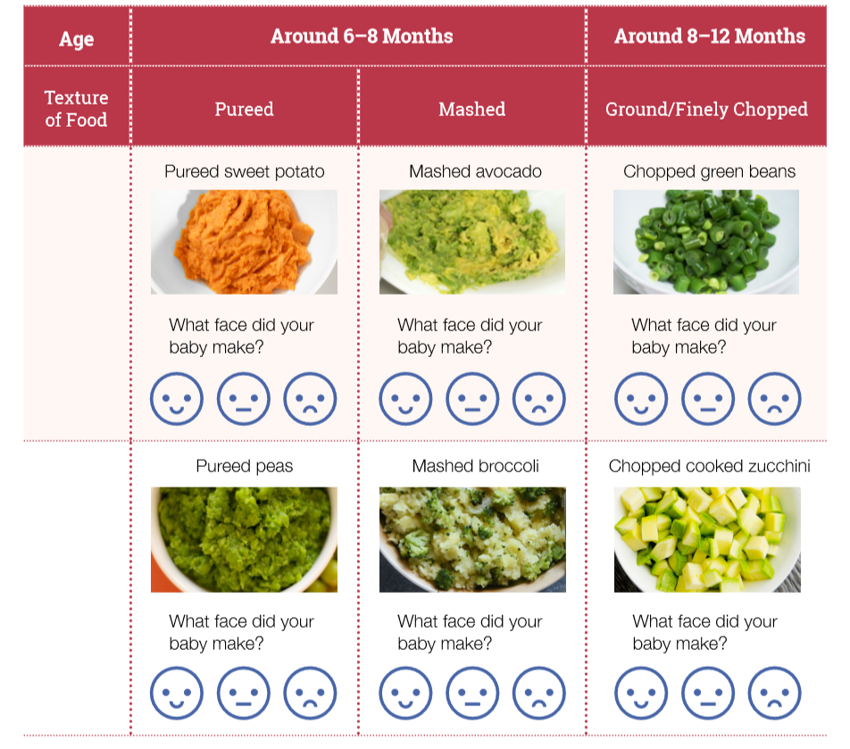

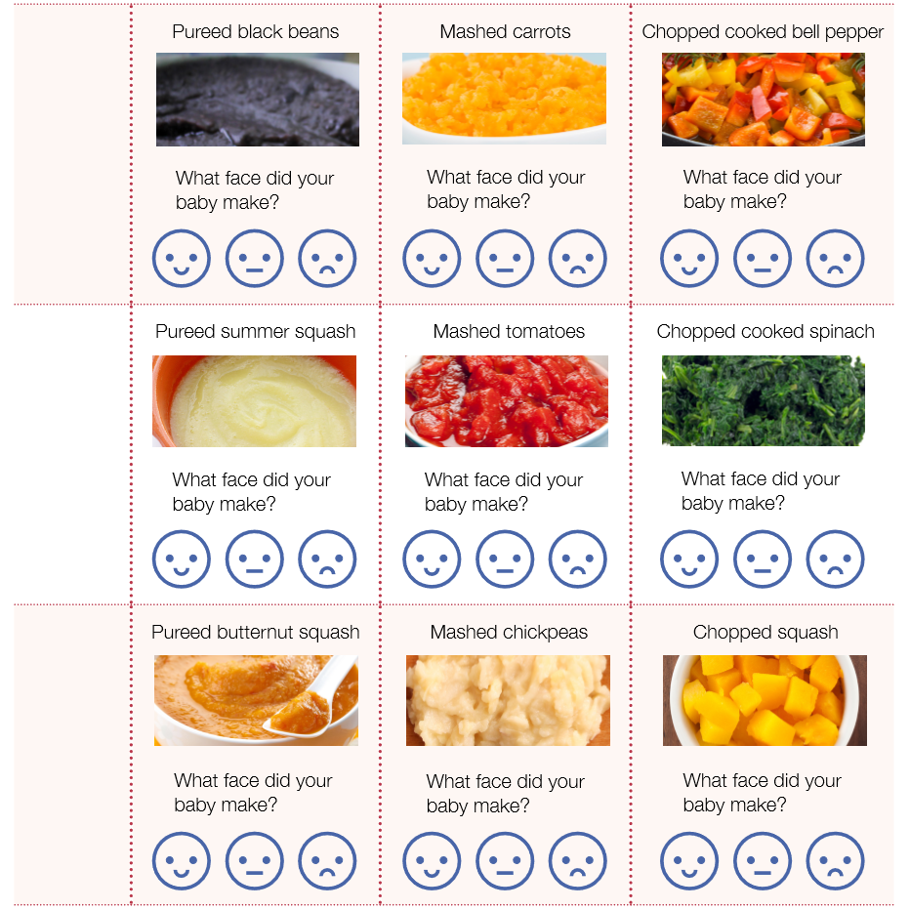

It’s okay if your baby makes this face or this one after you let them try a new food! You may have to offer a food more than 10 times before your baby might like it. Don’t give up – keep offering these foods to your baby! One day your baby may like the food and will make this face .

