For Parents: Making Sure Your Baby Gets Enough Iron

Iron is one of the key nutrients babies need during their first year of life. Iron helps to transport oxygen throughout the body, which is important for a baby’s growth and brain development. |  | Babies that are only breastfed typically run out of the iron they are born with between 4 and 6 months of age. Your baby’s health care provider may give your baby an iron supplement until your baby is ready for solid foods. When your baby is ready for solid foods, make sure your baby is eating foods that contain iron.

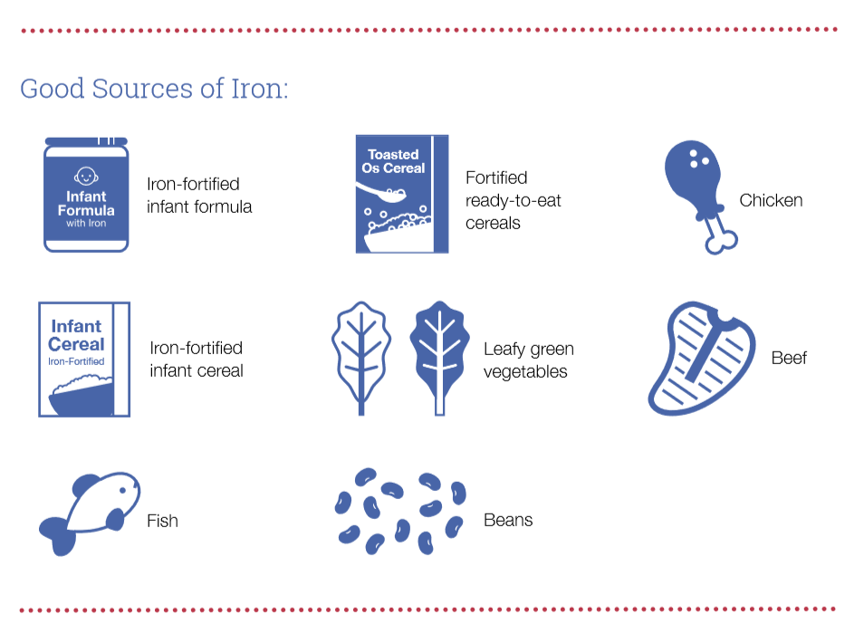

Continue reading on the back of this handout about good sources of vitamin C to pair with the iron-rich foods on this page.

Good Sources of Vitamin C

Vitamin C helps our bodies absorb iron! When you serve a baby iron-rich foods, like the ones on the other side of this handout, pair them with foods that contain vitamin C. Remember to prepare the following foods to the right texture and size to prevent choking.

