Instructions:

- Join Skype Meeting ← Click the link
This is an online meeting for Skype for Business, the professional meetings and communications app formerly known as Lync.
- Upon joining the meeting, you will be prompted to Run the Skype Meeting plugin. Click Run, and follow the onscreen instructions accordingly. Please have tech personnel available, if needed.

- After joining the Skype Meeting, Click OK to ‘Use Skype for Business (full audio and video experience)
- This will make the audio come through the computer.
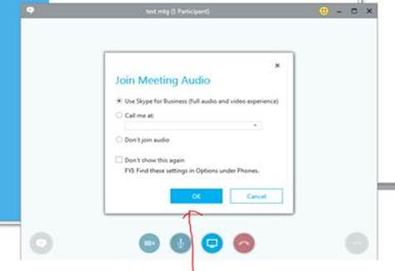

- If you are wanting to ask questions you will need:
  - a microphone on your computer
OR
  - type the question in Message Text box
OR
  - click ‘Don’t Join Audio’, and dial 866-410-8397 on your phone. When prompted, provide the Conference Code.
    - Conference Code: 5928755239

- Once you have joined the meeting a YELLOW bar will show up on your screen, you will need to Accept Meeting Content in order to see the presentation.

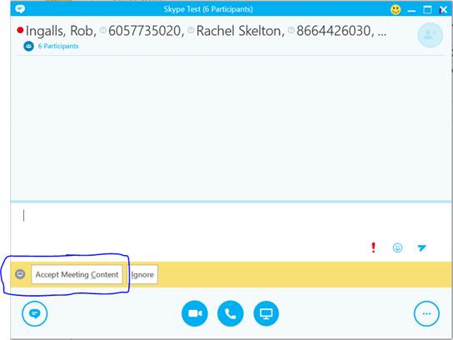

- If you are unable to make the Skype meeting work you need to call into the Conference Number and listen as you follow along with the attached training Manual.
  - dial 866-410-8397 on your phone. When prompted, provide the Conference Code.
    - Conference Code: 5928755239
  - This manual can also be found on the CANS NSLP page: http://doe.sd.gov/cans/nslp.aspx

