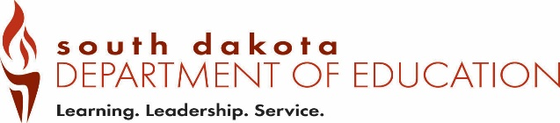
Date Received by SD DOE:
Form AC5 (12-2018)
Office of Educator Certification Alternative Certification District Intent to Employ
Type all information or use blue or black ink. Administration Alternative Certification

Part 1 – Applicant Information to be completed by the employing school district.

South Dakota Educator or Preliminary Certificate Number |  | Expiration Date
Last Name | Last 4 digits of the SSN
First Name | Maiden/Previous Last Name
Part 2 – Public or Department-Accredited school intent to employ through alternative certification.
Email completed form to certification@state.sd.us

Public or Department-Accredited School |  | School Building Name
☐ Superintendent:
Does the applicant have a master’s degree or higher from a regionally-accredited institution of higher education? ☐ Yes ☐ No

Does the applicant have three or more years of experience in a management role in a business, public school, or Department-accredited school or be employed as a teacher with a leadership role in a public or Department-accredited school?
☐ Yes -- If yes, list experience and years ☐ No

☐ K-12 Principal:
Has the applicant completed a state-approved teacher education program or alternative certification program? ☐ Yes ☐ No

Does the applicant have three or more years of teaching experience?
☐ Yes -- If yes, list years ☐ No

Was the above position advertised?  ☐ Yes ☐ No | If yes, where and how many applicants?
Did any of the applicants hold a South Dakota professional or advanced administrator certificate prior to hiring an applicant for the administrator alternative certificate? ☐ Yes ☐ No
If yes, state the reason for not hiring.

Part 3 – Employer requirements for employing an individual with an alternative teaching certificate.

According to ARSD 24:28:15:11, a public or Department-accredited school employing an individual with an administrator alternative certification must assign a mentor with experience as a school administrator to support the individual.
Explain the mentorship that will be provided.

We, the Public or Department-Accredited School, understand that:
- the certificate must be renewed yearly with our recommendation for renewal;
- the individual must pass the state-designated school superintendent assessment or the school leadership assessment prior to renewal of the certificate;
- the maximum length for alternative certification is five years;
- we must provide information about the South Dakota Code of Professional Ethics for Teachers in chapter 24:08:03, and the South Dakota Code of Professional Ethics for Administrators in chapter 24:11:03;
- we must train the applicant on the administrator and teacher evaluation system; and
- the individual must be working towards the requirements to obtain a professional administrator certificate for superintendent or K-12 principal.

Print Name of Authorized Official | Title of Authorized Official
Email Address | Telephone (including area code)
Address |  | City | State |  | Zip Code
Signature of Authorized Official |  |  |  | Date

Save the completed form as a PDF and Email to certification@state.sd.us

