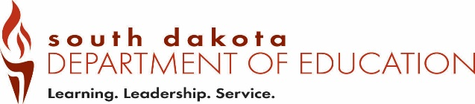
Date Received by SD DOE:
Form EPV3 (12-2018)
Office of Educator Certification Native American Lakota, Dakota, Nakota
Type all information or use blue or black ink. Language and Culture Proficiency Verification

Part 1 – To be completed by the applicant.

Complete Part 1 and send this form to the department chairperson for completion of Part 2.
The department chairperson contact information is listed on page 2.

Last 4 digits of SSN |  | Telephone Number
Last Name | First Name |  | Maiden/Previous Last Name
Email Address

Part 2 – To be completed by a regionally-accredited institution of higher education offering a teacher education program in Lakota studies.

Complete this section and Email to certification@state.sd.us

Proficiency Statement

I certify that _________________________________________has demonstrated proficiency in
(applicant name)
Lakota, Dakota, or Nakota oral and written language and culture with recognition from a regionally-accredited institution of higher education offering a teacher education program in Lakota studies or an organization approved by both a tribal government in South Dakota and the Department.

Also, the individual has successfully completed a three-semester-hour methodology course directly related to teaching Lakota, Dakota, Nakota language from a regionally-accredited institution of higher education.

Printed Name of Authorized Official | Print Title of Authorized Official
Email Address | Telephone Number
Address | City | State | Zip Code
Signature of Authorized Official |  | Date

Save the completed form as a PDF and Email to certification@state.sd.us

Regionally-accredited institutions of higher education offering a teacher education program in Lakota studies

Sisseton/Wahpeton Community College
PO Box 689
Sisseton, SD 57262
Chairperson – Dakota Language: Erin Griffin
Phone: 605.742.1117
Fax: 605.698.3132

Oglala Lakota College
PO Box 490
Kyle, SD 57752-0490
Chairperson – Lakota Language: Karen Lone Hill
Phone: 605.455.6000
Fax: 605.455.2787
Email: kloneh@olc.edu

University of South Dakota
414 E Clark
Vermillion, SD 57069-2390
Chairperson – Lakota Language: Armik Mirzayan
Phone: 605.677.3159
Email: armik.mirzayan@usd.edu

Sitting Bull College
1341 92nd St
Fort Yates, ND 58538
Chairperson – Lakota Language: Michael Moore
Phone: 701.854.8021
Fax: 701.854.8197
Email: michaelm@sbci.edu

Sinte Gleska University
PO Box 8
Mission, SD 57555
Chairperson – Lakota Language: Francis Cutt
Phone: 605.856.8194
Fax: 605.856.2213

