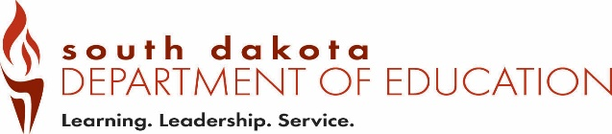
Date Received by SD DOE:
Form EPV4 (12-2018)
Office of Educator Certification Eminent Scholar Lakota, Dakota, Nakota
Type all information or use blue or black ink. Language and Culture Proficiency Verification

Part 1 – To be completed by the applicant.

Send this form to the authorized individual listed on page 2.

Last 4 digits of SSN |  | Telephone Number
Last Name | First Name, MI | Maiden/Previous Last Name
Email Address
Part 2 – To be completed by an authorized individual from the organization approved by the SD tribal government and the Department.

Email completed form to certification@state.sd.us.

Proficiency Statement

I certify that _________________________________________ has met the requirements of the
(applicant name)
eminent scholar program recognized by an approved indigenous language board or similar organization created and recognized by a tribal government.

Also, the individual has successfully completed a three-semester-hour methodology course directly related to teaching Lakota, Dakota, Nakota language from a regionally-accredited institution of higher education.

Printed Name of Authorized Official | Print Title of Authorized Official
Email Address | Telephone Number
Address | City | State | Zip Code
Signature of Authorized Official |  | Date

Save the completed form as a PDF and Email to: certification@state.sd.us

Organization approved by both a tribal government in South Dakota and the Department

Dakotah Language Institute
Contact Person: Tamara Decoteau
Phone: 605.698.2030
Email: tammyd@swo-nsn.gov

Cheyenne River Sioux Tribe
Contact Person: Harold Frazier, Chairman
PO Box 590
Eagle Butte, SD 57625
Phone: 605.964.4155

