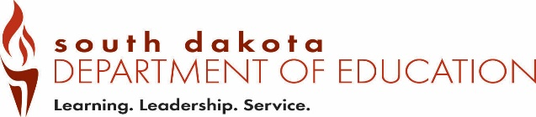
Date Received by SD DOE:
Form EPV8 (12-2018)
Office of Educator Certification Educator Permit District Intent to Employ
Type all information or use blue or black ink. Performing Artist

Part 1 – Applicant Information to be completed by the employing school district.

Last Name | Last 4 digits of the SSN
First Name | Maiden/Previous Last Name
Part 2 – Public or Department-Accredited school intent to employ through performing artist permit.
Email completed form to certification@state.sd.us

Public or Department-Accredited School |  | School Building Name
Grade Level |  | Content Area
Class Assignment(s)

Was the above position advertised?  ☐Yes ☐No | If yes, where and how many applicants?
Did any of the applicants hold a South Dakota professional or advanced teaching certificate? ☐Yes ☐No
If yes, state the reason for not hiring.
Explain the mentorship that will be provided during the school year?

We, the Public or Department-Accredited School, understand that:
- the certificate must be renewed yearly with our recommendation for renewal; and
- a mentor teacher must be provided to the applicant.

Print Name of Authorized Official | Title of Authorized Official
Email Address
Telephone Number
Address |  | City | State |  | Zip Code
Signature of Authorized Official |  |  |  | Date

Save the completed form as a PDF and Email to certification@state.sd.us

