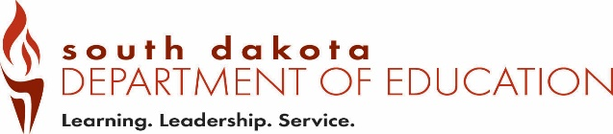
Date Received by SD DOE:
Form OSF2 (12-2018)
Office of Educator Certification Out-of-State Educator Certification Verification
Type all information or use blue or black ink.

Part 1 – To be completed by the Applicant.
Complete this section, then send this form to the licensure agency where you hold an educator license/certificate.

Last 4 digits of SSN | Telephone Number | Date of Birth
Last Name | First Name, MI | Maiden/Previous Last Name
Email Address
Part 2 – To be completed by the State Licensure/Certification Agency.
Email completed form to certification@state.sd.us

Current Licensure/Certificate Expiration Date
Licensure/Certificate Obtained Through |  | ☐Traditional Education Program ☐ State Approved Alternative Program
Current Licensure/Certificate Status | ☐ Valid ☐ Expired ☐ Emergency ☐ Temporary ☐ Provisional ☐ Substitute
Does the certificate holder have any deficiencies? | ☐ Yes -- If yes, explain ☐ No
Current Licensure/Certificate Type | ☐ Teacher ☐ Administrator ☐ Education Specialist
Preparation Type/Degree | ☐Early Childhood ☐Elementary ☐Secondary ☐CTE ☐K-12  ☐Early Childhood SPED ☐K-12 SPED ☐ K- 8 SPED ☐ Categorical SPED  ☐School Counselor ☐SPED Director ☐Curriculum Director ☐Other:  ☐Principal ☐Superintendent
Content/Endorsement Areas

Are there any prior or pending disciplinary actions against the license/certificate holder for actual or alleged ethics violations? ☐ Yes -- If yes, explain ☐ No
Is the certificate holder in good standing? ☐ Yes ☐ No
I have reviewed the information and certify that the individual named in Part 1 has received an educator license/certificate from the State of .
Name of State Agency | Print Name and Title of Authorized Official
Telephone (including area code) | Email Address
Authorized Official Signature |  | Date
Save the completed form as a PDF and Email to certification@state.sd.us

