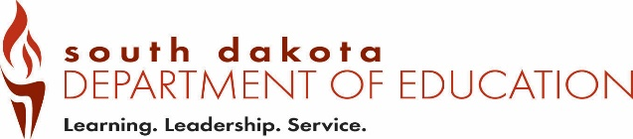
Office of Educator Certification Out-of-State Provisional Extension
Type all information or use blue or black ink. Use only to request year two of provisional
Date Received by SD DOE:
Form OSF3 (12-2018)

Part 1 – To be completed by the Applicant.
Complete this section. Email completed form to certification@state.sd.us

Last 4 digits of SSN | Telephone Number
Last Name | First Name | Maiden/Previous Last Name
Email Address

I, , have registered for the required South Dakota
(applicant name)
Indian Studies course with and will complete the course
(approved university name)
by .
(date)

After completing the course, I will send my official university transcripts to the South Dakota Department of Education, Office of Certification. I understand that this is a one-time extension of the provisional certificate and that no certification will be issued if I do not complete the requirements according to South Dakota State Codified Law 13-1-48.
Signature Date
Approved SD Indian studies courses are listed at https://doe.sd.gov/certification/requirements.aspx

Save the completed form as a PDF and upload to the application OR Email to certification@state.sd.us

