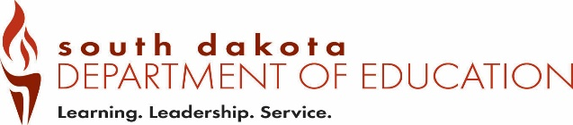
Date Received by SD DOE:
Form SOF2 (12-2018)
Office of Educator Certification Native American Lakota, Dakota, Nakota
Type all information or use blue or black ink. Recommendation for Certification

Part 1 – To be completed by the applicant.

Complete Part 1 and send this form to the education certifying officer for completion of Part 2.
The education certifying officer contact information is listed on page 2.

Last 4 digits of SSN |  | Telephone Number
Last Name | First Name |  | Maiden/Previous Last Name
Email Address

Part 2 – To be completed by a regionally-accredited institution of higher education offering a teacher education program in Lakota studies.

Complete this section and Email to certification@state.sd.us

Recommendation for Certification

I hereby recommend______________________________________________________ for licensure to teach
(applicant name)
Lakota, Dakota, or Nakota oral and written language and culture to grades kindergarten through 12 by a regionally-accredited institution of higher education offering a teacher education program in Lakota studies or an organization approved by a tribal government in South Dakota and the Department.

Printed Name of Authorized Official | Print Title of Authorized Official
Email Address | Telephone Number
Address | City | State | Zip Code
Signature of Authorized Official |  | Date

Save the completed form as a PDF and Email to certification@state.sd.us

Regionally-accredited institutions of higher education offering a teacher education program in Lakota studies

Sisseton/Wahpeton Community College
PO Box 689
Sisseton, SD 57262
Certifying Officer/Education: Jeanette Gravdahl
Phone: 605.742.1117
Fax: 605.698.3132
Email: jgravdahl@swc.tc

Oglala Lakota College
PO Box 490
Kyle, SD 57752-0490
Certifying Officer/Education: Shannon Amiotte
Phone: 605.455.6000
Fax: 605.455.2787

University of South Dakota
414 E Clark
Vermillion, SD 57069-2390
Certifying Officer/Education: Mark Baron or
Robin Wiebers
Phone: 605.677.5437
Email: mark.baron@usd.edu

Sitting Bull College
1341 92nd St
Fort Yates, ND 58538
Certifying Officer/Education: Laurel Vermillion
Phone: 701.854.8021
Fax: 701.854.8197

Sinte Gleska University
PO Box 8
Mission, SD 57555
Certifying Officer/Education: Cheryl Medearis
Phone: 605.856.8117
Fax: 605.856.2011
Email: cheryl.medearis@sintegleska.edu

