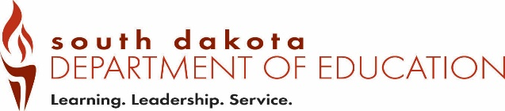
Date Received by SD DOE:
Form SOF3 (12-2018)
Office of Educator Certification Eminent Scholar Lakota, Dakota, Nakota
Type all information or use blue or black ink. Recommendation for Certification

Part 1 – To be completed by the applicant.

Send this form to the authorized individual listed on page 2.

Last 4 digits of SSN |  | Telephone Number
Last Name | First Name | Maiden/Previous Last Name
Email Address
Part 2 – To be completed by an authorized individual from the organization approved by the SD tribal government and the Department.

Email completed form to certification@state.sd.us.

Recommendation for Certification

I hereby recommend ____________________________________________________________ for licensure to teach
(applicant name)
Lakota, Dakota, or Nakota oral and written language and culture in grades kindergarten through 12 by an indigenous language board or similar organization created and recognized by a tribal government.

Printed Name of Authorized Official | Print Title of Authorized Official
Email Address | Telephone Number
Address | City | State | Zip Code
Signature of Authorized Official |  | Date

Save the completed form as a PDF and Email to: certification@state.sd.us

Organization approved by both a tribal government in South Dakota and the Department

Dakotah Language Institute
Contact Person: Tamara Decoteau
Phone: 605.698.2030
Email: tammyd@swo-nsn.gov

Cheyenne River Sioux Tribe
Contact Person: Harold Frazier, Chairman
PO Box 590
Eagle Butte, SD 57625
Phone: 605.964.4155

