MyLearningPlan/Frontline Deadlines for 2017-2018 School Year
Student Learning Objectives, Evaluations, Plans
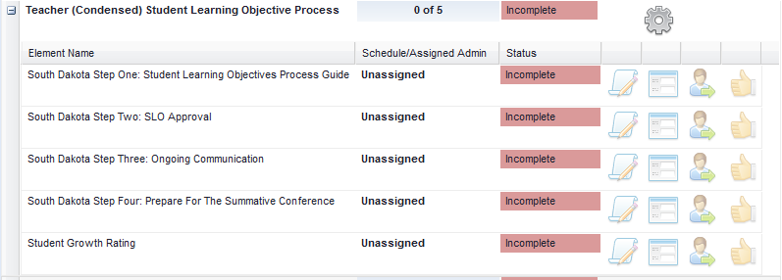
December 21, 2017
May 4, 2018
September 22, 2017
Completed by Principal

Completed by Principal
Completed by Teacher
Completed by Teacher
Completed by Teacher
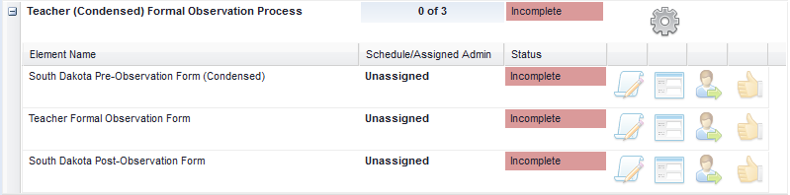
Completed by Principal

Completed by Teacher
Completed by Teacher
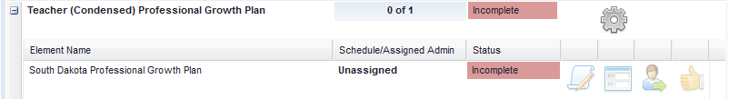
Completed by Teacher

