Name: Date:
Art Final: Grade 6

Please follow directions at each section for the best results.

List the 6 watercolor processes that you used in your WATERCOLOR TECHNIQUES booklet (try your best at spelling):
1) 4)
2) 5)
3) 6)

Color Mixing: use the key below for the letter that best fits the color “recipe:”

Key: R = Red; B = Blue; Y = Yellow; O = Orange; G = Green; V = Violet

7) R + = O 8) V + = RV 9) B + Y = 10) R + B =

Elements of Art: place the letter in the blank that best describes the Element. Each letter will be used once.

A) Texture B) Space C) Form D. Value E) Color F. Line G) Shape

11) How the surface of something looks, whether bumpy or smooth.
12) It can only be seen when there’s light; it can be bright or dull and has the ability to
affect our mood.
13) This element has three dimensions and can be looked at from different angles.
14) Different types of this two-dimensional element are organic, freeform, and geometric.
15) Light and dark, shading with a pencil, or using tints and shades of a color create this
element.
16) Near and far or negative and positive are terms referring to this element.
17) Thin, thick, curved, straight, and diagonal are types of this element.

Look at your Sea Creature Painting and describe how you used 3 different Elements of Art (you get to choose which 3 different Elements you would like to talk about). You will need to write in complete sentences:
18)
19)
20)

Art Final: Grade 6 page 2

Using only Red, Yellow, and Blue colored pencils, complete the color wheel below. Please go in the order of the colors starting with Yellow on the top, as labeled. Coloring smooth and evenly will help your colors blend together. When you are done please label PRIMARY and SECONDARY colors on the outside of the circle, right next to the color (12 points).

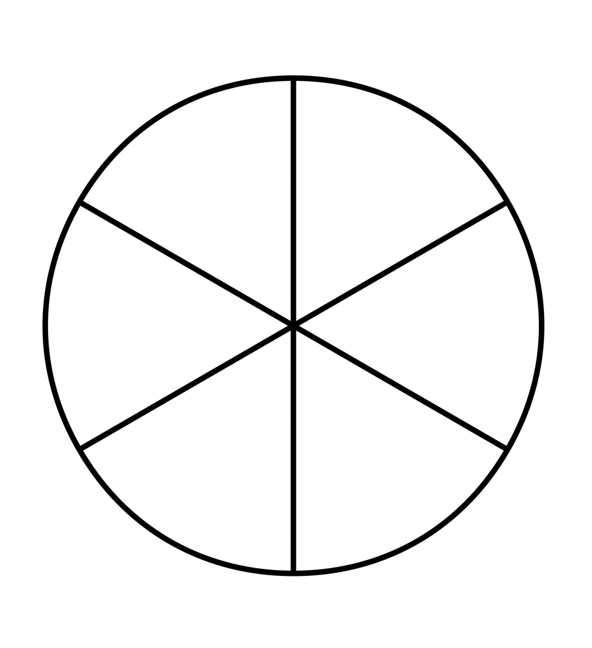

Yellow

➔➔➔Stop: Did you remember to label colors that are “Primary” and colors that are “Secondary?”⬅⬅⬅

Art Final: Grade 6 page 3

Think about something that you learned from our Optical Illusion/Op Art unit. Turn it into a question and write the answer in a complete sentence.

33) Your question:
34) Your answer:
List the 3 combinations of complementary colors here:
35/36) Complementary color combo #1: and
37/38) Complementary color combo #2: and
39/40) Complementary color combo #3: and
Write a reflection about your progress in Art class based on these questions: Do you think you improved with your art skills, why/why not? What are some of the struggles you overcame? What do you need to do to keep improving in Art? Do you want to continue to be in Art class, why/why not? Please use 5 COMPLETE SENTENCES:

41 – 45)

Art can be a challenging subject and expecting to create miracles with your work when you are just starting can be overwhelming. Art isn’t just about drawing straight lines or perfect circles; it’s can be about figuring out who you are and what you believe in. You are only beginning to show what you are capable of. If you want to get better at creating Art, YOU WILL, but it doesn’t happen overnight. Keep trying! I hope to see you again in Art class! --- Ms. M
BONUS QUESTION (one point per correct name):
List the names of any/all artists from Op Art.

