Frontline – Directions for Teachers

- Login at http://mylearningplan.com (in most cases, username is your k12 email address).

- Click on on the left side

- Click on

- Click on plus sign next to required activity 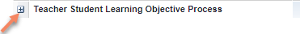

- Click on to complete required forms

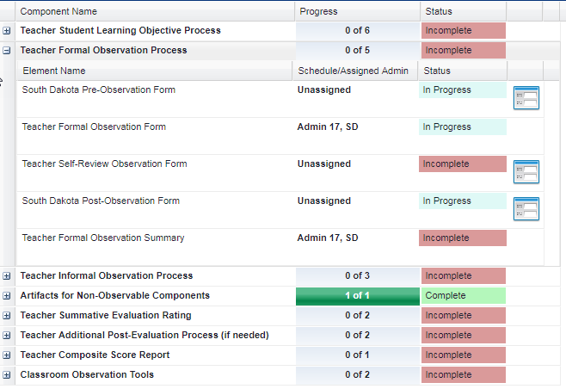

- Complete one of the following options:
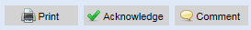
Adds a comment to the bottom of the form. Inform your principal if you make a comment.
Acknowledges the form, which completes the process
Prints this form

