Grade 6 Intro Assessment

Name: Date:

Welcome to SMS Visual Art class! The following assessment is to determine where your skill level and knowledge of Art is placed prior to taking this class. Please do the best you can based on the knowledge you already have.

Use colored pencils (located in the top green drawers by the door) to create a color wheel with 6 colors on the pie chart below. Please try your best to place the colors in order, as in a rainbow. Try your best to figure out which 6 colors to use.

When you are done coloring, please label “primary” colors or “secondary” colors outside of the appropriate section.

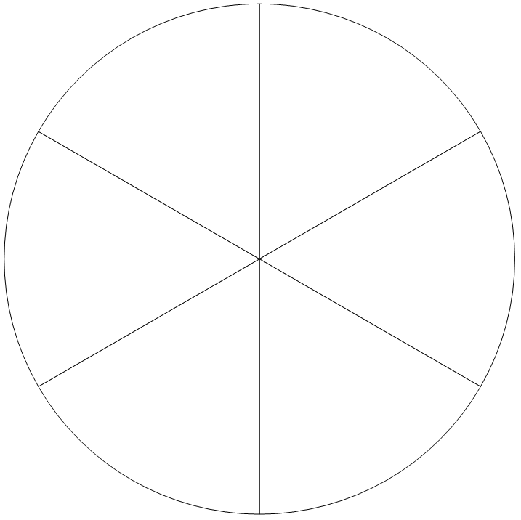

Next Page -->-->-->-->

Grade 6 Intro Assessment Continued

Please use a pencil and separate sheet of drawing paper to create the following character. Try your best at observing and drawing all the small details.

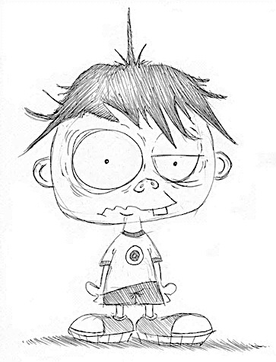

Next Page -->-->-->-->

Grade 6 Intro Assessment Continued

The Elements of Art are things that are necessary to create an Artwork. Place the letter in the blank that best describes each Element. Each letter will be used once.

A) Texture B) Space C) Form D) Value E) Color F) Line G) Shape

____How the surface of something looks, whether bumpy or smooth.
____This Element can only be seen when there’s light; it can be bright or dull and has the ability to
affect our mood.
____This Element is three-dimensional and can be looked at from different angles.
____Different types of this two-dimensional Element are organic, freeform, and geometric.
____Light and dark, shading with a pencil, or using tints and shades of a color create this Element.
____Near and far or negative and positive are terms referring to this Element.
____This Element is a mark made with a tool that starts and stops at different points.

Please give an example of each Element of Art (i.e. an example of a sport would be football).

Example of Color:
Example of Line:
Example of Texture:
Example of Shape:
Example of Form:
Example of Space:
Example of Value :

Next Page -->-->-->-->

Grade 6 Intro Assessment Continued
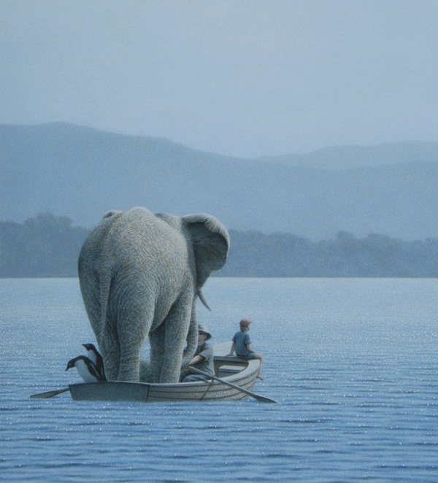

Please answer the following questions about this work of Art. Take as much or as little time as you need. 1 point = 1 complete sentence

What is going on in this Artwork?

What do you see that makes you say that?

The End: make sure to look over your answers then place your test upside down and work quietly at your table.

