1. Circle the model that correctly shows 1/3 shaded.
4.NF.1

2. Each shape is 1 whole. Divide equally and shade to show the given fraction.
4.NF.1
a. 1/2 b. 1 sixth c. 1 third

3. Write the fraction for the shaded part.  4.NF.1  a.  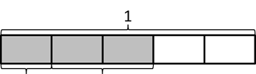 | b.  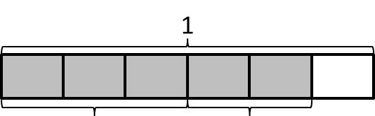

Birds with largest wingspan | Wingspan Length
Wandering Albatross | 11 7/8 feet
Marabou Stork | 10 5/8 feet
Andean Condor | 9 1/2 feet
Pelican | 10 6/8 feet
California Condor | 9 3/4 feet
Jabiru Stork | 9 2/8 feet
Kori Bustard | 9 2/4 feet
Whooper Swan | 9 3/8 feet
Great Bustard | 8 1/2 feet
Trumpeter swan | 8 4/8 feet
The chart above shows data Bob collected about bird wingspans.

4. What is the difference in wingspan between the widest and narrowest birds on the chart?

4.MD.2

5. Two birds have the same wingspan. Show how you know the measurements are equal.

4.NF.1

Solve each problem. Draw a model, write an equation, and write a statement for each.

6. Bob wants to display a Whooper and a Kori side-by-side in a photo box with a width of 18 ½ feet. Will these two birds fit? Solve by drawing a model, writing an equation AND write an equation.
4.MD.2
Level 3

Suggested answer: Bob will need a larger box than an 18 ½ feet because 9 3/8 feet plus 9 2/4 feet equals 18 7/8 feet which is larger than 18 ½ Feet.
4.MD.4

7. Bob wants to display three Andean Condors on a board. Using multiplication, create an equation and solve to show how long of a board he will need if the wings of each bird are touching.
4.NF.4

8. Make a line plot to display the data from the table above.
4.MD.4

9. A meteorologist set up rain gauges at various locations around a city and recorded the rainfall amounts in the table below. Use the data in the table to create a line plot using $\frac{1}{8}$ inches.
5.MD.3

Location | Rainfall Amount  (inches)
1 | $$\frac{\text{1}}{\text{8}}$$
2 | $$\frac{\text{3}}{\text{8}}$$
3 | $$\frac{\text{3}}{\text{4}}$$
4 | $$\frac{\text{3}}{\text{4}}$$
5 | $$\frac{\text{1}}{\text{4}}$$
6 | $$\text{1}\frac{\text{1}}{\text{4}}$$
7 | $$\frac{\text{1}}{\text{8}}$$
8 | $$\frac{\text{1}}{\text{4}}$$
9 | $$\text{1}$$
10 | $$\frac{\text{1}}{\text{8}}$$

- Which location received the most rainfall?
4.NF.1

- Which location received the least rainfall?
4.NF.1

