Fifth Grade Assessment- Britton-Hecla
Lynn Claeys, Kristin Platamone
4.NF.1; 5.NF.1; 5.OA.2; 5.MD.2; 5.NF.2; 6.NF.1

Compare using >, <, or =
- $\frac{7}{8} \frac{3}{4}$ 2. $\frac{1}{2} \frac{2}{3}$ 3. $\frac{7}{9} \frac{5}{6}$

Solve
4. $\frac{5}{8} + \frac{1}{4}$ = 5. $\frac{7}{12} - \frac{1}{3}$ = 6. $2\frac{2}{5}+ \frac{2}{3}$ =

Use the data from the table below to solve the following questions.
Tyler and five friends went to the zoo. They found the lengths of animals on the zoo’s map. They recorded the lengths of different animals’ body length and put them in a chart.
Animal | Length in Feet
Lion | 7 $\frac{1}{2}$
Marine Otter | 3 $\frac{2}{3}$
Black Howler Monkey | 1 $\frac{5}{6}$
African Elephant (trunk down) | 16 $\frac{1}{4}$

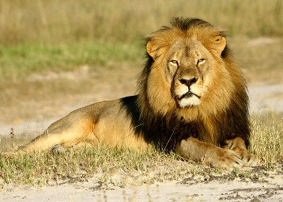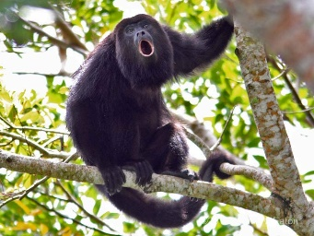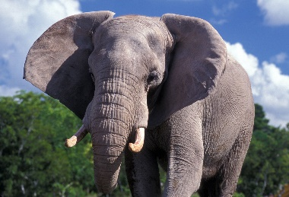
Lion Marine Otter Black Howler Monkey African Elephant
Use the data from the table on page 1 to solve the following questions.
7. Write an expression that shows the difference between an African elephant and a black howler monkey.

8. Write an expression that shows the combined lengths of a lion and a black howler monkey.

9. Use your expression from question #9 to create a number line showing the total length of the two animals. Explain how you got your answer.
Example student response

0 1 2 3 4 5 6 7 8 9 10
I know $\frac{1}{2}$ is $\frac{3}{6}$ , and $\frac{3}{6}$ +$\frac{5}{6}$ would be$\frac{8}{6}$ , which is equal to 1$\frac{2}{6}$ , which equals 1$\frac{1}{3}$ . When I add 7+1+1 $\frac{1}{3}$ I get 9$\frac{1}{3}$.

10. Tyler and his friends went to the animal show. During the show, the marine otter and the black howler monkey perform a trick in which the monkey and otter are standing nose to nose. If they are nose to nose, how long are they from tail to tail?

11. During the show, the African elephant raises his trunk. With his trunk extended, the elephant measure 22 $\frac{5}{8}$ ft long. How long is the elephant’s trunk?

12. The width of the elephant exhibit is 65 feet. If the elephants stood from nose to tail, how many elephants would fit along the exhibit wall?

13. After the zoo, Tyler and his friends went to his house. There was $\frac{3}{4}$ of a pizza left over from the night before. Tyler split the pizza with his friends. How much pizza did each person get?

