SLO Transformations Assessment
Students should be able to complete this assessment without the use of a calculator.

Standards Covered:
HSF.BF.3
HSF.IF.4
HSF.IF.5

Contributors:
Brittany Green
Jonathan Hanson
Samantha Schuetzle

Algebra 2: Transformations

Match the correct domain and range to the parent function. Some answers may be used more than once. (1 pt each) HSF.IF.5

____ 1. exponential function, $f(x)=2^{x }$  ____ 2. cubic function, $f(x)=x^{3 }$  ____ 3. square root function, $f(x)=\sqrt{x}$  ____ 4. rational function, $f(x)=\frac{1}{x}$  ____ 5. cube root function, $f(x)=\sqrt[3]{x}$  ____ 6. common logarithmic function, $f(x)=log(x)$  ____ 7. cosine function, $f(x)=cos(x)$ | - Domain: $\{x | x ϵ R\}$ Range:$\{y | y ϵ R\}$  - Domain:$\left\{x | x ≥ 0\right\}$ Range:$\left\{y | y ≥ 0\right\}$  - Domain: $\left\{x | x ≠ 0\right\}$ Range:$\left\{y | y ≠ 0\right\}$  - Domain: $\left\{x | x > 0\right\}$ Range:$\{y | y ϵ R\}$  - Domain: $\{x | x ϵ R\}$ Range:$\left\{y | y>0\right\}$  - Domain: $\{x | x ϵ R\}$ Range:$\left\{y |-1≤y≤1\right\}$

For problems 8 - 14, use the given instructions to identify various characteristics for the functions.
(1 pt per blank)
8. Consider the function: $f(x) = -3(x)^{2}-1$
- HSF.BF.3 Name the transformations:
- _______________________________
- _______________________________
- _______________________________
- HSF.IF.5 Domain: __________________ Range: ____________________

9. Consider the function: $g(x)=\frac{3}{x-2}+4$
- HSF.BF.3 Identify the parent function: __________________
- HSF.BF.3 Name the transformations:
- _______________________________
- _______________________________
- _______________________________
- HSF.IF.4 Vertical asymptote: _______________________________
- HSF.IF.4 Horizontal asymptote: _______________________________
- HSF.IF.4 End behavior: as $x →∞, g(x) →$____ and $x → -∞, g(x) →$____
- HSF.IF.5 Domain: ________________ Range:________________

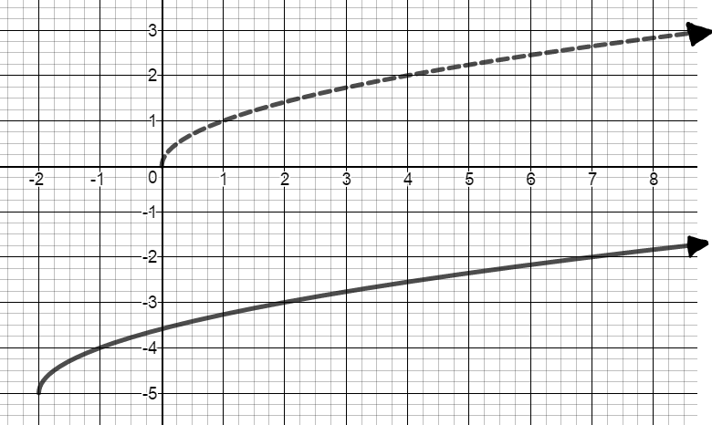
10. The parent function $f(x)=\sqrt{x}$ is given by the dashed line, looking at the solid line, complete the following statements.
- HSF.BF.3 Name the transformations:
- _______________________________
- _______________________________
- HSF.BF.3 Equation of transformed function:
$h(x)=$______________________
- HSF.IF.4 End behavior:
as $x →∞, h(x) →$________ and $x → -∞, h(x) →$________
- HSF.IF.5 Domain: ________________ Range:________________

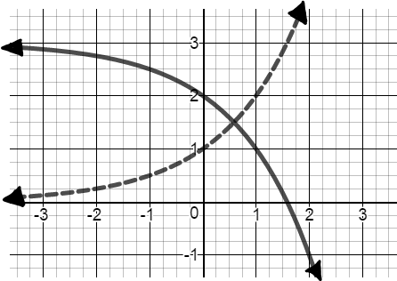
11. The parent function $f(x)=2^{x}$is given by the dashed line, use the solid line to complete the following statements.
- HSF.BF.3 Name the transformations:
- _______________________________
- _______________________________
- HSF.BF.3 Equation of the transformed function:
$j(x)=$__________________________
- HSF.IF.4 End behavior:
as $x →∞, j(x) →$____ and $x → -∞, j(x) →$____
- HSF.IF.5 Domain: ________________ Range:________________

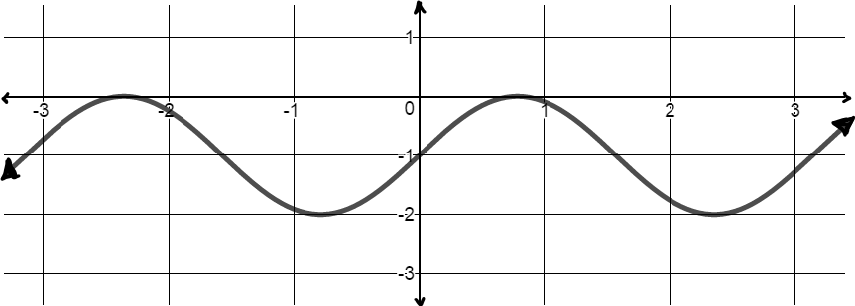
12. Consider the function: $k(x)=sin(2x)-1$
- HSF.BF.3 Name the transformations:
- _____________________________
- _____________________________
- HSF.IF.5 Domain: ________________ Range:________________

13. Consider the quadratic parent function, $f(x)=x^{2}$, and perform a minimum of three transformations to come up with a new equation $g(x)$. Then describe how the domain and range are affected.HSF.BF.3, HSF.IF.5
$g(x)=$ _________________
Transformations:
- _________________________
- _________________________
- _________________________
Describe: ______________________________________________________________________
______________________________________________________________________
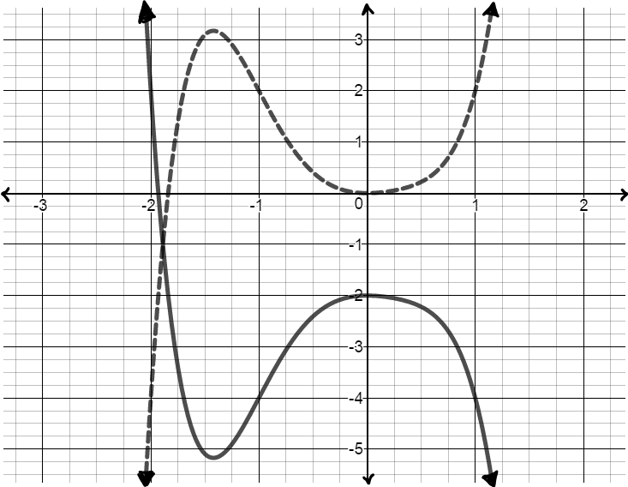
14. Identify using the relative maximum and relative minimum what the transformations are from the dashed function to solid function. HSF.BF.3, HSF.IF.4

Transformations:

______________________________________
______________________________________

15. Write a minimum of a five sentence well-developed paragraph over the following topic. You must include a topic sentence, at least three supporting sentences, and a concluding sentence. (7 pts) HSF.BF.3
Explain how to identify horizontal and vertical transformations (translations, stretches, compressions, and reflections) from the parent function. Be sure to be specific and provide examples.

_____________________________________________________________________________________

_____________________________________________________________________________________

_____________________________________________________________________________________

_____________________________________________________________________________________

_____________________________________________________________________________________

_____________________________________________________________________________________

_____________________________________________________________________________________

