Nutrition Unit
Fundamental Animal Science Assessment
Mr. Tom Wolff: Dell Rapids High School, Mr. Brady Duxbury: Menno High School, Mr. Jacob Englin: Parkston High School
Suggested interval of instruction: Approximately three weeks
List of standards addressed: 1.2, 1.3, 3.1, 3.2, 4.3, 5.2
- Multiple Choice: Circle the letter of the correct answer for the following questions (1 point).

- Pigs have which type of digestive system? (1.2)
  - Monogastric
  - Ruminant
  - Pseudo-ruminant
  - Avian

- The method or way food is delivered to the mouth is __________________. (1.2)
  - Mastication
  - Metabolism
  - Anabolism
  - Prehension

- Lack of certain nutrients can result in a nutrient ______________. (1.3, 3.2)
  - Toxicity
  - Deficiency

- Which of the following is an example of a roughage/forage? (3.2)
  - Soybean meal
  - Blood meal
  - Alfalfa hay
  - Dried distillers grains

- Which of the following most closely relates to calories? (3.1)
  - Crude Protein
  - Crude Fiber
  - Metabolizable Energy
  - Dry Matter

- Digestion begins here. (1.2)
  - Stomach
  - Small Intestine
  - Esophagus
  - Mouth

- Nutrient availability found in plants varies due to: (3.1, 3.2)
  - Age of plant
  - Geographic region of growth
  - Type of plant
  - All of the above

- What number is written in the center of a Pearson Square? (3.2)
  - The total amount of feed desired, expressed in weight
  - The total percentage of a desired nutrient
  - The total sum of both feedstuff nutrient percentages
  - A number selected at random

- The small intestine is responsible for: (1.2)
  - Nutrient absorption
  - Mixing feed
  - Digestion of roughages
  - Being the first site of digestion

- Which of the following is a concentrate? (3.2)
  - Silage
  - Corn
  - Paylean
  - Vitamins

- An example of a supplement is: (3.2)
  - Silage
  - Corn
  - Paylean
  - Vitamins
- If corn silage contains 77% moisture, what percentage of dry matter (DM) does it contain? (3.2)
  - 23%
  - 77%
  - 50%
  - 12%

- The process of breaking down feed into simple substances is called: (1.2)
  - Absorption
  - Digestion
  - Chewing the cud
  - Bacterial action

- Hormone implants are used to lower production costs by: (5.2, 6.2)
  - Improving rate and efficiency of weight gain
  - Lowering the per ton cost of feed
  - Controlling some diseases in livestock
  - Providing a cheaper source of protein from the animal

- Vocabulary: Write the letter of the correct answer from column B on the line of the term in column A. Not all choices will be used (1 point).

Column A Column B
__G___ 15. Ceca (1.2) O. Grinds and crushes feed in avian digestive systems
__O___ 16. Gizzard (1.2) N. The method or way food is delivered to the mouth
__J___ 17. Crop (1.2) K. Taking digested parts into the blood stream
__K___18. Absorption (1.2) D. Hair-like extensions which increase digestive surface area
__L___ 19. Enzymes (1.2) E. The stomach and intestines, the digestive system
__E__ 21. Gastrointestinal Tract (1.2) G. Two blind pouches
__M__ 22. Bile (1.2) L. Catalysts which speed up digestion
__C__ 23. Mastication (1.2) M. Fluid which aids in digestion of fats
__F__ 24. Prehension (1.2) J. Sac-like enlargement where avian’s store food

- Labeling: Using the terms from the box, label each part of digestives systems below (1 point per term).

Pseudo-ruminant/modified monogastric: (1.2)
Pseudo-ruminant/modified monogastric:
Esophagus
Small Intestine
Cecum
Large Intestine
Rectum
Stomach
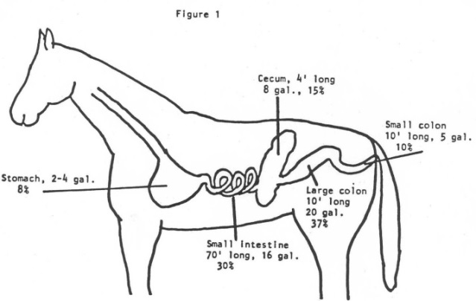

Avian: (1.2)
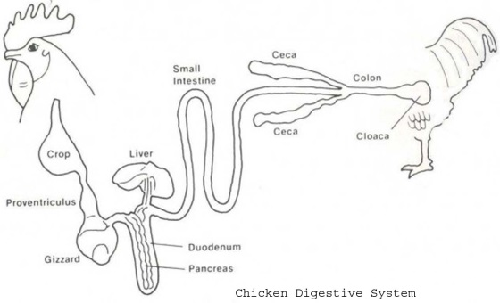
Avian:
Cloaca
Crop
Ceca
Small Intestine
Gizzard
Proventriculus

- Listing:

25. List the four compartments of the ruminant stomach (4 points). (1.2)
Rumen, Reticulum, Omasum, Abomasum

26. List two digestive parts unique to avian digestive systems (2 points). (1.2)
Gizzard, Proventriculus, Crop, etc…

27. List the six essential nutrients (6 points). (3.1)
Water, Carbohydrates, Vitamins, Minerals, Proteins, Fats (Lipids)

28. List three characteristics of a good ration (3 points). (3.1, 3.2)
Palatable, balanced, meets the needs of the animal

- High or Low: Write high or low in the blanks to make the statements true (2 points each).

29. Roughages are _low_____ in nutrients and __high_____ in fiber. (3.2)

30. Concentrates are _high______ in nutrients and _low_______ in fiber. (3.2)

31. If you feed hay to swine, the feed efficiency is __low______.

32. A yearling heifer has a _low_____ energy requirement, whereas a bred heifer has a __high____ energy requirement.

- Short Answer: With one complete sentence, answer the questions below (2 points).

How do methods of prehension differ among animal species? (1.2)
Chickens use beaks to peck their feed, whereas cattle use their mouths to collect feed, etc.

32. What is the difference between feeds and feedstuffs? (3.2)
A feedstuff is one ingredient blended together to make a feed.

33. Where are most nutrients absorbed? (1.2)
Most nutrients are absorbed in the small intestine.

34. What types of animals are fed a high fiber diet and why? (3.1)
Ruminant animals are fed a high fiber diet.

- Balancing Rations: For complete points, work must be shown. (3.2)
=
% nutrient, DM basis
100% DM
% nutrient, as fed basis
% DM of feed

37. What percent crude protein (CP) does a 44% CP (AF basis) soybean meal contain on a dry matter basis if the DM = 89% (4 points)? (3.2)

38. What percent CP does a 45.2% CP (DM basis) cottonseed meal contain on an AF basis if the DM = 91% (4 points)? (3.2)

39. Using the nutrient requirements below, balance a 1500 lb ration first blending fresh alfalfa hay and silage at 11 % CP. Next, blend in the dehydrated distillers grains at 15% CP. Express your answers in lbs. Write your answer in the chart (10 points). (3.2)
Nutrient | % Crude Protein | Lbs needed
Fresh Alfalfa | 19.7
Dehydrated Distillers Grains | 29.5
Silage (ears with husks) | 8.9

- Essay: Answer the following questions with 5 complete sentences (6 points each).

40. In an indented paragraph of no fewer than five sentences, list and explain the purpose and function of each chamber of a ruminant digestive system. (1.3)

41. In an indented paragraph of no fewer than five sentences, explain the differences among mechanical, chemical, and biological digestion and where each type of digestion occurs within the animal’s digestive system. (1.3).

42. In an indented paragraph of no fewer than five sentences, select a species and explain how nutritional needs change throughout its life cycle. (3.1)

