Consumer Concerns Assessment
Fundamental Animal Science
Ms. Amanda Hoover, Mr. Wyatt DeJong, Mr. Josh Christiansen
Suggested interval of instruction: 3 weeks
Standards addressed: 1.3, 2.1, 4.2, 4.4, 5.1, 6.1, 6.2

- Match the term with the correct response. Write the letter of the term by the definition. (6.1, 6.2)
a. Animal rights | b. Cloning | c. Animal welfare
d. Ethics | e. Biotechnology | f. Genetic engineering

_______ 1. The application of biology to technology.
_______ 2. The belief that animals have the same right to life and liberty as humans.
_______ 3. Creating exact duplicates of plants and animals.
_______ 4. The movement of genes from one cell to another.
_______ 5. Examination of moral issues to determine right from wrong when dealing with human character and conduct.
_______ 6. The belief that humans should provide animals with surroundings that meet their needs while under their control.

- Utilize the chart below to define EACH of the practices listed as animal welfare concerns AND pick three to justify why the practice is used within agriculture. (6.1, 6.2, 2.1)

Animal Welfare Concern | Define what it is | Justify why it is used
Gestation Crates
Tail Docking (Dairy, Pigs, Sheep)
Castration
Branding
Cages for birds
Debeaking
Dehorning
Teeth clipping (swine)
Ear notching
Sheep shearing

- How many growth hormones are approved for pork production? (6.1)
  - 3 - Estrogen, Progesterone, Testosterone
  - Only 1 - Ractopamine
  - There are no regulations on the use of hormones in pork production.
  - 0 - It is illegal to use hormones in pork production.

- How many growth hormones are approved for poultry production? (6.1)
  - 0 - It is illegal to use hormones in poultry production.
  - Only 1 - Ractopamine
  - 3 - Estrogen, Progesterone, Testosterone
  - There are no regulations on the use of hormones in pork production.

- Which of the following is NOT required for an animal food product to be labeled as a ‘USDA Certified Organic’ product? (6.1)
  - Must contain 95% organically produced ingredients (excluding water & salt)
  - Must contain 100% organically produced ingredients
  - Livestock must be allowed year-round access to the outdoors
  - Livestock must be raised on certified organic land

- Read the background information and analyze chart below.
Texas A&M Extension conducted a beef cattle performance study on 100 calves to investigate the effects of implants on cattle. All 100 calves were weighed on June 2nd to establish their weaning weight. The first 25 steers and the first 25 heifers that came through the working chute, were given a hormone implant at the labeled rate. The other 25 heifers and 25 steers served as the control group for evaluation purposes. The calves were again brought through the working chute on July 18th to establish the payweight prior to leaving to ranch for the preconditioned sale. Listed below are the results of the study. (5.1, 6.1, 6.2)
Avg. Weaning  Weight (6-2) | Avg. Weight  (w/o Implants) 7-18 | Avg. Weight  (w/ Implants) 7-18
452 lbs. | 482 lbs. | 519 lbs.
  - What is the difference in average weight gain between the calves with implants and those without? 37 pounds
  - List two specific steps that the researchers did to make the study valid.
    - Control group is the same size as the test group
    - Each group (control & test) were selected randomly
    - Each group (control & test) had the same number of male and female cattle
    - The weights were taken at the beginning and then again at the same date for both groups.
  - Write a one sentence rationale for why hormone implants in beef cattle are used.
  - List one potential drawback for using hormone implants.
- For each of the statements below, identify whether that fits the view of someone who believes in animal rights (AR) or animal welfare (AW). (6.2)
_________ a. “We are releasing dogs from a shelter to keep them from being euthanized.”
_________ b. “I raise beef cattle using the best genetics I can to produce the highest quality product to feed consumers.”
_________ c. “My livelihood depends on the comfort and health of my dairy cattle, so although I’m using them to provide milk and meat for consumers, I’m going to do what I can to make sure they are comfortable and well-cared for.”
_________ d. “Pigs are animals, and humans are animals. They deserve the same rights as us and should not be cooped up in pens all the time.”
________ e. “I raise hogs and when one gets sick, I give antibiotics. I always document the antibiotic given and the date and dose to make sure the animal is not harvested prior to the end of the withdrawal period.”
- What is pasteurization? (6.1)
  - Heating milk to a level that will kill pathogens
  - A process used to increase the shelf-life of milk
  - A heating process that destroys or reduces the nutritional content of milk
  - the process of physically breaking up the fat globules in cow’s milk to make a “homogenous” fluid milk beverage
- List three steps used in processing dairy products from the farm to the store to keep food products safe. (6.1)

- What is meant by “withdrawal period” AND why is it important in animal agriculture? (6.1)

- While you are shopping at a local farmer’s market, a community member confronts you, stating that they will only purchase free-range eggs from the stand at the market, and not from the grocery store you manage. They argue that the eggs in your grocery store come from chickens raised inhumanely in cages. Based on food safety, animal welfare, economics, etc justify your decision to sell the eggs you that do. (2.1, 6.1, 6.2)

- While milking your dairy cow at the state fair, people approach you and begin shouting about how you are harming the animal, humans shouldn’t be drinking milk, the animal is too skinny and must be unhealthy, and that the milk is full of hormones and antibiotics. Based on your knowledge of animal welfare and food processing, how would you respond to these allegations? (1.3, 5.1, 6.1, 6.2)

- Using the Venn Diagram, classify the following statements as a concern of Animal Rights Groups, Animal Industry Groups, or both. (6.2)
  - Provide for humane slaughter of animals
  - Ensure that all animals are never harmed
  - Using animals is morally wrong
  - Human needs are more important than the needs of animals
  - We should not use animals to benefit humans if it hurts animals
  - As humans, it is our responsibility to care for animals
  - The main purpose to to remove “unnecessary” pain or death
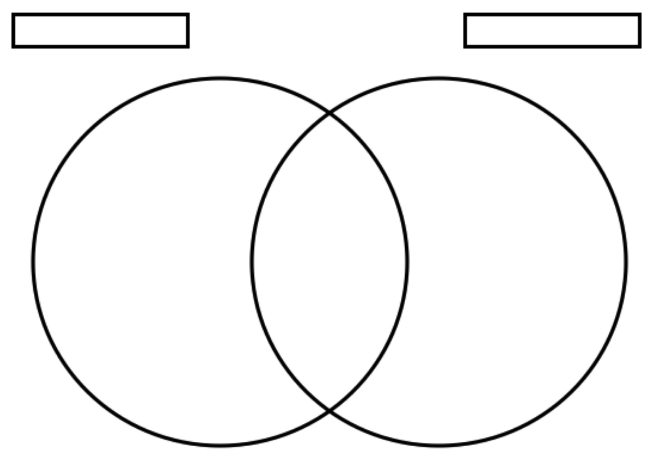

- A medication with a 30 day withdrawal time given on January 1 will allow the animal to be free of all medication on which of the following dates? (6.2, 1.3)
a. January 30th
b. February 1st
c. February 28th
d. January 31st

