Breed Identification
Mrs. Dixie Opheim: Selby Area; Mr. Andrew Jensen, Chester Area
Suggested interval of instruction: 3 - 5 weeks, based on course length.
List of standards addressed: 1.1, 1.2, 2.1, 5.1, 5.2
Please draw a line to match the correct species to its picture. (AN1.1)
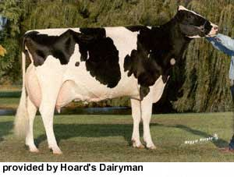
Sheep
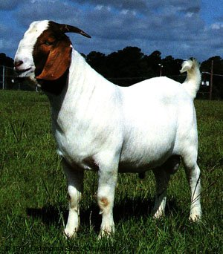

Beef
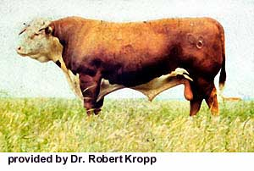

Swine
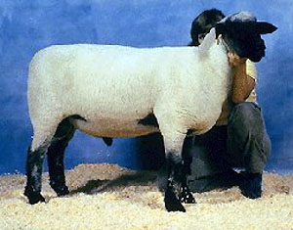

Goat
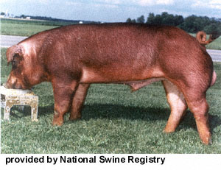

Equine
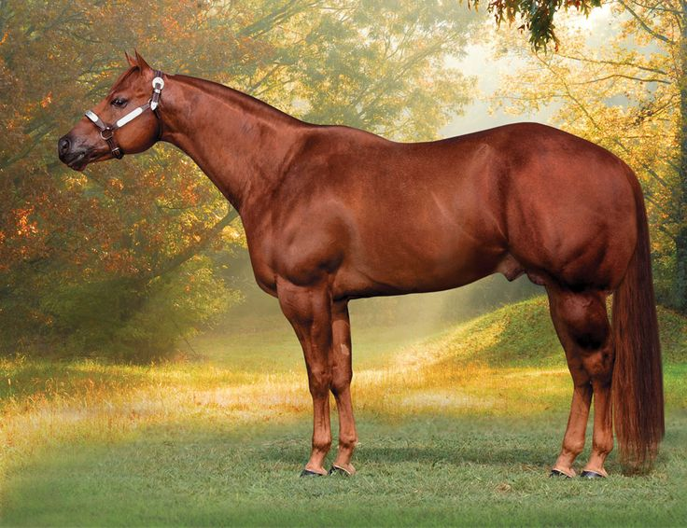

Dairy

Please fill in the table with the correct term. You might use terms more than once. (AN1.2)
 | Beef/Dairy | Swine | Sheep | Goats | Equine | Poultry
Intact Male
Old Female
Young Female
Castrated Male
Baby/newborn

Stallion/Colt
Mare
Filly
Gelding
Foal

Rooster
Hen
Pullet
Capon
Chick

Ram
Ewe
Ewe Lamb
Wether
Lamb

Buck
Doe
Doeling
Wether
Kid

Bull
Cow
Heifer
Steer
Calf

Boar
Sow
Gilt
Barrow
Piglet

PRODUCTION:
Explain the difference between a purebred animal and a crossbred animal.

Goats (AN1.1):

- _______Boer________ This breed of goat originated from South Africa and was recently imported to the United States. They typically have a brown head and white body. Sometimes they have a black head or moon-spotted bodies.
- _______Lamancha________This breed of goat has to have a gopher ear to be eligible for registration. Their ears look like they were froze off, but that is their breed identifier.
- _______Angora________ This breed of goat is used for mohair. They are typically found in the state of Texas, and often look like they have curly hair.
- __________Pygmy_____ This breed of goat is typically a pet or show, but can also be used for meat and milk. They are typically black with a white overlay. When mature, they are typically only 16 to 23 inches tall at the withers.
- ________Saanan_______ This breed of goat is known as the Holstein of the Dairy Goat world. They are all white, with erect ears.
6. A term for a dairy goat that is producing milk after birth is what? _______Fresh or freshened__________
7. The term for what goat meat is called is what? _______Chevon_______

Swine
Three different common white breeds of swine are penned together. Explain how you can tell the breeds apart and what breeds they are. (1.1, 1.2, 5.1)

The _______________ breed of swine is light to dark red in color, are often used in swine programs because of it’s heavy muscling, high feed conversion, and top-producing retail cut carcasses.

Write the breed of the black-marked hogs under the correct picture.

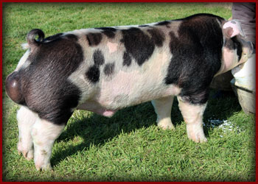

POULTRY:
Define the terms below:
Turkey Production
Broiler Production
Egg Production

You recently graduated from South Dakota State University, and want to raise poultry in South Dakota. Thinking about what we talked about in class, select one of the three segments listed above, and tell me 5 factors to consider when wanting to start a large-scale poultry operation. (5.1, 5.2, 2.1)

SHEEP

Which breed of sheep has the qualities listed below _______________________? (5.1, 1.1, 1.2)
- White-faced
- Developed from the Merino breed
- The foundation of most Western U.S. range flocks
- Largest in sized of the fine wool breeds
- #1 breed of sheep in S.D.

List two other white-faced breeds that are common to S.D. that have the qualities listed below. (5.1, 1.1, 1.2)
_____________________________ and ______________________________.
- Developed from the breed in the previous question
- Developed in the United States
- Are dual purpose sheep

What are the two black-faced breeds of sheep that are commonly raised in S.D? (5.1, 1.1, 1.2)
________________________ and __________________________________

List 2 characteristics that are used to tell the above two black-faced breeds apart?

BEEF:

Match the beef breed with its distinguishing characteristic: (1.1, 5.1)
- Angus
- Charolais
- Chianina
- Galloway
- Gelbvieh
- Hereford
- Limousin
- Maine-Anjou
- Shorthorn
- Simmental

_____ Good milking ability, produce very acceptable carcass, single color – black to reddish yellow.
_____ Perform well in feedlot; high-quality, well-marbled meat, black or red in color, smooth coat
_____ Largest framed breed; high heat tolerance; good foragers; good mothers; high insect tolerance; fine-textured meat, extremely tall, can be black, white, or patterned.
_____ Docile, easily handled; superior foraging ability, vigor, hardiness, red with white face
_____ Docile; extremely rapid growth, thickly muscled; produce carcass without excess fat; adaptable to wide range of climates; good milking ability, can be black or red.
_____ Heavily muscled in round and loin; high feed efficiency; well adapted to many areas, white in color.
_____ Noted for hardiness, carcass quality, and foraging ability, shaggy, wavy hair, black-dun-reddish in color.
_____ Small and short head with broad forehead; short neck; lean carcass, large loin area, red with dark points around the eyes, ears and nose.
_____ Adaptable to main climates; good mothers, excellent milking ability; produce desirable carcass, red, white, or roan.
_____ Docile, easily handled; fast growth rate; well-marbled carcass, dark red, or black, and white

Explain the difference between British/Continental beef breeds and European beef breeds. (1.1)

You have a herd of Hereford cows, and you would like to produce black baldie calves with a higher carcass weight. Which breed of bull would you select to produce the desired results? Explain your answer in one paragraph, at least 5 sentences. (1.1, 1.2, 5.1)

Please match the correct description to the correct picture. (1.1, 5.1)

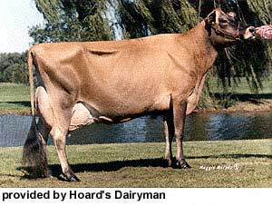
This breed of dairy cow originated in the country of Ayr. This are a shade of cherry red, but can be dark red, too. They can mature or 1,200 pounds in weight. This breed ranks third in milk production, averaging about 11,700 pounds of milk per lactation. (AYRSHIRE)

This breed of dairy cow originated in Switzerland, and are solid brown. Their nose and tongue are black. Mature cows can weigh 2,000 pounds. Cows and heifers are docile in nature. This breed is also one of the longest living breeds of dairy cattle. They rank second in milk production, averaging 12,100 pounds of milk per lactation.
(BROWN SWISS)

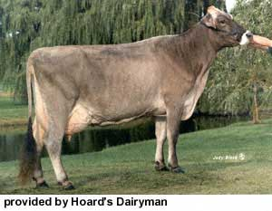
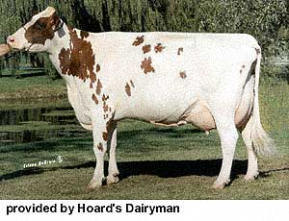
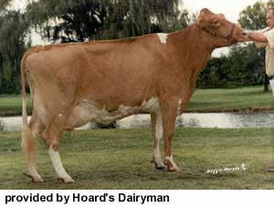
This is the smallest breed of dairy cow, whose color range from light fawn to almost black. Their milk is high in butterfat, making is perfect for ice cream! Mature cows weigh about 1,000 pounds. They rank fifth overall in average milk production, 10,000 pounds per lactation. (JERSEY)
This breed of dairy cow is black and white, but can also be found in red and white. They were first brought to the U.S. by Dutch settlers between 1621 and 1664. This is the largest registered breed of dairy cattle. They rank first in average milk production with 14,500 pounds per lactation. (HOLSTEIN)
This breed of dairy cow originated off the Isle of Guernsey. They are fawn with white markings, and mature cows weigh about 1,100 pounds. This breed ranks fourth in average milk production with 10,600 pounds of milk per lactation. (GUERNSEY)

