Name _Max Hodgen, Dr. Larry Browning, Mary Jo Bondy
HS-PS2-1 Analyze data to support the claim that Newton’s Second Law of motion describes the mathematical relationship among the net force on a macroscopic object, its mass, and its acceleration.
Newton’s 2nd Law
For questions 1-8, consider the cart on a track below. A force is applied acting to the right. Assume that friction can be ignored.
For each question, one or more features of the system has been changed. You are to indicate what effect the change will have on the acceleration.

Use the following answer key:
A. The acceleration will be greater.
B. The acceleration will be less.
C. The acceleration remains the same.
D. It's not possible to tell.
_____1. The mass of the cart is increased to 2 kg.
_____2. The towing force is increased to 1.0 N.
_____3. Both the mass of the cart and the towing force are doubled.
_____ 4. The 0.5 N towing force is applied at an angle as shown.
_____ 5. The track is inclined as shown
_____ 6. The length of the towing string is increased.
_____ 7. The track is inclined as shown.

_____ 8. The 0.5 N force is applied to two 500 g carts hooked together as shown.

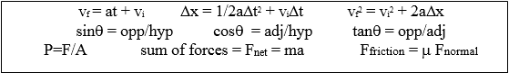

9. Draw a free body diagram of a cubic block on an incline plane tilted at 20.0º above the horizontal. Label the gravitational, normal, and friction forces acting on the cubic block.
(3 points)

Diagram:

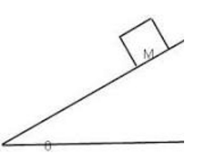

10. Calculate the force required to accelerate a 5.0 kg cubic block up an inclined plane at 20.0º above the horizontal at a rate of 2.0 m/s². Show all work. (5 points)

11. A 700.0 kg object accelerates constantly from rest to a speed of 45.0 m/s in 9.00 seconds. Determine the net force on the object. Show all work. (5 points)

12. The diagram below depicts a frictionless apparatus similar to that used to torture you while performing a Newton’s 2nd Law experiment. Block A has a mass of 25.0 Kg and block B has a mass of 5.0 kg.

a. Determine the acceleration of the system. Show all of the work. (5 points)
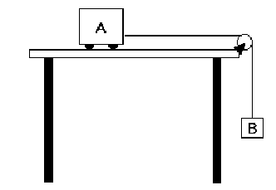

b. __________ If the mass of block A was increased, the acceleration would (1 point)
a. increase
b. decrease
c. stay the same

c. __________ If the masses of blocks A and B were both doubled, the acceleration would (1 point)
a. increase
b. decrease
c. stay the same

13. __________ In the free-body diagram shown below, which of the following is the gravitational force acting on the balloon? (1 point)
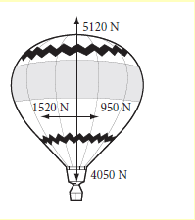
a. 1520 N
b. 950 N
c. 4050 N
d. 5120 N

14. __________ In a the free-body diagram shown below, calculate the magnitude of the net force acting on the balloon. (1 point)
a. 180 N
b. 1212 N
c. 570N
d. 15240 N

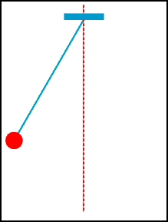
15. A ball of mass 0.5 kg hangs from the roof of a car by a light string. It swings back to an angle of 20 degrees from the vertical as the car begins to move forward. What is the tension in the string as the car moves forward?

What is the acceleration of the car?

