Making the Career Connection
6-8th Grades Career Development-Session 4
Essential Questions:
• What classes offered at your school interest you?
• Why is it important to follow a course plan that interests you?
• How can specific courses prepare you for a future career?
Stage 1—Desired Results

STANDARD(S): Revised Bloom’s Level:
C:B2.4 Select course work that is related to career interests Create
Stage 2—Assessment Evidence & Learning Plan

Summative Evidence: Students will rank their favorite classes and complete a list of high school courses that match their career interests.
Materials needed:
Classroom/Career Connection activity
(one per student)
Subject-Job Directory
Getting Ready for High School activity
(one per student)

Introduction
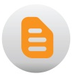
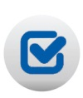
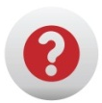
Divide students into small groups and hand out the ‘Classroom/Career Connection’ activity. Give each group a few minutes to complete the activity and then go through the answers as a class. While going through the activity ask students:
• What other jobs might this person enjoy?
• Why might they enjoy this career?
• Why is it important to match interests to a career?
• Is it possible for someone to fit into more than one career path?
Instruction
- Next hand out the ‘My Favorite Subjects’ worksheet. Have the students rank their favorite subjects individually. After they have ranked their subjects, post the ‘Subject-Job Directory’ so students can see jobs that match their favorite subjects.
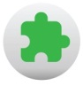
- Finally hand out the ‘Getting Ready for High School’ activity sheet. Have students complete this individually.
Closure/Wrap Up
Remind students how important it is to match their interests to their career choice. Let students know that in the next session they will be working on their Personal Learning Plan for high school so it is important to know what subjects interested them and have an idea of which courses they would like to take.

