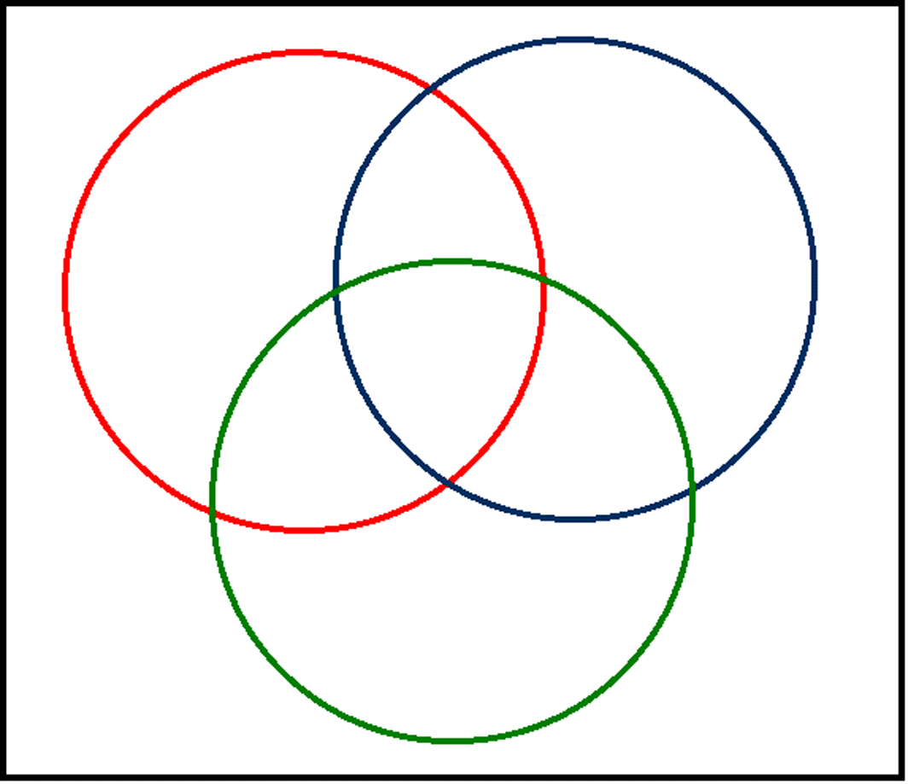
Career Cluster 1:
Career Cluster 2:
Similar Career Skills:
Career Cluster 3:

