GMS User Maintenance Guide



Table of Contents

Introduction. 2
Quick Tips & FAQs. 2
Forgot Password. 3
New User Set-Up and Modifying Existing Account 4
Definition of Roles 6

Introduction

The GMS User Logon Page gives access to E-Grants for an LEA through users entering their email address and assigned password.

The GMS User Login Page displays a link for users that have forgotten passwords.

Forgot Password: The Forgot Password link allows a user to request a password if they no longer can logon because of a forgotten password. When requested, the user will receive an email with a one-time temporary password. Upon entering this password the user will be requested to change their password. There is no minimum requirements for passwords.

Quick Tips & FAQs

I have a question about GMS User Maintenance. Who do I contact?

Before contacting SDDOE directly, please review this entire document. We have tried to list clear step-by-step instructions so that users do not need to rely on our specialists’ availability to receive answers to their questions.

In the event that your question is not answered within this document, please submit your question, via email, to our Security Helpdesk at egrants@mt.gov. Our security coordinator will respond to you within 24 hours.

I need an GMS User account. What now?
Please skip ahead to the New User Set-Up section.

Where is the E-Grants Security Form?

All E-Grants security will now be done through the E-Grants system itself. No more paper forms- hooray!

Why is my password not working?

If you receive an error message stating that your password has expired or not working, please follow the Forgot Password instructions on page 5.

I have an GMS User account but I’m switching districts. How do I change my security access to the new district?
Please see the section Modify Existing Users.

I requested a new account for my superintendent. How do I know if their account was created?

If you have submitted a New User Request on behalf of a coworker or supervisor, you will not receive a notification email once that process has been completed. Only the email address listed on the New User account will receive a notification. Please have the requested new user themselves check their email for the GMS User notification.

My organization has two District Admins or LEA Business Managers listed, but one of them isn’t with our district anymore. How do we remove them?
Please have the current District Admin or Business Official remove any outdated Users using the instructions listed in the section Modify Existing User Accounts.

Forgot Password

Step 1. If a user has either forgotten their password – OR – has an expired password, enter the user's email address and click
the Forgot Password link.
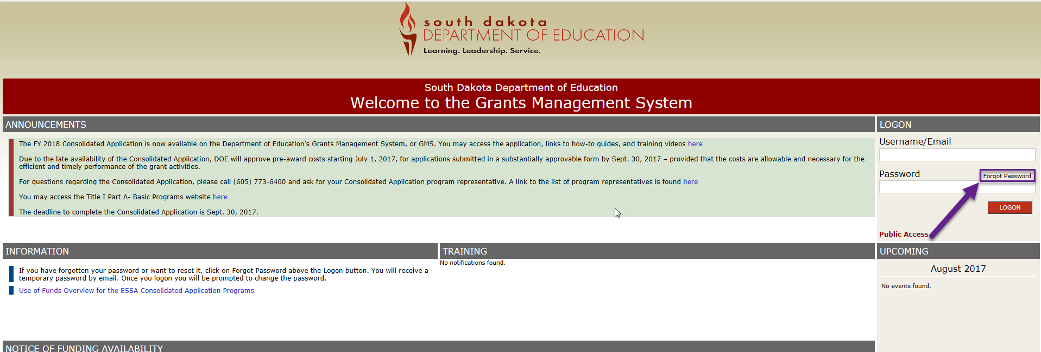

Step 2.
A one-time temporary password will then be emailed to the email address that was entered.

When the user enters this password, he or she will be prompted to change the password. Note: It is best to copy and paste the temporary email rather than typing it in.
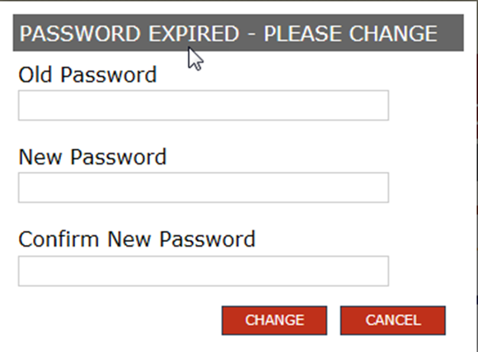
Helpful Hint!
Once the user has entered their email address and temporary password, this box (bottom) will appear.
The user must enter the temporary password in the Old Password box in order to create a new password. Do not attempt to input previous password once the Forgot Password process has been initiated. Do not click on Forgot Password multiple times.

New User Set-Up & Modifying Users

Note: Only District Admin and LEABusinessMgr Roles have the ability to add/modify users for their district/agency.

Step 1. After logging in, select the User Maintenance link from the Menu List.

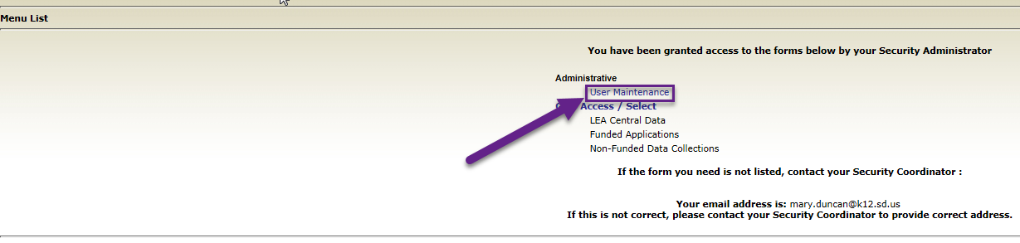

Step 2. Determine if the user is New to the GMS or an existing user. If the person is a New User, click on the New User Link in the top right corner. If the person is not new to the GMS, Enter their email into the search box. This will bring up the users request box.

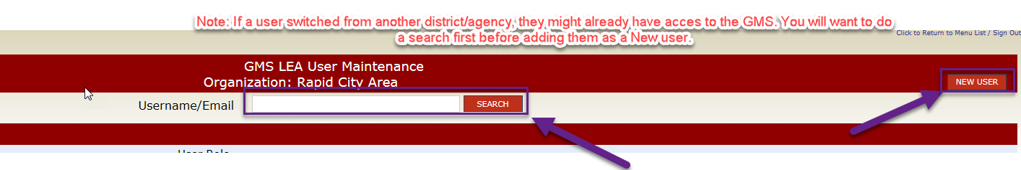

Step 3. The User Request Box will pop up. Enter in the required information. Assign the available roles and attendance centers. (See Definition of Roles Page) When you are done entering the information, click on Update and Close. You have now added the user to your district/agency. The User Request Box will be completed with the users name and email if they are an existing user. 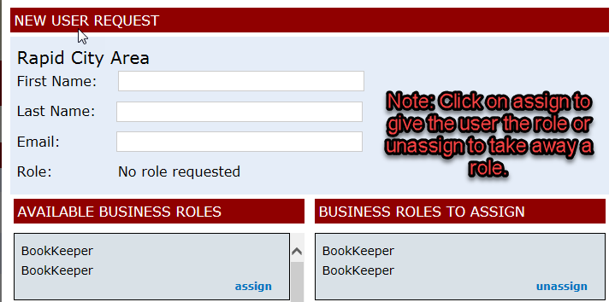

Step 4. To modify an existing user, click on a user name. The User Request Box will pop up and you will be able to un-assign or reassign roles and you can also remove them if they left your district/agency.

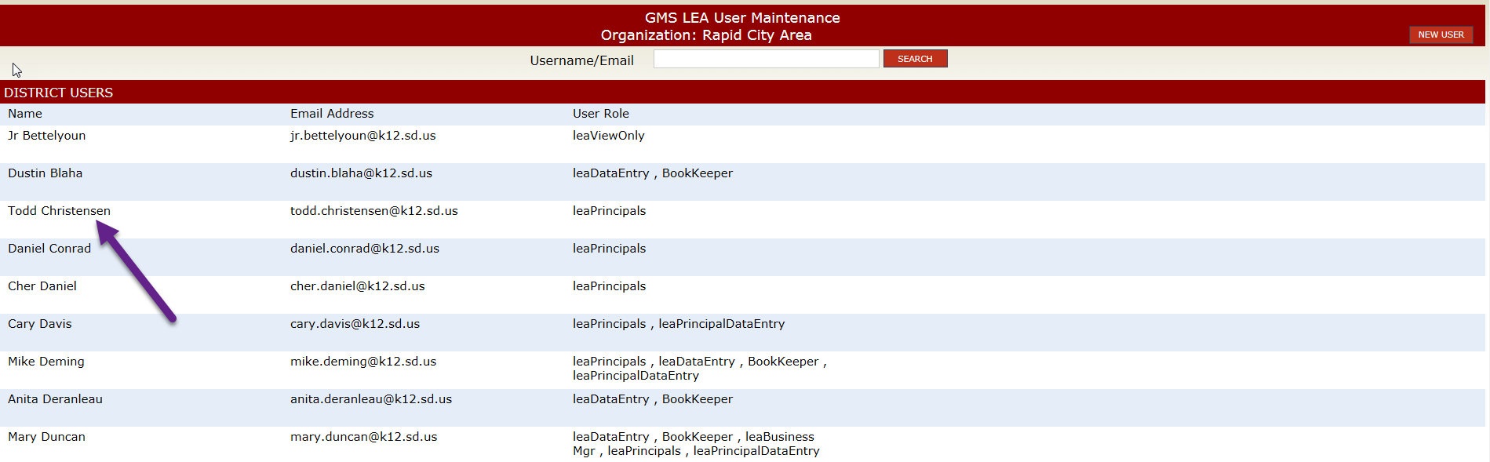
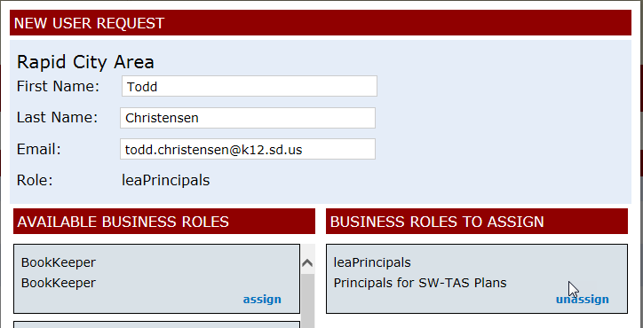

Definition of User Roles

Bookkeeper – Can edit & save grant applications and reimbursements. Cannot submit grant applications or reimbursements to SDDOE.
Bookkeeper21st Cent – This role can access and edit the 21st Century applications only. Cannot submit applications.
LEADataEntry- Can only access and edit the Central Data Application. This role should be assigned with anyone who has Bookkeeper rights.
LeaPrincipals - Can only access and edit the School Wide, Targeted and Comprehensive District plans. This role needs to be assigned with the correct attendance centers. Can submit plans to District Admin/Superintendent. Districts will need to assign the correct attendance with this role.
LeaPrincipalDataEntry- This role gives access to the 1003a applications for Principals. Only schools that receive this grant should assign users this roll.
DistrictAdmin - Can submit applications and Reimbursements to SDDOE. Can sign assurances on behalf of the District/Agency. This role is assigned to Superintendents or users that are authorized to submit applications.
DistrictAdmin21stCentury – This role is used for Agencies that only receive the 21st Century Grant. Can access, edit and submit applications.
LEABusinessMgr - Can submit applications and Reimbursements to SDDOE. Can sign assurances on behalf of the District/Agency. This role is assigned to the District/Agency main fiscal officer or users that are authorized to submit applications and reimbursements.
LEABusinessMgr21stCent - This role is used for Agencies that only receive the 21st Century Grant. Can access, edit and submit applications.
LeaViewOnly – Users have View only access.

