Unity for Youth
Sept. 24-26 – Pierre, SD
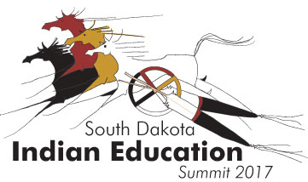

Request for presentation proposals

The South Dakota Department of Education’s Office of Indian Education (SD OIE) invites you to submit a proposal to present at the 2017 Indian Education Summit. The 14th annual summit will be held at Pierre’s Ramkota Conference Center. Speaker presentations will be scheduled to take place Sunday evening through early Tuesday afternoon.

Each year, education professionals from across the state and around the country attend this summit to access high quality professional development, information on the latest trends and proven best practices in the field of Indian education. We seek to showcase successful projects, programs and initiatives for all ages, from preschool to postsecondary.

Preference will be given to proposals addressing one or more of the following strands:
- Achievement
- Culture and Language
- Success from Within
- Building Future Leaders

Schedule/format: Presenters may choose to lead one-hour or two-hour sessions. The first hour of two-hour sessions is to be informational, with the second hour an opportunity for attendees to work in small groups to develop action plans based on the information presented.

Presenter information (required for all proposed presenters & co-presenters)
Please submit the following to Marta.Neuman@state.sd.us

Name:
Tribal affiliation (if applicable):
Title & company:
Address:
City/State/Zip:
Phone & fax:
Alternate contact #:
Email:
Biography (50 words maximum):

Presentation title:
Presentation type (one-hour or two-hour session):
Presentation description (50-80 words):

For more information, contact Marta Neuman:
- (605) 773-8194
- Marta.Neuman@state.sd.us

