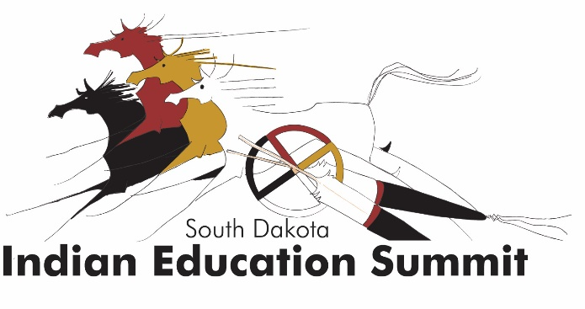
Unity for Youth
Sept. 23-25, 2018 – Pierre, SD
Ramkota Conference Center

Request for presentation proposals

The South Dakota Indian Education Summit targets South Dakota PK-16 educators of all content areas, as well as administrators and school board members. The goal of the summit is to provide training on best practices in the field of Indian education, for educators of both majority and minority American Indian student populations.

We seek a wide variety of topics/presentations. Some preference will be given to proposals addressing classroom and school-wide implementation of the Oceti Sakowin Essential Understandings and Standards (http://doe.sd.gov/ContentStandards/documents/18-OSEU.pdf)

Youth Day: Approximately 200 high school students will attend a Youth Day on Sept. 25. We are seeking presenters for students, in the areas of leadership, peer networking and postsecondary planning.
Schedule/format: Presenters may lead 50-minute breakout sessions or 80-minute workshops. Workshops should devote significant time to hands-on activities and/or collaboration for the development of practical applications of information presented.

Presentations will be scheduled the evening of Sept. 23 through early afternoon Sept. 25.

Presenter information (required for all proposed presenters & co-presenters)
Please submit the following to Marta.Neuman@state.sd.us
Name:
Tribal affiliation (if applicable):
Title & organization:
Address
Phone:
Email (to be listed in conference booklet):
Fax:

Presentation title:
Presentation length (choose one): __50-minute breakout session __80-minute workshop
Intended audience:
__General
__Teachers
__All __Early Childhood __Elementary __Middle School __High School
__Administrators
__School-level __District-level
__Students
Presentation description (50-80 words):
For more information, contact Marta Neuman:
- 605-773-8194
- Marta.Neuman@state.sd.us

