What’s New in SDSL E-Resources for Your Community
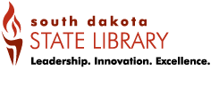
Fall 2016
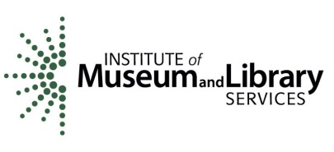
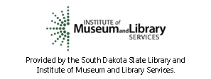
Provided by the South Dakota State Library and
Institute of Museum and Library Services.
 | The State Library now provides Ebsco databases at no charge to public & K-12 libraries + tech institutes. See the list on the back of the puzzle map. Includes general and scholarly eresources, such as Academic Search Premier, and eresources for specific subject areas including health and business.
 | Ebsco's new Explora designed for K-12 student and educator research.The 4 modules are: Educator (education info for teachers), Kids, Teen, and Libraries (for public libraries). General magazine database with AP videos.
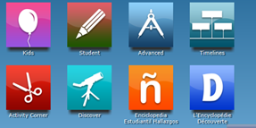 | World Book no longer has Public/School Editions. Public Library Edition modules were consolidated into World Book Advanced and Student. Activity Corner was added, offering activities for all ages with easy, clear instructions, photographs, illustrations, and more. World Book Advanced is now mobile friendly. Article pages have tabs for other information, including multimedia, ebooks, websites, and primary sources. Click “Research & Resources” in the home page upper right for favorite features including Atlas, Pathfinders, Timelines and more. Educator Tools in that list include Teaching with Documents.
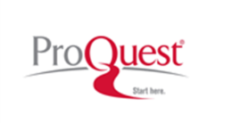 | Added US Major Dailies, the 5 main newspapers in the US: Chicago Tribune, LA Times, NY Times, Wall Street Journal and Washington Post, full-text from 1980-present.
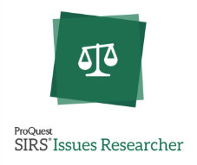 | Now mobile friendly. Contains 300+ Leading Issues, same balanced approach to essential questions. “Educators Tools” offers: Curriculum Guides, Editorial Cartoons, Infographics, Maps of the World, Note Organizers, Standards Correlations, World Almanac
 | Added 23 non-fiction ebooks in pdf for simultaneous use
 | Updating German Unit 1 for more in-depth, more vocabulary, and more cultural notes. Corresponding quizzes and tests will also be updated.
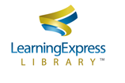 | Added more than 50 new resources since January, including 25 new resources for SAT test prep, new eBooks for GED, Praxis II, Praxis Core, Nursing and others, plus new test prep for military exams

