When every second counts, sometimes educators and school personnel become the first responders
Active shooter incidents are an increasing reality within our schools, and in most cases they are resolved before, or just as, first responders arrive on the scene. In what could seem like a lifetime, but in reality is a matter of seconds or minutes, school personnel—teachers, administrators and security staff—actually become the first responders and must act in the blink of an eye to protect students in their care. Proper resources, action plans and training are key to ensuring that staff are ready should the most unfortunate scenario occur. This is where the Enhanced Dynamic Geo-Social Environment (EDGE) virtual platform can help.

EDGE helps stakeholders train together—for free
In June 2017, the Department of Homeland Security Science and Technology Directorate (S&T) and the U.S. Army Research Laboratory released the first EDGE virtual training environment for first responders. Using a high-rise hotel as the backdrop, first responders of all disciplines can navigate through a number of complex incidents, including active shooters, arson, hostage negotiation, bomb threats and more. This training environment is now available for free to response agencies across the country.
Developing a second training environment featuring a school was a natural progression. The team worked with several first responder and education stakeholders, including the Educator’s School Safety Network, to gather feedback and requirements.
EDGE provides a format to train school personnel or law enforcement agencies separately or collaboratively so all are prepared in the event of a school shooting. The goal is to improve communication, coordination and response skills prior to an attack. They can practice various strategies together, and the technology analyzes how different security measures might change the outcome of an attack and response. This EDGE environment is also free to all U.S. public safety and education institutions.

Gaming tech fosters communication, coordination
Though EDGE is built on the Unreal gaming engine, it is not a single-player video game with programmed scenarios. In fact, there is little artificial intelligence; the platform is tactic-agnostic, allowing school staff to create training plans and responses based on their own operating procedures.
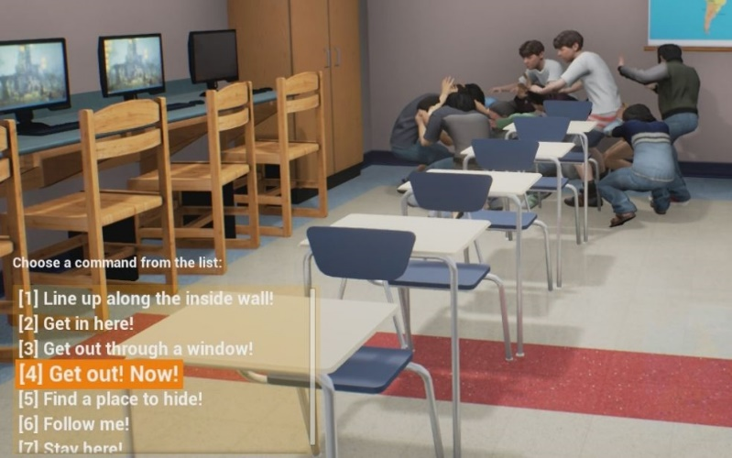
Trainees select courses of action in the EDGE
school virtual training environment

Highlights of the EDGE school environment:

Avatars include teachers, school administrators and school resource officers—all have realistic roles and capabilities similar to what they have in a real school environment. Additional avatars include students and suspects, as well as law enforcement, for a coordinated response. More avatars will be added in the future to build in unified command, firefighters and emergency medical services.

EDGE is meant to complement existing training tools, including live tabletop exercises, which can be costly and time consuming. Because EDGE is accessible online, training can be conducted without disrupting the school environment.

Communications functions allow role-players to actively converse or exchange commands while running live EDGE training exercises. There is also an after-action capability, so trainers can replay the exercises for further discussion and instruction.

How to obtain EDGE access and training resources
S&T partnered with game developer Cole Engineering Services, Inc. to provide a point of distribution for EDGE. All EDGE account requests are fully vetted and, once approved, Cole Engineering provides online access. They also provide a help desk function for schools or first responder agencies just getting started with EDGE. Visit www.cesiedgetraining.com or contact 877-EDGE-011 (877-334-3011) for additional information.

