INDICATOR 11 (Compliance)
Child Find: Timely Initial Evaluations
Measurement: Percent of children who were evaluated within 25 school days of receiving parental consent to evaluate.

Indicator Goal: The goal of Indicator 11 is to improve efforts to locate and serve students with disabilities by ensuring 100% of children with parental consent to evaluate, are completed within 25 school days.
Indicator Connections: Districts establish processes and procedures pertaining to the timely identification, location, and evaluations for all children having or suspected of having a disability. During the initial evaluation process, students are assessed using appropriate evaluations, procedures, and instruments (Ind. 9 & 10). Parent and professional collaboration is used to promote active participation (Ind. 8). Timely evaluations are needed to support efficient and effective transitions for children transitioning from Part C to Part B (Ind. 12).

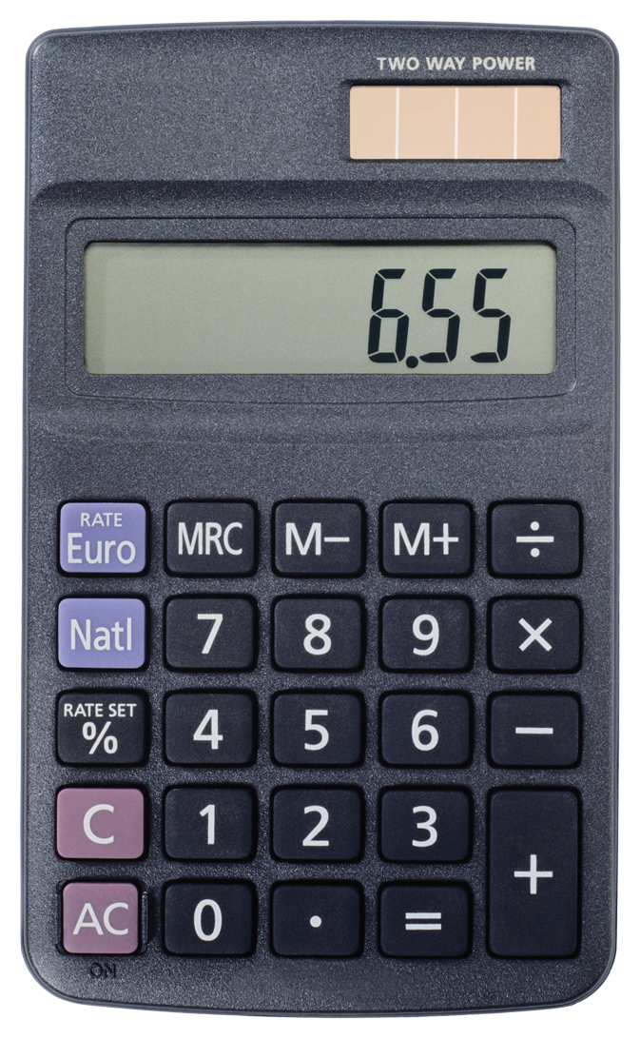 Entering/Accessing Your Data
Indicator Access Points  - District evaluation timeline records &/or dates are collected throughout the year. Spreadsheet can be used to assist in collecting student data during the year: https://doe.sd.gov/sped/SPP.aspx  - Individual student data collected is entered directly in: Launchpad Secure Website: https://apps.sd.gov/DP42LaunchPad/Logon.aspx  - Usernames and passwords remain the same each year.  - Contact Indicator 11 contact for login assistance. |  | Submission Timeline  - Student data is collected between July 1st - June 30th of each year.  - All individual student data must be entered in Launchpad and signed off by August 1st.

Calculation Guide |  | Calculation Example
- # of students for whom parental consent to evaluate was received  - # of students whose evaluations were completed within 25 school days  - % of initial evaluations completed within 25 school days  (B ÷ A) x 100 = C %  of initial evaluations met timeline |  | A = 10 parental consents received  B = 8 children whose evaluations were completed within 25 school days=  (8 / 10) x 100 = 80%  of initial evaluations met  the 25 day timeline
 Analyzing Your Data
 | SY1314 | SY1415 | SY1516 | SY1617 | SY1718 | SY1819
Target = | 100.00% | 100.00% | 100.00% | 100.00% | 100.00% | 100.00%
State Rate | 99.86% | 99.84% | 99.85%
*Targets are set every 6 years
Improving Your Results
Not happy with your results?
- Determine district processes and procedures that need to be addressed to assure the timelines are being met, for example, counting the 25 school days accurately.
- Review policies and procedures and provide training for all staff regularly.
- Create and continuously update a calendar that includes all timeline dates along with other important IEP-related dates.
Frequently Asked Questions
Is my district’s data accurate?
A district should pull the report called “Child List District” under reports in Launchpad to review submitted student data. If your district discovers errors, you should notify the Indicator 11 SEP contact person.
How do I calculate the 25-day timeline?
The date a district staff member receives the signed permission in-hand is considered day one. For further guidance on which days may be included in the timeline, see Indicator 11 Directions at https://doe.sd.gov/sped/SPP.aspx.
What if I’m concerned about exceeding the 25-day timeline?
If you are concerned, be sure to obtain a signed parental permission to extend the evaluation timeline including date of extension. Refer to the IEP TA guide for further guidance and forms.

Remember:
This is a compliance indicator requiring 100% of initial evaluations completed on within 25 school days. If not, districts will be determined out of compliance and a corrective action plan (CAP) will be issued.
District calendars must be uploaded and include any snow/make-up days and for PK students, indicate the days student attends, if different than the district calendar.
Resources
- SD DOE State Performance Plan webpage: https://doe.sd.gov/sped/SPP.aspx
- Indicator 11 Reporting Guide: Ind 11 Reporting Guide
- Launchpad Submission Guide: Launchpad Guide
- Self-Analysis Tool: https://doe.sd.gov/sped/documents/SPP_Indicator11_selfanalysistool.pdf

