INDICATOR 12 (Compliance)
Transition from Part C to Part B
Measurement: Percent of children referred by Part C prior to age 3, who are found eligible for Part B, and who have an IEP developed and implemented by their third birthday.

Indicator Goal: The goal of Indicator 12 is to ensure seamless transitions for children and families as they move from Part C to Part B so they can access appropriate services in a timely manner.
Indicator Connections: Coordination and collaboration play a key role for children and families transitioning to preschool programs (Ind. 8). Timely evaluations are needed to ensure access to appropriate services (Ind. 11). Successful transitions enable children to access inclusive high-quality early childhood programs (Ind. 6) and learning opportunities to improve child outcomes (Ind. 7).

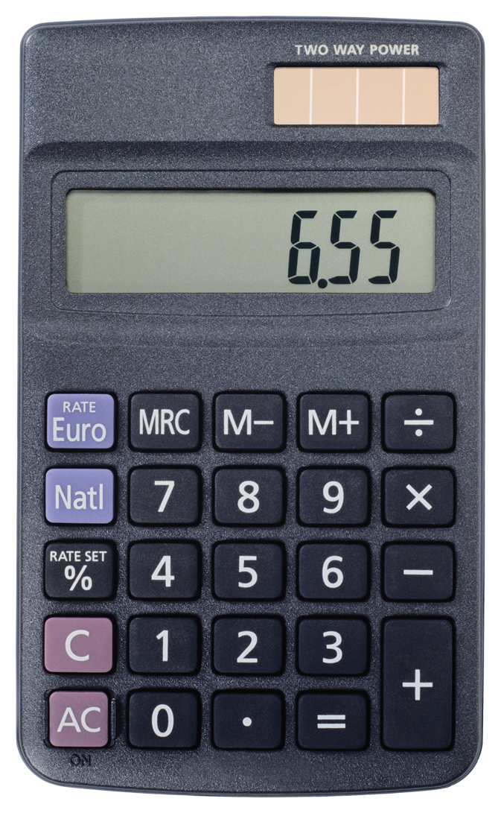 Entering Your Data
Indicator Access Points  - Part B staff collects exit data from Part C programs.  - District evaluation timeline records &/or dates is collected throughout the year (spreadsheet can be used to assist in collecting student data: https://doe.sd.gov/sped/SPP.aspx  - Individual student data collected is entered in Launchpad Secure website: https://apps.sd.gov/DP42LaunchPad/Logon.aspx  - Usernames and passwords remain the same each year.  - Contact Indicator 12 contact for login assistance. |  | Submission Timeline  - Student data is collected between July 1st - June 30th of each year.  - All individual student data must be entered into LaunchPad and signed off by September 1.  - LaunchPad submission and sign off can be completed anytime May 1 through August 31.  - District calendars must be uploaded and include snow days/makeup days, and for PK students, indicate day’s students attend, if different than the district calendar.

Calculation Guide |  | Calculation Example
- # of children who have been served in Part C and referred to Part B for eligibility determination.  - # of those referred determined to be NOT eligible and whose eligibilities were determined prior to their third birthdays.  - # of those found eligible who have an IEP developed and implemented by their third birthdays.  - # of children for whom parent refusal to provide consent caused delays in evaluation or initial services or to whom exceptions under 34 CFR §300.301(d) applied.  - # of children who were referred to Part C less than 90 days before their third birthdays.  [(C) ÷ (A – B – D – E)] x 100 = %  of Part C students who transitioned to Part B by their third birthday |  | A = 653 total # children referred by Part C  B = 184 children NOT eligible prior to their third birthday  C = 422 children found eligible & have IEP in place before their 3rd birthday  D = 0 parent refusals  E = 47 children referred to Part C <90 days before their third birthdays  [422 ÷ (653-184-0-47)] X 100 =  100% of Part C students who transitioned to Part B by their 3rd birthday

Analyzing Your Data
 | SY1314 | SY1415 | SY1516 | SY1617 | SY1718 | SY1819
Target = | 100.00% | 100.00% | 100.00% | 100.00% | 100.00% | 100.00%
State Rate | 99.00% | 99.76% | 99.54
*Targets are set every 6 years

Improving Your Results
Not happy with your results?
- Are district procedures in place and followed for evaluating students turning age 3, including during the summer?
- Are districts receiving notice from Part C at least 90 days prior to the student turning 3, in order to begin transition activities and evaluations?
Frequently Asked Questions
Is my district’s data accurate?
A district should pull the report called “Child List District” under reports in Launchpad to review submitted student data. If your district discovers errors, you should notify the Indicator 12 SEP contact person.

Remember:
If the timeline is not met, ensure appropriate documentation, implementation date and reason for delay, is placed in the file and documented in the “other” column during submission.
Resources
- SD DOE State Performance Plan webpage: https://doe.sd.gov/sped/SPP.aspx
- Launchpad Submission Guide: Launchpad Guide
- Indicator 12 Reporting Guide: Ind 12 Reporting Guide
- SD DOE Early Intervention Preschool 619 webpage: https://doe.sd.gov/sped/Early-Intervention.aspx
- South Dakota Early Childhood Transition from Part C to Part B Timeline Manual and Timeline.

