INDICATOR 13 (Compliance)
Secondary Transitions
Measurement: Percent of youth with IEPs (aged 16 and above) whose IEP includes appropriate measurable postsecondary goals that are annually updated and based upon an age-appropriate transition assessment; transition services, including courses of study, that will reasonably enable the student to meet those postsecondary goals; and annual IEP goals related to the student's transition needs. Districts must document evidence that the student was invited to the IEP team meeting where transition services were discussed. Districts must also document that, when appropriate, a representative of any participating agency was invited to the IEP team meeting.
Indicator Goal: The goal of Indicator 13 is to monitor the percent of youth (16 and above) with an IEP that includes an appropriate transition plan. Indicator 13 is composed of a variety of factors that districts should focus on to improve a student’s experience as they transition to post-secondary success. A good transition should be focused around the student and include independent living, training, and employment.

Indicator Connections: Creating and implementing a strong transition plan with appropriate supports for students (Ind. 13), will help to create a strong foundation for students to reach the goal of college, career, and life readiness (Ind. 14: Post-School Outcomes). Graduation (Ind. 1) is more likely to occur when post-secondary goals are established within a transition plan.
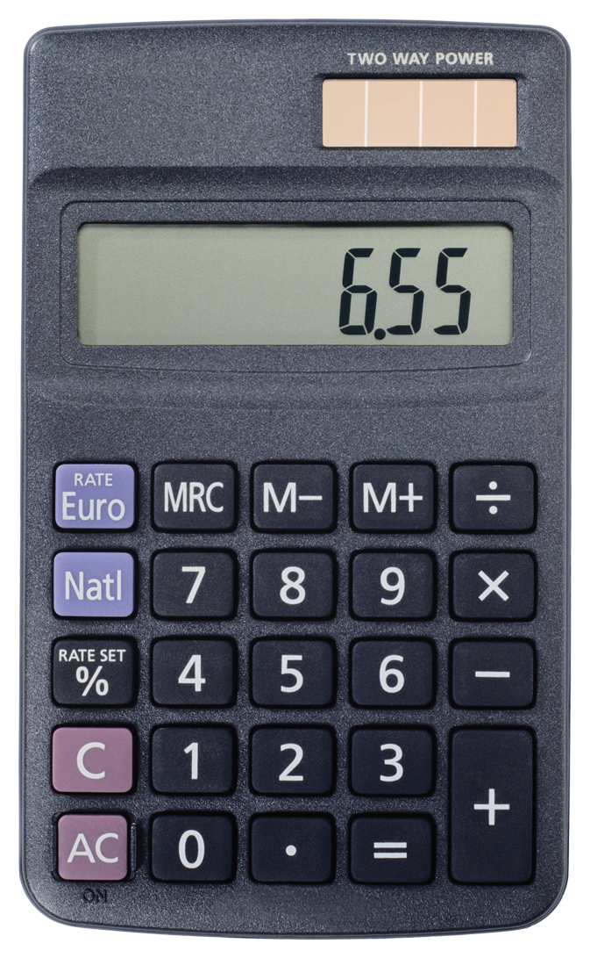 Entering/Accessing Your Data
Indicator Access Points  Data for this indicator comes from the onsite accountability review of IEPs of students age 16 and above. |  | Submission Timeline  - Review Team examines transition IEPs during the SPED on-site accountability review.  - The submission date is the date of the on-site accountability review

Calculation Guide  (A ÷ B) x 100 = %  of the IEPs reviewed by the onsite review team met compliance.  - # of students with IEPs age 16 and above whose IEP includes an appropriate transition plan that meets the indicator 13 checklist.  - # of students with an IEP age 16 and above. |  | Calculation Example  10 files in compliance  15 files checked for ages 16 and above.  10 ÷ 15 x 100 = 66.67%  of the IEPs reviewed by the onsite review team met compliance.

 Analyzing Your Data
 | SY1314 | SY1415 | SY1516 | SY1617 | SY1718 | SY1819
Target = | 100.00% | 100.00% | 100.00% | 100.00% | 100.00% | 100.00%
State Rate | 86.19% | 85.28%
*Targets are set every 6 years

Improving Your Results
Not happy with your results?
- Utilize the Indicator 13 checklist throughout school year: July 1 to June 30.
- Consult your regional transition liaison (http://tslp.org/schools/).
- When appropriate, are you working with an outside agency to improve student post-secondary outcomes?
Frequently Asked Questions
Is my district’s data accurate?
Your data is taken from review team examination of transition IEPs during the SPED on-site Accountability review.
When should I hold a transition IEP for each student?
The IEP meeting must occur on or before a student’s 16th birthday.

Remember:
If 100% is not met, districts will be required to complete a corrective action plan (CAP).
Resources
- SD DOE State Performance Plan webpage: https://doe.sd.gov/sped/SPP.aspx
- Indicator 13 Checklist: https://doe.sd.gov/sped/documents/Indicator13-checklist.pdf
- Transition Service Liaison Project: http://tslp.org/schools/
- National Technical Assistance Center on Transition (NTACT): http://transitionta.org/
- Tab at NTACT for additional resources for Indicator 13: http://www.transitionta.org/transitionplanning

