INDICATOR 4A (Results) & 4B (Compliance)
Suspension and Expulsion

Measurement (4A): Percent of districts identified by the State as having a significant discrepancy in the rates of suspensions and expulsions of students with IEPs for greater than 10 days (consecutive or accumulated) in a school year.

Measurement (4B): Percent of districts that have: (a) a significant discrepancy, by race or ethnicity, in the rate of suspensions and expulsions of students with IEPs of greater than 10 days (consecutive or accumulated) in a school year for; and (b) policies, procedures or practices that contribute to the significant discrepancy and do not comply with requirements relating to the development and implementation of IEPs, the use of positive behavioral interventions and supports, and procedural safeguards.
Indicator Goals:
The goal of indicator 4A is to identify the percent of districts that have a significant discrepancy in the rates of suspensions and expulsions of students with IEPs of greater than 10 days in a school year.
The goal of indicator 4B is to identify the percent of districts that have: (a) a significant discrepancy, by race or ethnicity, in the rate of suspensions and expulsions of greater than 10 days in a school year for students with IEPs, and (b) policies, procedures or practices that contribute to the significant discrepancy and do not comply with requirements relating to the development and implementation of IEPs, the use of positive behavioral interventions and supports, and procedural safeguards.


Indicator Connections: A student’s academic achievement (Indicator 3) and graduation rate (Indicator1) are directly related to their exposure to the general curriculum. When students are suspended from school they are losing access to the general curriculum and falling further behind academically. Also, research shows a strong link between suspension and student dropout rates (Indicator 2) https://www.edutopia.org/blog/link-between-suspension-and-dropout-robyn-gee

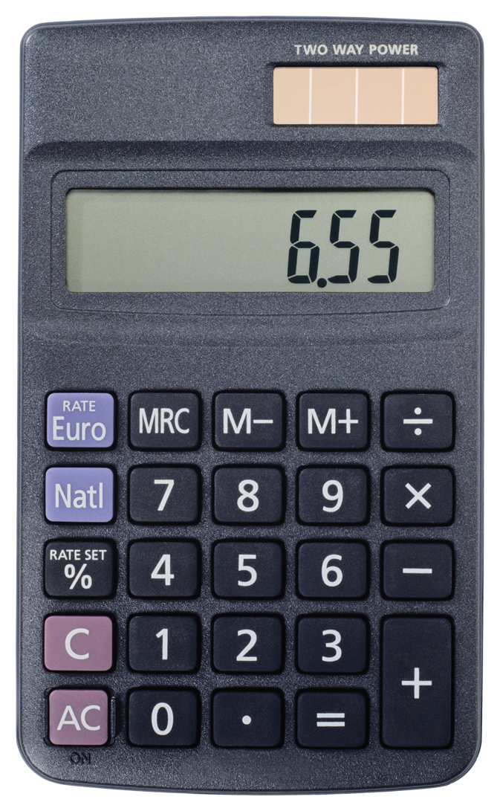 Entering/Accessing Your Data
Indicator Access Points  Districts use suspension/expulsion data maintained throughout the year as well as Child count from that year (i.e. 2014-15 SPP report uses Child Count data from 2013-14).  SEP secure website at https://apps.sd.gov/DP42LaunchPad/Logon.aspx |  | Submission Timeline  - Data collection: September 1 to June 30  - Districts must submit data by June 30

Calculation Guide  - (4A) Students with IEPs suspended/expelled in the district > 10 school days in the school year  - (4B) Students with IEPs per race and ethnic group suspended/ expelled in the district >10 school days during the school year  - District Child Count  4A: (A ÷ C) x 100 = % discrepancy  4B: (B ÷ C) x 100 = % discrepancy  * A discrepancy >5% of the district child count constitutes a significant discrepancy. |  | Calculation Example 4A  28 students with IEPs suspended or expelled >10 school days during the year.  340 Total SPED Child Count  (28 ÷ 340) x 100 = 8.23%  is a significant discrepancy  Calculation Example 4B  5 Native American Students with IEPs suspended or expelled >10 school days during the year.  340 Total SPED Child Count  (5 ÷ 340) x 100 = 1.47%  is not a significant discrepancy
 Analyzing Your Data
 | SY1314 | SY1415 | SY1516 | SY1617 | SY1718 | SY1819
Target A ≤ | 1.30% | 1.30% | 1.30% | 1.30% | 1.30% | 0.00%
State Rate | 0.00% | 0.00%
Target B = | 0.00% | 0.00% | 0.00% | 0.00% | 0.00% | 0.00%
State Rate | 0.00% | 0.00%
*Targets are set every 6 years

Improving Your Results
Not happy with your results?
- Review your district’s policies, practices, and procedures regarding suspension/ expulsion. Has the process been followed?
- What training does staff need to positively and proactively handle problem behavior?
Frequently Asked Questions
Is my district’s data accurate?
Your data is taken from the SEP secure website.

Remember:
Districts enter data into a Special Education Secured Website, which is different than the Safe & Drug Free Schools secure website utilized by Title 1.

Resources
- SD DOE State Performance Plan webpage: https://doe.sd.gov/sped/SPP.aspx
- SD Discipline in Special Education for Principals Presentation:
PowerPoint: https://doe.sd.gov/sped/pbis.aspx
Writing Behavior Plans: https://doe.sd.gov/sped/pbis.aspx
- Positive Behavioral Interventions and Supports: www.pbis.org

