INDICATOR 5 (Results)
Least-Restrictive Environment: Ages 6-21
Measurement: Percent of children with IEPs aged 6 through 21:
- Inside the regular class 80% or more of the day;
- Inside the regular class less than 40% of the day; and
- In separate schools, residential facilities, or homebound/hospital placements.
Indicator Goal: The goal of Indicator 5 is to determine whether students with IEPs are appropriately placed in the least restrictive educational environment

Indicator Connections: When students with IEPs receive instruction in the least restrictive environment, they are more likely to demonstrate success on the statewide assessment (Ind. 3), to effect graduation rate (Ind. 1), and the dropout rate (Ind. 2).

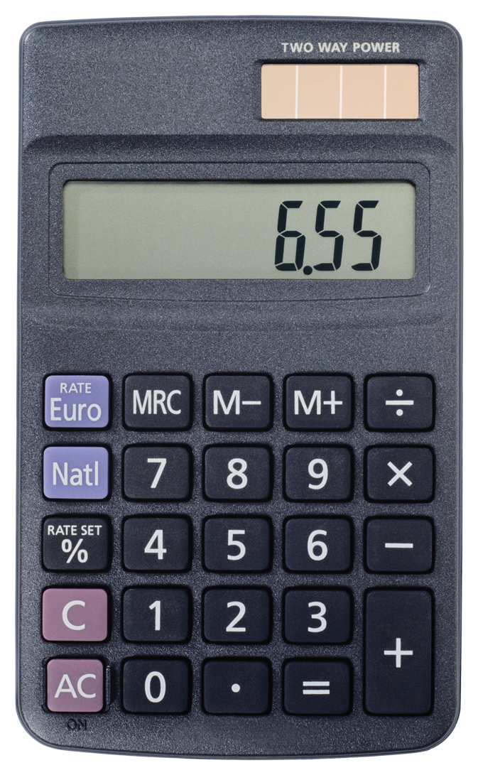 Entering/Accessing Your Data
Indicator Access Points  Results for this indicator come from the current year’s December 1st Child Count.  Information is collected through the special education tab in SIMS/Infinite Campus. |  | Submission Timeline  - Collection Dates: July 1-June 30 when students enter SPED or placement changes.  - Deadline: Districts verify and sign off on Dec. 1 Child Count annually.

Calculation Guide  Reg. Classroom w. Modifications  A ÷ D x 100  Self-Contained Classroom  B ÷ D x 100  Out of District  C ÷ D x 100  - Students with IEPs served in regular classroom 80% or more of the day  - Students with IEPs served in regular classroom less than 40% of the day  - Students with IEPs served in separate schools, residential facilities, or homebound/hospital placements  - Total students age 6-21 with IEPs |  | Calculation Example  50 Students with IEPs served in regular classroom 80% or more of the day  10 Students with IEPs served in regular classroom less than 40% of the day  1 Students with IEPs served in separate schools, residential facilities, or homebound/hospital placements  80 Total students age 6-21 with IEPs  Reg. Classroom w. Modifications  50 ÷ 80 x 100 = 63%  Self-Contained Classroom  10 ÷ 80 x 100 = 13%  Out of District  1 ÷ 80 x 100 = 1%

 Analyzing Your Data
 | SY1314 | SY1415 | SY1516 | SY1617 | SY1718 | SY1819
Target A ≥ | 66.00% | 66.50% | 67.00% | 67.00% | 67.50% | 68.00%
State Rate A | 69.58% | 68.44%
Target B ≤ | 6.00% | 6.00% | 6.00% | 6.00% | 6.00% | 6.00%
State Rate B | 5.43% | 5.54%
Target C ≤ | 3.80% | 3.69% | 3.59% | 3.49% | 3.39% | 3.29%
State Rate C | 2.01% | 2.11%
*Targets are set every 6 years
Improving Your Results
Not happy with your results?
- Analyze your Childcount data for any specific disability category, grade level, school building, etc. that has a higher rate of removal.
- Consider scheduling, staffing, or other accommodations that could assist a student in being successful in the general education classroom.
Frequently Asked Questions
I have students who are being served in a separate facility, which puts me out of compliance on this indicator. Should I provide services at the school instead?
It is the IEP team’s responsibility to determine the best placement for each student. If the IEP team determines that a separate placement is best for a student, that is the placement a district should use.
Some classroom teachers in my district have reservations about having students with IEPs in their classrooms. What can I do to help those teachers?
See the “Tips and Strategies” (SPP Binder) for inclusion strategies.
Contact your region representative or local education agency for resources and in-service opportunities on best practices in education.

Remember:
Students placed in the general education classroom 40-79% of their day (Resource Room) are not represented in Indicator 5.
Resources
- SD DOE State Performance Plan webpage: https://doe.sd.gov/sped/SPP.aspx
- IRIS Center: http://iris.peabody.vanderbilt.edu
- Florida’s Multi Tiered Systems of Support:
http://www.florida-rti.org/floridaMTSS/index.htm

