INDICATOR 7 (Results)
Early Childhood Outcomes
Measurement: Percent of preschool children aged 3 through 5 with IEPs who demonstrate improved:
- Positive social-emotional skills (including social relationships);
- Acquisition and use of knowledge and skills (including early language/communication and early literacy); and
- Use of appropriate behaviors to meet their needs.
Summary Statement 1: Of those preschool children who entered or exited the program below age expectations, the percent who substantially increased their rate of growth by the time they turned 6 or exited the program.
Summary Statement 2: Percent of children who were functioning within age expectations by the time they turned 6 or exited the program.
Indicator Goal: The goal of Indicator 7 is to track children’s functioning at entry and exit in the 3 outcomes areas in order to determine quality of services to children and families and identifies areas of program improvement.

Indicator Connections: Helping children improve functioning in the three outcomes supports their participation in inclusive high-quality early childhood programs (Ind. 6). A child with improved early childhood outcomes has demonstrated impacts for improving; reducing challenging behaviors, suspensions and expulsions (Ind. 4), and increasing family-school collaboration (Ind. 8).
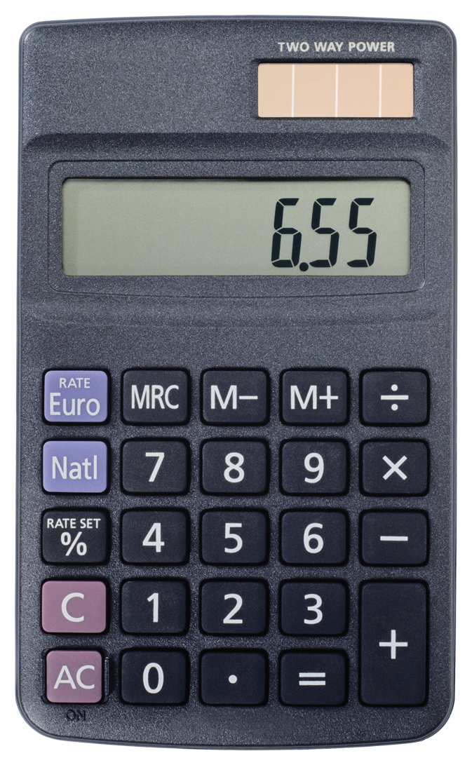Entering/Accessing Your Data
Indicator Access Points  - The Battelle Developmental Inventory-2 (BDI-2) is given to children when they Enter and Exit the Part B 619 Program (3-5).  - Entry and exit scores are entered into the online Data Manager for comparison.  - Child Count report from SIMS/Infinite Campus can be used to verify that students are accounted for, have been correctly exited from EC, and are enrolled in Part B (6-21), if eligible. |  | Submission Timeline  Scores are entered into the BDI-2 Data Manager from July 1 to June 30 of each year.  - All entry and exit scores must be entered into BDI-2 Data Manager by July 1 of each year.

Calculation Guide and Example
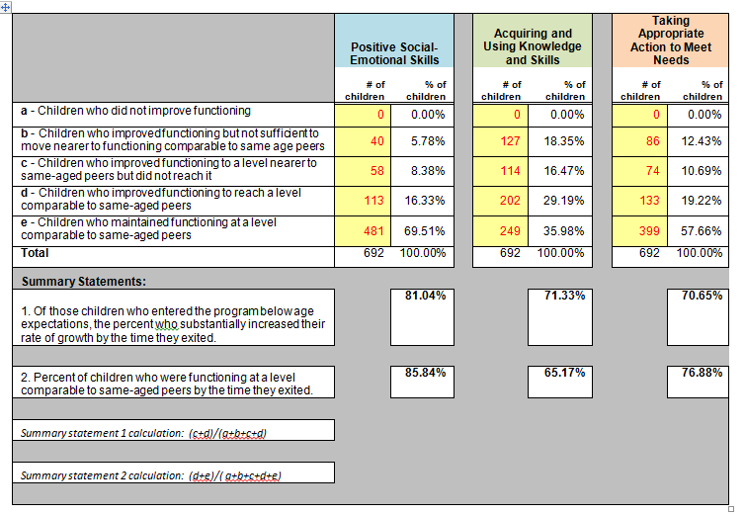
Analyzing Your Data
Indicator Targets | SY1314 | SY1415 | SY1516 | SY1617 | SY1718 | SY1819
Target A-1 ≥ | 79.15% | 79.15% | 79.15% | 79.15% | 79.25% | 79.35%
State Rate | 74.67% | 75.50%
Target 7A-2 ≥ | 84.15% | 84.15% | 84.15% | 84.15% | 84.25% | 84.35%
State Rate | 84.48% | 85.93%
Target 7B-1 ≥ | 64.50% | 65.50% | 66.50% | 67.50% | 68.50% | 69.50%
State Rate | 68.92% | 66.73%
Target 7B-2 ≥ | 55.96% | 55.96% | 55.96% | 55.96% | 56.96% | 57.96%
State Rate | 64.21% | 62.17%
Target 7C-1 ≥ | 67.10% | 68.10% | 69.10% | 70.10% | 71.10% | 71.60%
State Rate | 68.29% | 71.27%
Target 7C-2 ≥ | 72.10% | 72.10% | 72.10% | 72.10% | 72.60% | 73.60%
State Rate | 74.34% | 76.95%
*Targets are set every 6 years
Improving Your Results
Not happy with your results?
- Compare results based on location (LRE), type, and/or quantity of intervention.
- Consider factors such as age, level of functioning at entry, and disability.
- Does the district use data for program improvement or?
Frequently Asked Questions
Is my district’s data accurate?
Review and verify each exiter’s entrance and exit information in BDI-2 Data Manager. Ensure program notes are accurately entered.
Is there a report that shows student growth from entry to exit?
Yes. Request a district report for Indicator 7 student specific data from SEP (Special Education Program).

Remember:
Enter information into the BDI2 data manager according to instructions, with particular attention to Program Note(s). https://doe.sd.gov/sped/Early-Intervention.aspx.

Resources
- SD DOE State Performance Plan webpage: https://doe.sd.gov/sped/SPP.aspx
- SD DOE Early Intervention – Preschool Section 619 resource webpage https://doe.sd.gov/sped/Early-Intervention.aspx
- Ind. 7 “Brown Bag” webinar: https://www.youtube.com/watch?v=yC4PQmNIlsQ&feature=youtu.be
- Early Childhood Technical Assistance center (ECTA): http://ectacenter.org
- Child Outcomes Step-by-Step: http://ectacenter.org/eco/pages/videos.asp

