

INDICATOR 11 and 12 Data Launchpad Submission Guide

South Dakota Department of Education
800 Governors Drive
Pierre, South Dakota 57501
TABLE OF CONTENTS

- Login ……………………………………………………………………………………………. Pg. 3
- Calendar ………………………………………………………………………………………. Pg. 4
- Enter Students Individually ………………………………………………………….Pg. 7
- Color Codes …………………………………………………………………………………. Pg. 10
- Edit Student Information ……………………………………………………………..Pg. 10
- District Summary Report ………………………………………………………………Pg. 11
- Sign Off ……………………………………………………………………………………….. Pg. 13
- Reports ……………………………………………………………………………………….. .Pg. 14

HOW TO LOGIN
- Login: https://apps.sd.gov/DP42LaunchPad/Logon.aspx
- Login information was sent to your district Special Education Director.
  - Login is used for both Indicator 11 and 12
  - Login and password is unique to Indicator 11 and 12
  - Both will be used in coming years
  - If you forget your password contact Elizabeth.Jehangiri@state.sd.us
- Password will need to be changed when you log in for the first time.
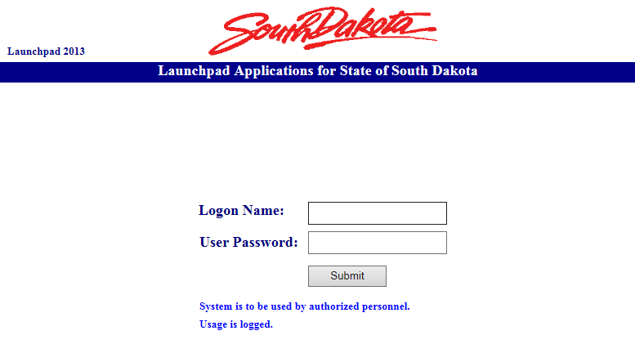

- Enter the application “DE67IND11And12”
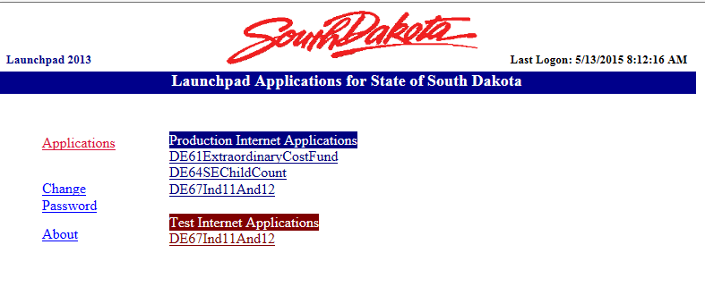
HOW TO UPLOAD DISTRICT CALENDAR
- Select the year you are submitting from the drop down
- Choose the district you are submitting for from the drop down

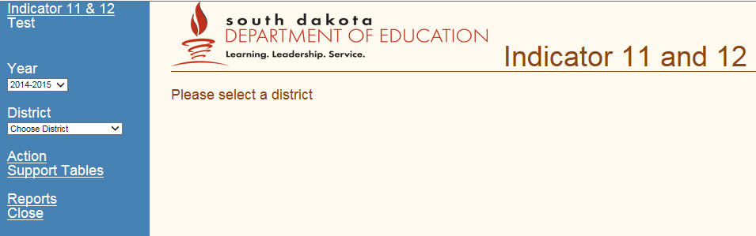
1
2

- Select “Action” and it will bring down a new menu of options
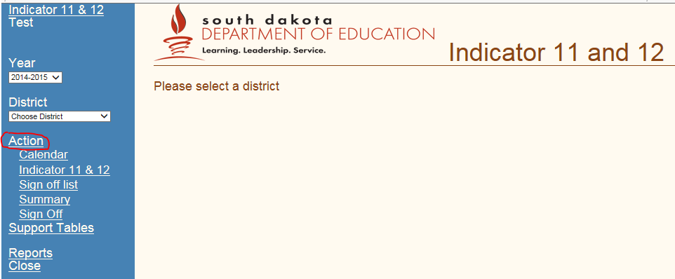
3

- Upload District Calendar

  - Select “Calendar”
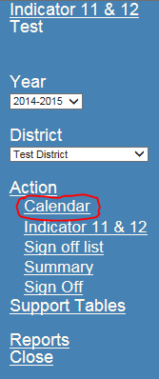
4

  - Select “Browse” and find the location of the calendar on your computer. Then select upload (make sure your calendar indicates snow days and/or other non- school days). PDF, Word, or Excel are the only acceptable formats.
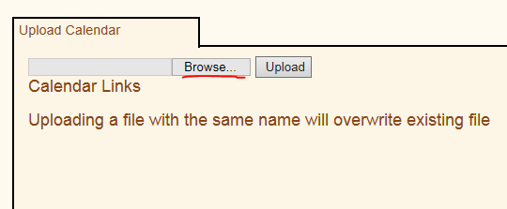

Once you have uploaded the file will appear.
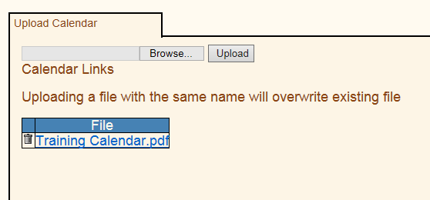

Indicator 11 Reporting:
- Indicator 11 data collection is completed for each fiscal year beginning July 1st and ending June 30. A compiled list of district initial evaluations must be entered manually (spreadsheets are no longer accepted) in Launchpad no later than August 1.
- All initial evaluation data must be entered in Launchpad and signed off by August 1st. You must upload a copy of the most current school calendar. It is imperative that you note snow days and/or other non- school days to ensure accuracy. This can simply be marked on your calendar or indicated and uploaded on another sheet.

Indicator 12 Reporting:
- Indicator 12 data collection is completed for each fiscal year beginning July 1st and ending June 30. A compiled list of children who were served in Part C and upon turning 3, were evaluated for Part B determination must be entered manually (spreadsheets are no longer accepted) in Launchpad no later than September 1.
- All transition evaluation data must be entered in Launchpad and signed off by September 1st. You must upload a copy of the most current school calendar. It is imperative that you note preschool days, snow days and/or other non- school days to ensure accuracy. This can simply be marked on your calendar or indicated and uploaded on another sheet.
- If you get an error message stating “SIMS number already exists” this could mean you have already reported the child on Indicator 11. You will need to confirm which indicator the student needs to be reported.
- If you have no students to report a district calendar must be uploaded, then you will sign off for Indicator 12.
ENTERING STUDENTS INDIVIDUALLY
Indicator 11:
- Manually enter the student information for which you have. Type directly into each of the white boxes noted below. All fields are required unless a student does not qualify, eligibility could not be determined, or moves. The system will give you an error if a field is required that you have not completed.
  - SIMS or DOB+Initials (SIMS # is the state ID from Campus and is 9 characters long OR if one has been assigned, enter “DOB+ student initials”).
  - Date Permission Received
  - Date Last Evaluation Completed
  - School days from day permission received to day last evaluation completed
  - Date Eligibility Determined
  - Eligibility meeting date
  - Eligible for Special Education (Drop down: Yes, No, Eligible Parent Declined Services, or Student Moved)
  - Disability Area
  - Reason over 25 days
  - Other
- NOTE: You may have situations where a student moves in the middle of the evaluation process or the evaluation could not be completed for other reasons. If you do not have a “Date Last Evaluation Completed or Date Eligibility Determined”, this is ok. Once you note the Student Moved or that Part B Eligibility couldn’t be determined, the system will allow you to save. You may use the “Other” box to enter a short note.
- When complete, click the save button and the student information will populate at the bottom.
- If you have no students to report a district calendar must be uploaded. Once the calendar has been uploaded simply sign off for Indicator 11.
- After the student information has been saved and populates at the bottom:
  - You always have the option to edit or delete the entry. Click on the paper/pencil to edit or the trash can to delete the entry.
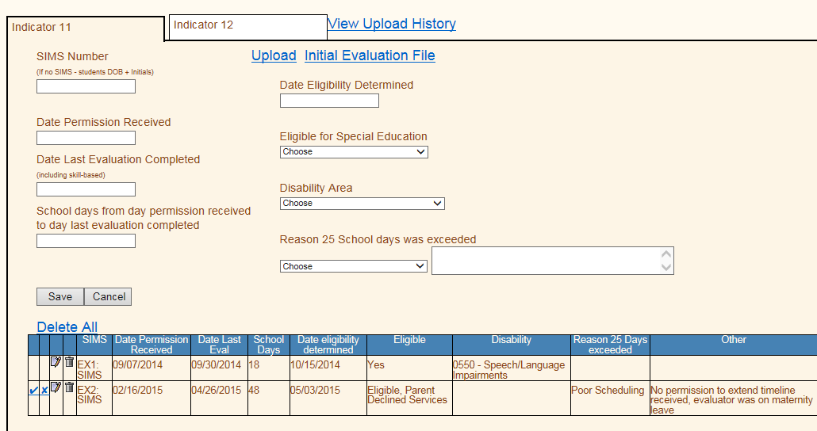

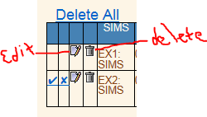

Indicator 12:
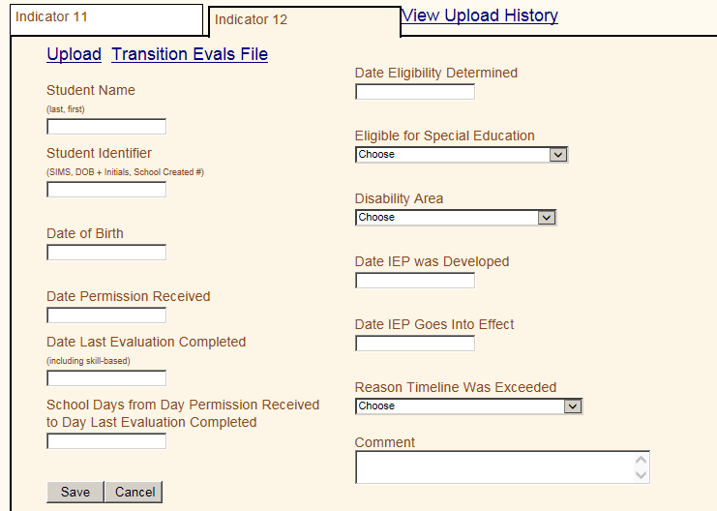

- Follow the same steps as completed for Indicator 11. The system will give you an error if a field is required that you have not completed.
- Student Name
- Student Identifier
  - SIMS or DOB+Initials (ex. DOB+Initials = 05/21/12ET) (SIMS # is the state ID from Campus and is 9 characters long)
- Date of Birth
- Date Permission Received
- Date Last Evaluation Completed
- School days from day permission received to day last evaluation completed
- Date Eligibility Determined
- Eligible for Special Education (drop down: Eligible, Eligible- Parent Declined Services, Not Eligible, Eligibility Not Determined, or Student Moved)
- Disability Area
- Date of IEP Developed
- Date IEP Goes into Effect
- Reason timeline was Exceeded
- Other
NOTE: The Date the IEP Goes into Effect CANNOT be prior to the 3rd birthday.

COLOR CODES
Red error with student information. Scroll over student name a pop-up will appear stating the error
Orange Student Eligibility meeting/IEP developed after students 3rd birthday
Green over the 25 days or past the 3rd birthday but determined in compliance
Yellow over the 25 days or past the 3rd birthday and determined non-compliance

EDITING STUDENT INFORMATION

- Click on the paper/pencil icon next to students name
- Scroll to top of page
- Students information will be displayed in the white boxes at the top where you can edit each field
- Click save when finished
  - If the district has signed off you will not be able to make changes and will need to contact Elizabeth.Jehangiri@state.sd.us to unsign your form.
  - Once you have made edits you will need to sign off again.

HOW TO VIEW DISTRICT SUMMARY

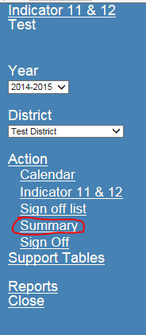
Indicator 11
This provides the district with a summary of the number of students who were eligible, not eligible, or those who did not meet compliance for Indicator 11’s 25 day timeline.
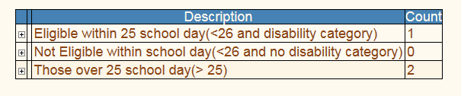
If you expand the plus sign, each student’s corresponding SIMS # is listed allowing you to click and view the information submitted for that student.
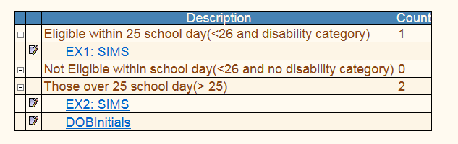
Indicator 12
This provides the district with a summary of the number of students who were eligible, not eligible, or those who did not meet compliance for Indicator 12.
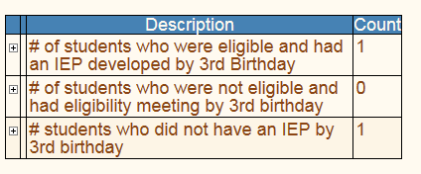
If you expand the plus sign, each student’s corresponding SIMS # is listed allowing you to click and view the information submitted for that student.
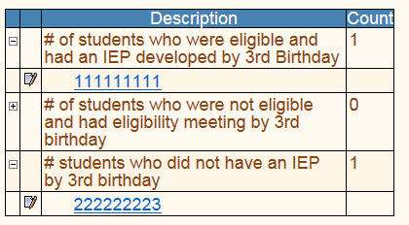

HOW TO SIGN OFF
All errors must be fixed or the system will not allow you to sign off.
- Click on “sign off” on menu bar
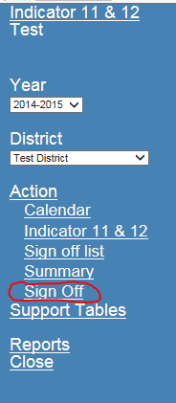

- Choose the Indicator for which you want to sign off and complete the boxes.
- Once you have entered name, title, and email you can click “sign off” at the bottom.
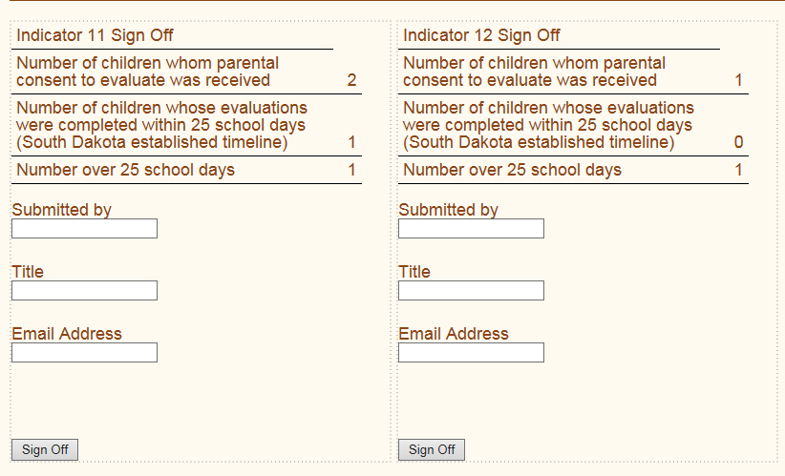

- You will need to sign off on each indicator individually.
- The contact for corrections will be the person who signs off.
- Once you have signed, you will not be able to change information unless you contact SEP to open it back up.

HOW TO VIEW REPORTS
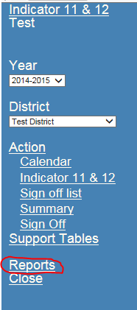

- Click on “Reports” on the menu bar and click on the paper/pencil icon next to the type of report you want.
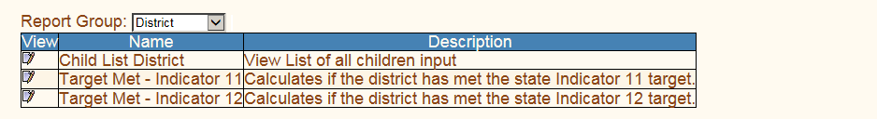

- Child List - Select the year for which you want a spreasheet printout
- Target Met - Indicator 11 – Calculates if the district has met the state target of 100%
- Target Met - Indicator 12 – Calculates if the district has met the state target of 100%

- A new window will open and you can select the year for which you want to view.
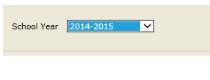
- Select “view report” on right hand side of page.
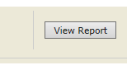

- You will receive a printout that looks like one of these:

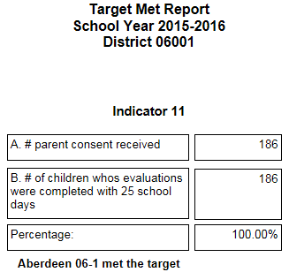

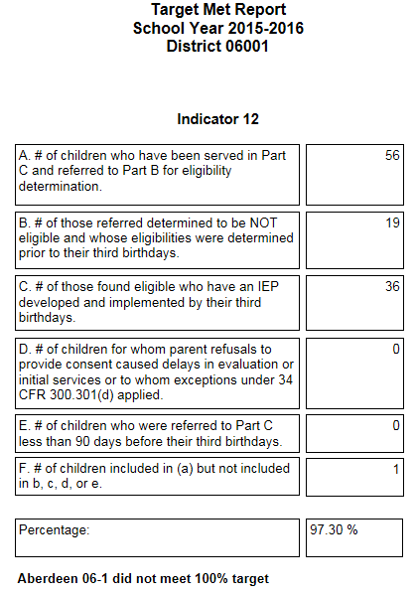

Questions or problems with the application? Please contact Elizabeth Jehangiri at Elizabeth.Jehangiri@state.sd.us or by calling (605)773.3678.

