What Can You Do to  Help Your Child Stay on  the Path of Positive Behavior?  - Ask your child about his/her school day every day.  - Make sure your child is ready every day. Ensure a good night’s sleep.  - Provide a quiet time and space for your child to do homework nightly.  - Keep in touch with your child’s teacher.  - Encourage your child to use appropriate language and tone.  - Practice positive phrases with your child, such as “Thank you,” “Excuse me,” “Please,” and “I’m sorry.”  - Be a visible part of your child’s school day. Attend meetings and other school activities as your schedule allows. | Shannon County  PBIS Team  Red Shirt: Vanna Roubideaux  Batesland : Torey Yankton and Melody Bohlender  Rockyford: Barb Blaney, Melvin Young Bear and Steve Red Owl  Wolf Creek: Allen Ecoffey, Saunie Wilson and Bryan LaPorte  Shannon Co. Office: Shawn Callanan and Joni Sasse   | Parent’s Guide to  PBIS  Positive  Behavior  Interventions  & Supports  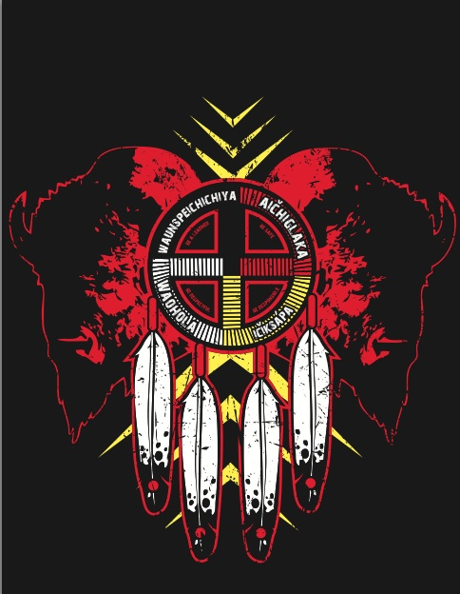
POSITIVE BEHAVIOR INTERVENTIONS & SUPPORTS  What is PBIS?  PBIS (Positive Behavioral Interventions & Supports) is a school-wide approach to discipline and process for creating safer and more effective schools.  PBIS is a systems approach to enhancing the capacity of schools to educate all children by developing research-based, school-wide, and classroom discipline systems.  The process focuses on improving a school’s ability to teach and support positive behavior for all students.  With PBIS, instructional time is more effectively used for teaching and the overall school environment is calm and conducive to learning. | Our school expectations are:  - Be Safe  - Be Respectful  - Be Responsible  - Be a Learner  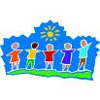 | What happens in a PBIS school?  The instructional educational plan can be implemented at its best. Teachers are able to teach in an environment conducive to teaching and students are able to learn in an environment that is comfortable and safe. Students can also earn rewards!  Encourage your child to always follow  the expectations and remain on the  path of positive behavior!  