


South Dakota Multi-Tiered System of Supports

The South Dakota Multi-Tiered System of Supports Data Workbook for Reading was developed to assist school districts in creating the practices necessary to collect and analyze building, school, and grade level data, as well as individual student data to make necessary and appropriate instructional changes to meet the needs of all students. This document serves as a workbook for either schools working within the MTSS project with the South Dakota Department of Education or as a do-it-yourself guide for schools implementing on their own. This document provides an explanation of why each component is important as well as suggests steps that have helped other schools successfully complete the tasks and decision making necessary for creating structures that support a sustainable system. All South Dakota MTSS documents align with the MTSS Practice Profile, which describes the critical components of a MTSS and what each looks like when fully implemented, and the MTSS Implementation Manual, which provides a basic overview of the research support for a MTSS.

South Dakota MTSS would like to express our gratitude to our Kansas MTSS friends at the Kansas State Department of Education in the development of this MTSS Reading Data Workbook. Their generous offer of allowing us to replicate their manual and customize it for our use is greatly appreciated.

Table of Contents

Step 1: Review and Validate Universal Screening Data ..........................................................................5

Step 2: Analyze Building Level Data By Grade ...........................................................................................7

Step 3: Analyze Grade Level Data ................................................................................................................13

Step 4: Grade Level Goal Setting ..................................................................................................................16

Step 5A: Planning for Support ......................................................................................................................19

Step 5B: Evaluating the Effectiveness of Instructional Support ........................................................21

Step 6: Analyze Student Level Data Using the Initial Instructional Sort ........................................26

Step 7: Determine What Additional Information Is Needed ………………………………………………...30

Step 8: Finalize Groupings by Determining Instructional Focus and Appropriate Materials 32

Step 9: Prepare for Progress Monitoring ..................................................................................................35

Step 10: Determine the Instructional Level for Off Grade Level Progress Monitoring .............38

Step 11: Review Progress Monitoring Data for Instructional Decision-Making ..........................40

Step 12: Continual Student Information Updating ................................................................................50

Secondary Level Implementation Supplement .......................................................................................52

References ..........................................................................................................................................................55

Appendix ......................................................................................................................................

Artifact A: Building Level Status Worksheet ..................................................................................57

Artifact B: Grade Level Need for Support Worksheet .................................................................58

Artifact C: Grade Level Status Worksheet .......................................................................................59

Artifact D: Grade Level Goal Setting Worksheet (aimsweb)......................................................60

Artifact E: Grade Level Goal Setting Worksheet (DIBELS Next) ..............................................61

Artifact F: Student Level Support Worksheet .................................................................................62

Artifact G: Support Effectiveness Worksheet MOY ………………………………………......................63

Artifact H: Support Effectiveness Worksheet EOY ………………………..........................................64

Artifact I: Initial Instructional Sort Worksheets ……………………...............................................65

Beginning of the Year Worksheets …………………………………………………………………………………66

Middle of the Year Worksheets ………………………………………………………………………………………76

End of the Year Worksheets …………………………………………………………………………………………90

Artifact J: Instructional Focus Documents ……………...................................................................103

Artifact K: Phonological Awareness Continuum ………………………………………………..………106

Artifact L: Phonics Continuum …………………………………………………………………………..………107

Artifact M: Final Reading Student Grouping Worksheet – Strategic ...................................108

Artifact N: Final Reading Student Grouping Worksheet – Intensive ...................................109

Artifact O: Final Reading Student Grouping Worksheet – Other …......................................110

Artifact P: Student Monitoring Form ……………………………………………......................................111

Artifact Q: Intervention Documentation Worksheet …………………….....................................112

Artifact R: aimsweb Back Testing Worksheet ………………………………......................................113

Artifact S: Research Based Instructional Practices ……………………........................................114

Artifact T: SD MTSS Problem Solving Worksheet ……………………….........................................115

Artifact U: Instructional Groupings Model Examples ……………………….................................123

Artifact V: Kindergarten – aimsweb Universal Screening Flowchart .................................129

Artifact W: 1st Grade – Universal Screening Flowchart …………………….................................130

Artifact X: Oral Reading Fluency – Universal Screening Flowchart ...................................131

Artifact Y: MAZE – Universal Screening Flowchart ………………….............................................132

Artifact Z: Secondary Level Universal Screening Flowchart ………......................................133

Artifact AA: Determining Progress for Instructional Decision Making Flowchart ........134

Step 1: Review and Validate Universal Screening Data
Teams should designate the week after the end of the benchmark window for data analysis and grouping of students so that no time is lost in initiating intervention groups. “The goal is to spend one week analyzing the data and placing students into groups so that intervention instruction can start the Monday of the week after the data analysis week” (Hall, 2008, p. 79).
Critical Components:
Who: Building Leadership Teams and Grade Level Teams
What: Universal Screening Data
When: After every Universal Screening
Where: Building Leadership Team and Grade Level Team meetings
Why: To ensure the data collected is valid and reliable in order to make the most accurate instructional decisions

Building Leadership Team
In addition to considering the validity of scores for individual students, the Building Leadership Team must review systemic issues that may affect the validity of data screening. The team needs to review the fidelity of administration of the universal screening assessment by discussing and reviewing any information collected regarding the following questions:

- Were the directions for the administration of the screening assessment followed exactly?
- Were the time limits for each test followed exactly?
- Was the assessment calendar followed?
- Have all the staff members who administer the assessment been trained?

It is important for the leadership team to review its procedures for collecting fidelity data regarding the universal screening process. The leadership team needs to ask “How do we know?” regarding each of the issues listed above as verification that adequate information about assessment fidelity is being collected.

The goal of the validation process is to ensure that the screening results can accurately identify students in need of assistance, so that appropriate intervention can start as early as possible. Validated scores must be entered in the data management system and final reports generated. Once questionable scores have been validated, the universal screening data can be used with confidence.

Remember, the need to validate the data does not apply only to the universal screening data. All data collected throughout the implementation process, including screening, diagnostic, and progress monitoring data, must be reviewed to ensure that teams have confidence in the screening results. If any individual student’s scores are questionable, other data and information should be used to validate and corroborate the measure of performance.

Grade Level Team
The goal of the validation process is to ensure that the screening results accurately identify students in need of assistance. If the classroom teacher or Leadership Team has a question about a student’s scores, then reviewing and validating the student’s scores may be necessary. This initial examination of the data ensures that the data are sound before they are used for instructional decision making. Following are questions that should be considered when validating the screening results:
- Was the screening assessment administered with fidelity?
- Were there environmental circumstances or events in the student’s life that may have affected score results?
  - For example, was the student sick the day the universal screening assessment was administered? Has a traumatic event happened recently?
If the classroom teacher or Leadership Team lacks confidence in any score, further screening of the student’s skills should be completed, using an alternate progress monitoring form of the universal screener.

Step 2: Analyze Building Level Data By Grade
Critical Components:
Who: Building Leadership Teams and Grade Level Teams
What: Building Level Status Worksheet (Artifact A)
aimsweb: Tier Transition Report (Criterion-Referenced)
U of Oregon DIBELS users: Distribution Report (select Former Goals from Need for Support drop-down)
DIBELS.net DIBELS users: School Overview Report
When: After every Universal Screening
Where: Building Leadership Team and Grade Level Team meetings
Why: Determine overall progress

The Building Leadership Team responsibility:
After every universal screening administration, the Building Leadership Team will review building level data to determine if the core curriculum has sufficiently met the needs of most students (80% or more of students at or above benchmark), and, if not, provide a general understanding of how many students may need additional Tier 2 or Tier 3 support from the system.
To determine the overall progress of the building using the appropriate report from those listed above, the Building Leadership Team will begin the process. The fall report provides a visual representation of student scores falling within each instructional tier (by subtest). Subsequent reports (winter, spring) provide additional information indicating the number of scores that have moved into higher or lower tiers. In the fall, the report provides an initial illustration of how students in each grade level are performing on the predictive skills measured by the screening tool, whereas winter and spring reports are an indication of student improvement.
It’s important to note that Composite Scores will be used to determined overall growth for the building. Both U of Oregon and DIBELS.net sites provide Composite Scores for DIBELS users. For aimsweb users, it will be necessary for the Building Leadership Team to compute a grade level composite for each grade.

U of Oregon DIBELS Data System users:
Schools using U of Oregon DIBELS Data System will be able to download the Distribution Report to determine the overall progress of the building (select Former Goals from Need for Support drop-down).
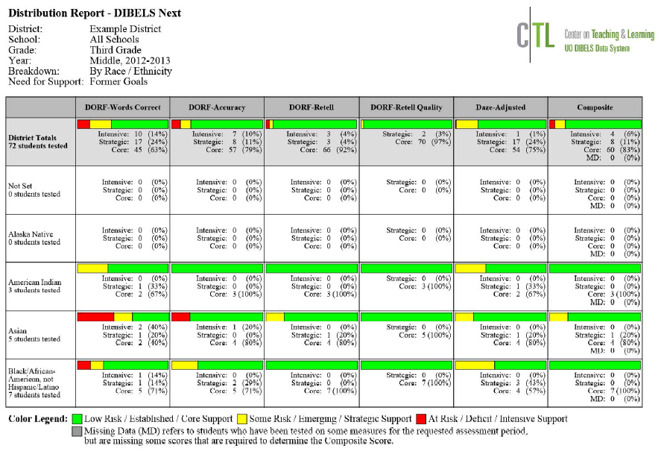
DIBELS.net DIBELS Data System users:
Schools using DIBELS.net DIBELS Data System will be able to download the School Overview Report to determine the overall progress of the building.
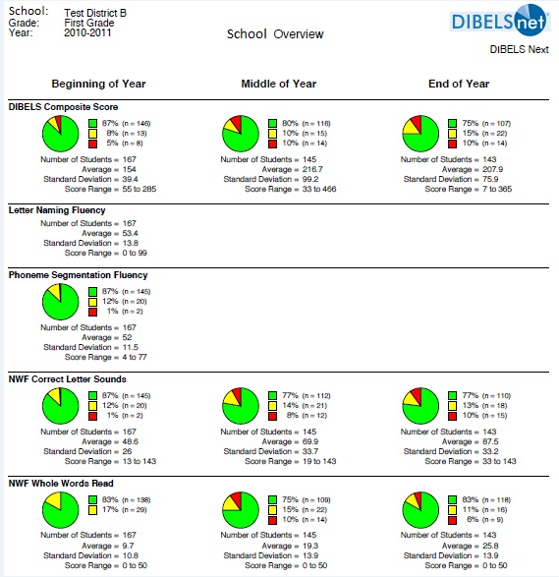

aimsweb Data System users:
Schools using aimsweb will be able to download the Tier Transition Report to determine the overall progress of the building.
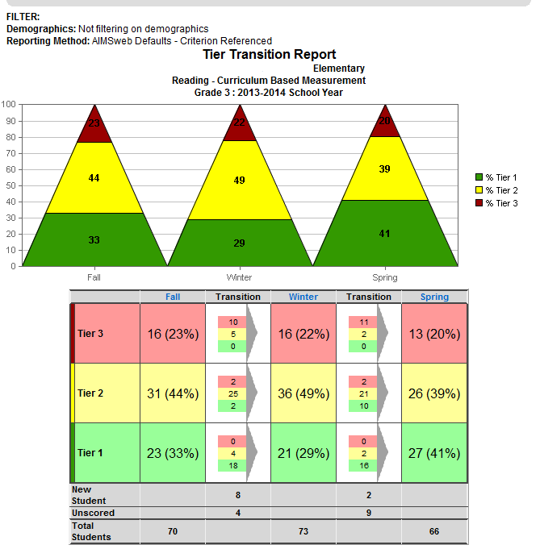
When using aimsweb Defaults (Criterion Referenced), teams will compute the grade level composite for each grade level. The Building Leadership Team will determine the percentage of students in each instructional recommendation category (i.e., Tier 1-Green, Tier 2-Yellow, Tier 3-Red). To determine the percentage of students in each instructional recommendation category, teams will need to:
- By category (Tier 1-Green, Tier 2-Yellow or Tier 3-Red), add the percent of students for all grade level subtests together.
- Divide by the number of subtests given for each grade level.
- Repeat first two steps for each category (Tier 1-Green, Tier 2-Yellow, Tier 3-Red).

The following table shows which subtests to use to determine the grade level composite for aimsweb, depending on the time of year and grade level.
Note: When first grade students have mastered PSF, their scores may drop between fall and winter once they begin reading (Farrell, Hancock, & Smartt, 2006).

aimsweb
Grade | Fall | Winter | Spring
Kdg | LNF | LNF; LSF; PSF; NWF | LNF; LSF; PSF; NWF
1st | LNF; LSF; PSF; NWF | PSF; NWF; R-CBM | NWF; R-CBM
2nd | R-CBM | R-CBM | R-CBM
3rd – 6th | R-CBM; MAZE | R-CBM; MAZE | R-CBM; MAZE
7th – HS | MAZE | MAZE | MAZE

The following is an example of how to compute a grade level composite for first grade using aimsweb data:
1st Grade (Fall) | Tier 1 | Tier 2 | Tier 3
LNF | 100% | 0% | 0%
LSF | 86% | 0% | 14%
PSF | 71.3% | 14.2% | 14.2%
NWF | 85.6% | 14.2% | 0%
Total Composite Score | 342.9%/4=85.7% | 28.4%/4=7.1% | 28.2%/4=7.0%
*Scores are displayed as decimals because rounding group percentages does not equal 100 percent.

The following is an example of how to compute a grade level composite for third grade using aimsweb data:
3rd Grade | Tier 1 | Tier 2 | Tier 3
R-CBM | 38% | 29% | 33%
MAZE | 26% | 42% | 32%
Total Composite Score | 64%/2= 32% | 71%/2=36% | 64%/2=32%

It is important that the Building Leadership Team understands the similarities and differences between the Tier Transition Report and the Instructional Recommendations Report (that will be used later in Steps 3 & 4). Information provided on the Tier Transition Report is more global in nature, while the Instructional Recommendations Report provides individual student scores in relation to specific benchmark scores also indicating the instructional level in which the individual scores fall (Tier 1-Green, Tier 2-Yellow, Tier 3-Red). Though similar, the total percent of students falling within a given tier may vary slightly between the two reports and is to be expected. The main point to remember is that the Tier Transition Report is a broad measure, and provides a “big picture” view of current status and improvement over time.

The Building Leadership Team must also understand the importance of setting instructional target and cut-scores according to the criteria established by the publishers of the specific assessment system (e.g., aimsweb, DIBELS) as each system uses well established criteria for placing students into Benchmark (Tier 1), Strategic (Tier 2), and Intensive (Tier 3) instructional recommendation categories. Setting instructional targets higher than the assessment system default cut-scores has not been proven to be an effective practice (Hasbrouck, 2010).

Once the grade level composite has been determined for each grade level, the percentages can be transferred to the Building Level Status Worksheet (Artifact A).

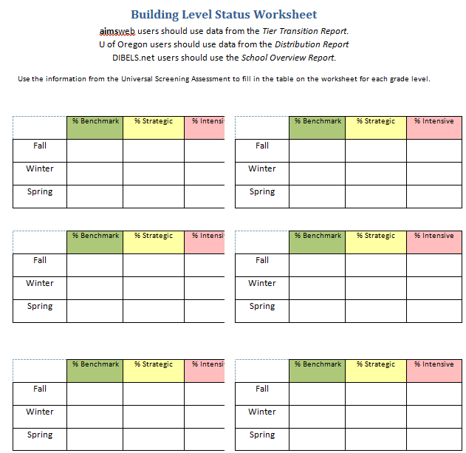

Building Leadership Teams should begin to evaluate beginning-of-year data and reflect on implications of the data for their upcoming year. To provide suggestions/recommendations to the district level team, buildings should not make changes based on limited data, but instead should look for patterns across time regarding effectiveness of curriculum, instruction, professional development decisions, and fidelity. Questions to consider when looking at building level data include:
- Are core instruction and the core curriculum being implemented with fidelity? How do we know?
- Is core instruction explicit, systematic, and scaffolded? How do we know?
- Is professional development or support needed with core curriculum or instruction? How do we know?
- Are there sufficient examples, explanations, and opportunities for practice to support new learning?
- Based on the strengths and needs of the students within this grade level, how is the core being differentiated?

When a building has a high percentage of students who fail to reach benchmark at a grade level, it may indicate problems within core instruction and curriculum. Even outstanding Strategic and Intensive interventions cannot serve to support students who are failing because of issues within the core curriculum. The issues with core instruction and curriculum should be addressed prior to focusing on new or additional interventions. In some buildings, the leadership team needs to consider the question “What is our core curriculum?” and ensure that staff members are in fact using that core curriculum. A review of the materials that teachers are expected to use at each grade level as a part of core curriculum may be necessary. Building Leadership Teams must be cautious about making changes to core curriculum based on limited data. The leadership team will need multiple data points and sufficient time to examine patterns across the grade levels before making significant adjustments to core curriculum and instruction.

The Building Leadership Team also must review any information that has been collected about the fidelity of implementation of the core curriculum. A lack of fidelity in teaching the core curriculum is a problem in many buildings, and it is one of the first things that should be addressed when trying to increase the number of students who are at benchmark with their reading skills. The Building Leadership Team will need to consider whether there are any needs for professional development within the building. It is important that there be clear two-way communication about grade level results and any issues related to core curriculum between the Building Leadership Team and the Grade Level Teams, and between the Building Leadership Team and the District Leadership Team.

Step 3: Analyze Grade Level Data

Building Leadership Team
Critical Components:
Who: Building Leadership Teams and Grade Level Teams
What: Grade Level Status Worksheet (Artifact C), Grade Level Need for Support Worksheet (Artifact B)
aimsweb: Instructional Recommendation (Criterion Referenced) and Tier Transition Report (Criterion-Referenced)
U of Oregon DIBELS users: Distribution Report (select Former Goals from Need for Support drop-down)
DIBELS.net DIBELS users: School Overview Report
When: After every Universal Screening
Where: Building Leadership Team and Grade Level Team meetings
Why: Determine overall progress
After every universal screening administration, the Building Leadership Team meets to review grade level reports showing the distribution of student scores. The purpose of these meetings is to determine whether each grade level has all the procedures in place so that implementation runs smoothly. Building Leadership Teams should look at student progress of the grade level as a whole, as well as the effectiveness of the procedures (Hall, 2008). Recommended assessment systems (e.g., aimsweb, DIBELS) will provide reports that use criteria established by those systems. U of Oregon DIBELS Next Distribution Report utilizes the Composite and categorizes need for support as Core, Strategic, and Intensive. DIBELS.net School Overview Report utilizes the Composite and categorizes need for support as Core, Strategic, and Intensive. aimsweb instructional recommendations are identified as Benchmark, Strategic, and Intensive. When using the aimsweb assessment system, scores should be reported based on criterion referenced information, using the aimsweb default scores for the system. When reviewing the effectiveness of the curriculum of each grade level, teams will identify the need for grade level support. On the Grade Level Need for Support Worksheet (Artifact B), provide a response to each question for each grade level.

It is important to recognize that students who are in the Strategic or Intensive categories will need additional instructional support. This can be provided through the use of differentiated instruction during core instruction and through intervention. This is a decision that the Building Leadership Team will make depending on the number of students needing intervention and the available resources.

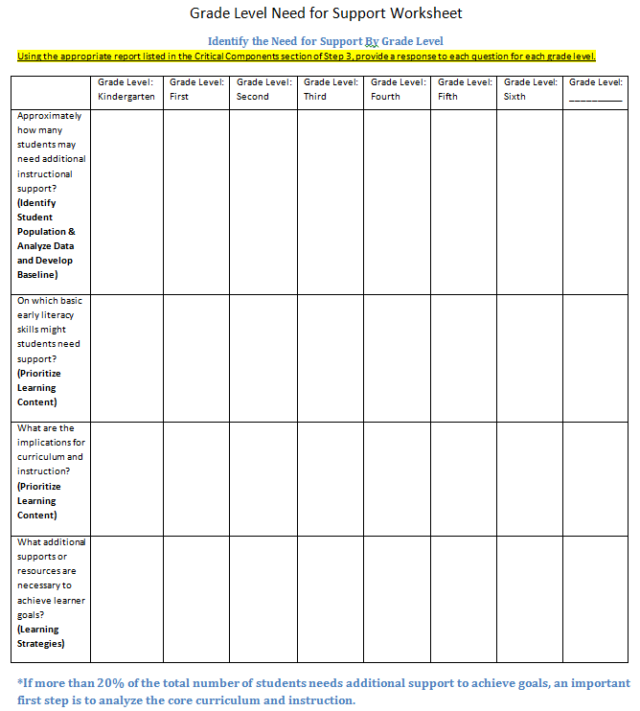

After every universal screening administration, the teams review and record grade level data on the Grade Level Status Worksheet (Artifact C). The distribution of the class level Composite for DIBELS Next users and the number of students from the Instructional Recommendation report for aimsweb users should be documented on the worksheet.
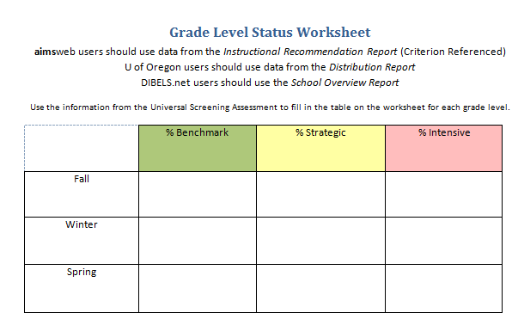

Step 4: Grade Level Goal Setting
Critical Components:
Who: Building Leadership Teams and Grade Level Teams
What:
aimsweb: Instructional Recommendation (Criterion Referenced), Grade Level Goal Setting Worksheet (Artifact D)
U of Oregon DIBELS users: Distribution Report (select Former Goals from Need for Support drop-down), Grade Level Goal Setting Worksheet (Artifact E)
DIBELS.net DIBELS users: School Overview Report (Artifact E)
When: After every Universal Screening
Where: Building Leadership Team and Grade Level Team meetings
Why: Set goals for literacy skills

When setting the grade level goal, teams should consider what they would want the previous grade level’s team to write. Keeping in mind the building level goals for each grade, grade level goal setting should not be done in isolation.
For each set of subsequent universal screening data, teams ask:
- Based on current progress, what should the goal for this academic year be?
- Is this goal realistic?
- Do we need to accelerate the rate of progress?
Using the Grade Level Goal Setting Worksheet (Artifact D/E), record the percent of students meeting benchmark for each subtest. Then, using the questions above set the goals for MOY and EOY and record on the Grade Level Goal Setting Worksheet (Artifact D/E).

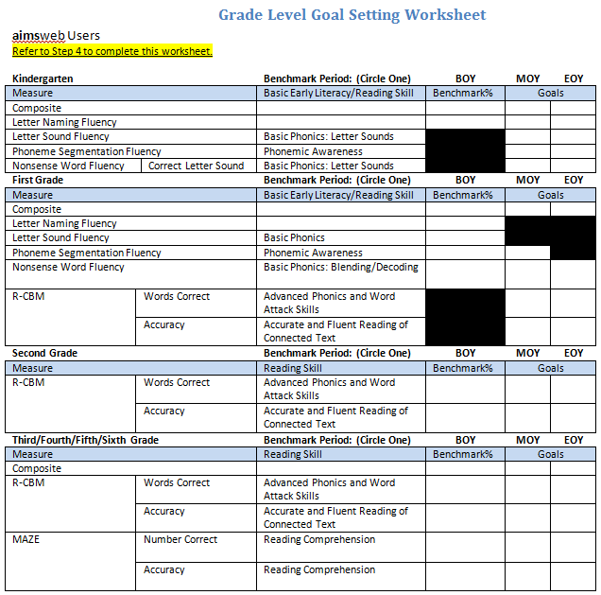

*Keeping in mind the EOY benchmark goals, grade level teams should compare the most recent scores to previous scores after MOY and EOY benchmarking periods. Teams must discuss how much each classroom should increase their overall student growth.

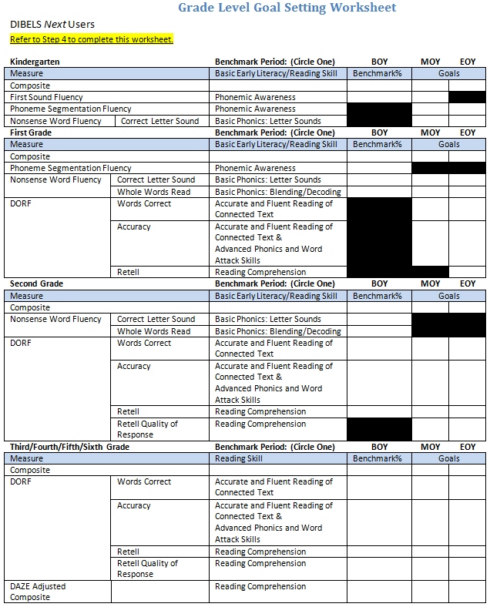

Step 5A: Planning for Support

Critical Components:
Who: Building Leadership Teams and Grade Level Teams
What: Student Level Support Worksheet (Artifact F)
aimsweb: Instructional Recommendation (Criterion Referenced)
U of Oregon DIBELS users: Class List Report (select Former Goals from Need for Support drop-down)
DIBELS.net DIBELS users: Classroom Report
When: After every Universal Screening
Where: Building Leadership Team and Grade Level Team meetings
Why: To improve Tier I instruction and provide appropriate interventions for students in Tiers II and III
The Instructional Recommendations Report (Criterion Referenced) for aimsweb users/Class List Report for U of Oregon DIBELS Next users/ Classroom Report for DIBELS.net users provides information on individual students at a given assessment period. These reports include all the students from one class. The grade level teams will review individual student scores on each measure (and on the composite score for DIBELS Next), as well as the likely need for support category (i.e. Needs Core, Strategic, or Intensive Support) for each student’s score on each subtest and on the composite.

Keeping in mind the goals for each grade level:
- What is the plan for achieving these goals?
- Does data provide evidence of sound core instruction in foundational literacy skills?
- Does data provide evidence that differentiated instruction is needed for some students in particular grade levels/classrooms?
- Does data provide evidence that targeted support in foundational literacy skills is needed for some students in particular grade levels/classrooms?
- When analyzing core instruction be sure to consider:
- Is a protected block of 90-120 minutes of uninterrupted core reading instruction given to all students every day?
- Do all teachers use the research –based scope and sequence and instructional strategies approved by the district? Do all teachers implement this with fidelity?
- Have all teachers been well trained in the use of the scope and sequence and instructional strategies? Does this include all teachers new to the district after adoption of the scope and sequence and instructional strategies?
- Is the majority of time spent in small, flexible, skill-based groups?
- Is screening data used to inform instructional groups?
- Is progress monitoring data used to inform changes in groups?
- Are grade level teachers afforded appropriate common planning times each week?

It’s important to note that when system-wide changes are made in regards to curriculum, instruction and levels of support, the number of students making gains in a single year will be higher. In general, gains are greater when larger numbers of students are below the benchmark, and when preventative support occurs in earlier grades.
Using student names, respond to the questions on the Student Level Support Worksheet (Artifact F).

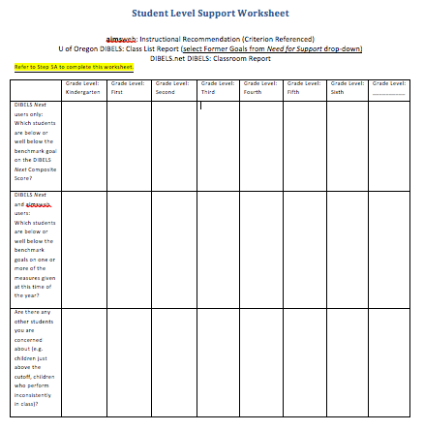

Step 5B: Evaluating the Effectiveness of Instructional Support (to be completed after MOY and EOY benchmarking periods)
Critical Components:
Who: Building Leadership Teams and Grade Level Teams
What: Support Effectiveness Worksheet (Artifact G/H)
aimsweb: Summary of Impact Report
U of Oregon DIBELS users: Summary of Effectiveness Report (select Former Goals from Need for Support drop-down)
DIBELS.net DIBELS users: Effectiveness of Instructional Support Levels Report
When: After middle of the year and end of the year Universal Screening
Where: Building Leadership Team and Grade Level Team meetings
Why: To improve Tier I instruction and provide appropriate interventions for students in Tiers II and III
As subsequent universal screening data has been collected, the Grade Level Teams do an analysis to determine whether instructional support is effective. An analysis of the instructional effectiveness can help determine whether individual students are making sufficient progress and judge the effectiveness of all levels of support.
The Leadership Team will analyze the aimsweb Summary of Impact Report/U of Oregon Summary of Effectiveness Report (select Former Goals from Need for Support drop-down)/DIBELS.net Effectiveness of Instructional Support Levels Report. This report provides details about the proportion of students at/above, below, and well below the benchmark at MOY or EOY by level of support. NOTE: This report only contains data for students who are in school for the entire year this far.
U of Oregon DIBELS Data System users: The Summary of Effectiveness Report provided by U of Oregon (select Former Goals from Need for Support drop-down) shows how many students stayed the same or moved to a score at or above target.
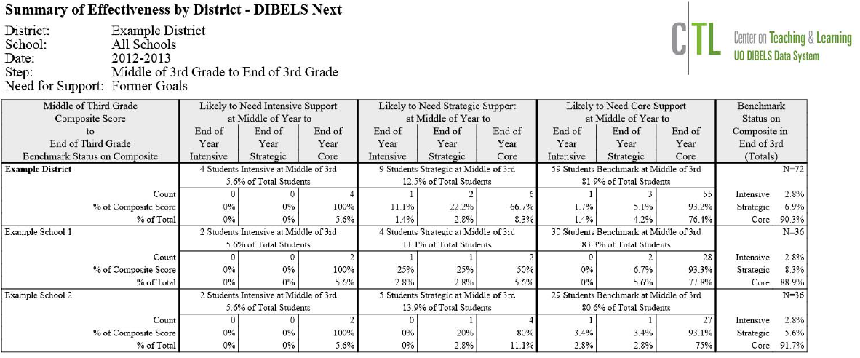
DIBELS.net DIBELS Data System users: The Effectiveness of Instructional Support Levels Report provided by DIBELS.net shows how many students stay the same or moved to a score at or above target.
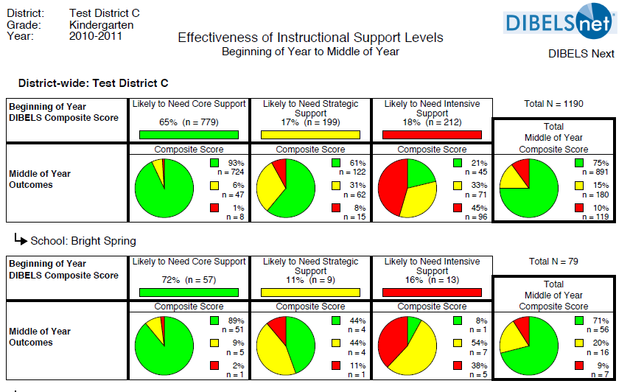
aimsweb Data System users: The Summary of Impact Report provided by aimsweb indicates which students in Benchmark, Strategic, or Intensive support have reached the benchmark target for a selected benchmark period and measure. These students are marked with a checkmark or a smiley face.
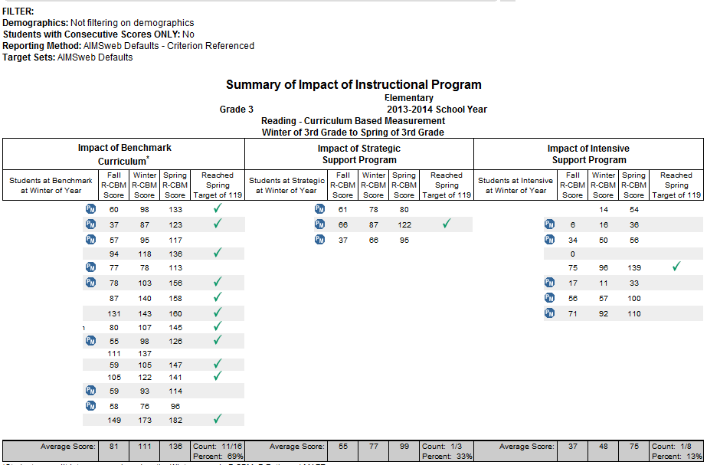
In order to determine how effective each level of support is in meeting the needs of students, use the data from the Instructional Recommendation Report for aimsweb users/Distribution Report for U of Oregon DIBELS Next users/School Overview Report for DIBELS.net users, to complete the Support Effectiveness Worksheet (Artifact G/H).

When reviewing instructional effectiveness, the big questions are always:
Is the core curriculum and instruction supporting enough students to meet the benchmark goal?

Are the Strategic and Intensive supports providing students what they need in order to achieve adequate progress to close the gap?
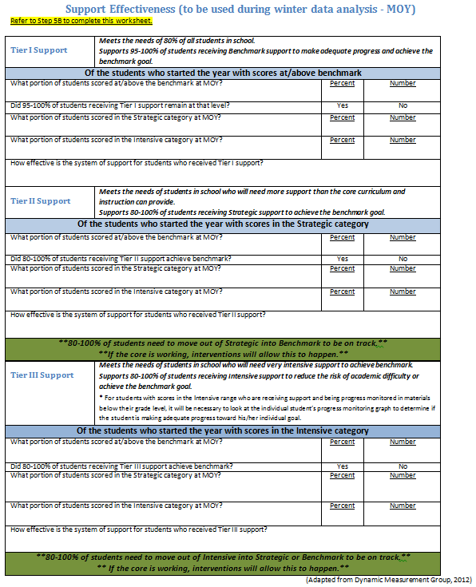

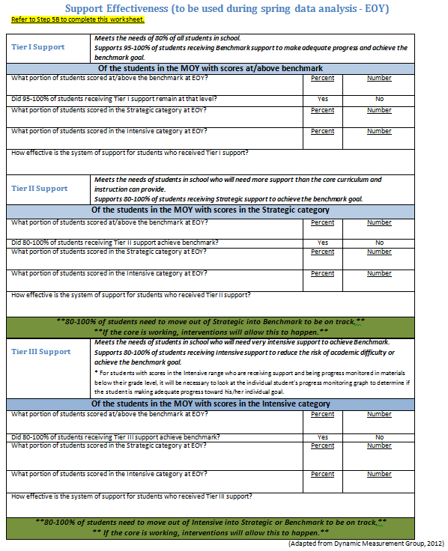

Step 6: Analyze Student Level Data Using the Initial Instructional Sort
Critical Components:
Who: Grade Level Teams
What:
aimsweb: Class Distribution Report by Score and Percentile (change Reporting Method to Criterion to yield Class Distribution by Scores and Level Report); aimsweb Initial Instructional Sort Worksheet (Artifact I)
U of Oregon DIBELS users: Class List Report (select Former Goals from Need for Support drop-down) and all available individual student response data; DIBELS Next Instructional Grouping Suggestions Worksheets
DIBELS.net DIBELS users: Initial Grouping Suggestions Report
When: After every Universal Screening
Where: Grade Level Team meetings
Why: Use screening data to conduct the initial sorting of students into groups using accuracy and fluency scores

Grouping students according to instructional recommendations is not enough because these recommendations only indicate the level of support students require for success. Grade Level Teams must also determine the skill focus for instruction.
Students are initially grouped for all assessments using the accuracy and fluency data from the universal screening assessment. A four group instructional grouping worksheet, such as the generic one illustrated below, is used to provide a reasonable and practical way to organize data into four groups to determine the instructional focus for each student.
Group 1: Accurate and Fluent | Group 2: Accurate but Not Fluent
Group 3: Inaccurate and Not Fluent | Group 4: Inaccurate but Fluent

  - Important Consideration when reviewing initial grouping suggestions:
Using the results of the initial group sort, the Collaborative Team should consider whether the data indicate the need to implement a class-wide intervention. The MTSS Core Team recommends any teacher who has a class with more than 40% of the students scoring in a single group (Groups 2, 3, or 4) needs to deliver additional intervention as a class-wide intervention during core instruction. Trying to deliver the same intervention to more than 40% of a class puts too much strain on a system and is an inefficient use of resources. If additional support is needed to provide a class-wide intervention, the Collaborative Team should communicate those needs to the Building Leadership Team. If a building consistently has a large percentage of students in Group 2 or 3, year after year, it may be appropriate to examine the core curriculum.

When grouping students for reading, it is essential to consider the most significant skill indicator associated with the grade level and the time of year the assessment is given. The following charts reflect the most significant indicator at various grade levels for beginning the grouping process.
aimsweb Grouping Indicators for Reading
 | Kindergarten | 1st Grade | 2nd – 6th Grades | 7th – 12th  Grades
Fall | Letter Naming Fluency (LNF) for Alphabet Knowledge | Nonsense Word Fluency  (NWF) or  Phoneme Segmentation  (PSF) | Reading Curriculum Based  Measurement (R-CBM) | MAZE
Winter | Phoneme Segmentation  Fluency (PSF) | Nonsense Word Fluency  (NWF) | Reading Curriculum Based  Measurement (R-CBM) | MAZE
Spring | Phoneme Segmentation  Fluency (PSF) | Reading Curriculum Based  Measurement (R-CBM) | Reading Curriculum Based  Measurement (R-CBM) | MAZE

DIBELS Grouping Indicators for Reading
 | Kindergarten | 1st Grade | 2nd | 3rd-– 6th Grades | 3rd – 6th  Grades | 7th-9th  Grades
Fall | First Sound Fluency (FSF) | Phoneme Segmentation  (PSF) and Nonsense Word Fluency  (NWF-CLS) | Oral Reading Fluency (DORF-Words Correct) and Nonsense Word Fluency  (NWF-WWR) | Oral Reading Fluency (DORF-Words Correct and DORF-Accuracy) | DAZE | CARI  *to be determined upon final release
Winter | Phoneme Segmentation  Fluency (PSF) and Nonsense Word Fluency  (NWF-CLS) | Oral Reading Fluency (DORF-Words Correct) and Nonsense Word Fluency  (NWF-WWR) | Oral Reading Fluency (DORF-Words Correct and DORF-Accuracy) | Oral Reading Fluency (DORF-Words Correct and DORF-Accuracy) | DAZE | CARI  *to be determined upon final release
Spring | Phoneme Segmentation  Fluency (PSF) and Nonsense Word Fluency  (NWF-CLS) | Oral Reading Fluency (DORF-Words Correct) and Nonsense Word Fluency  (NWF-WWR) | Oral Reading Fluency (DORF-Words Correct and DORF-Accuracy) | Oral Reading Fluency (DORF-Words Correct and DORF-Accuracy) | DAZE | CARI  *to be determined upon final release

aimsweb Data System users: using the Class Distribution Report by Score and Percentile Report complete the aimsweb Initial Instructional Sort Worksheets (Artifact I) by entering the student names, score, and accuracy percentage in the appropriate group.

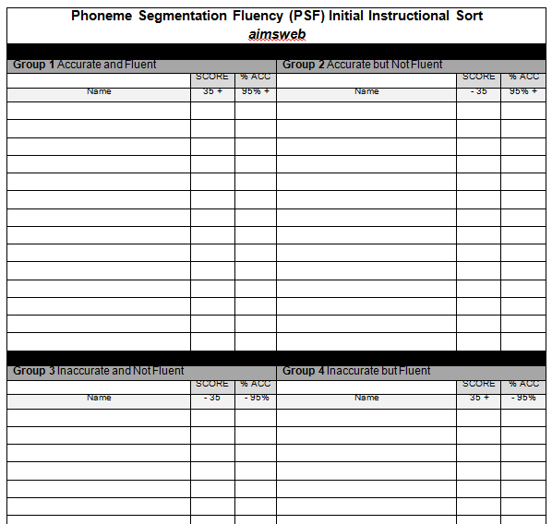
Use the Instructional Focus Documents (Artifact J) to determine the instructional focus.

U of Oregon DIBELS Data System users: using the Class List Report complete the Initial Instructional Grouping Suggestions Worksheets by following instructions that accompany the worksheets. Grouping Suggestions Worksheets can be obtained from a DIBELS mentor.
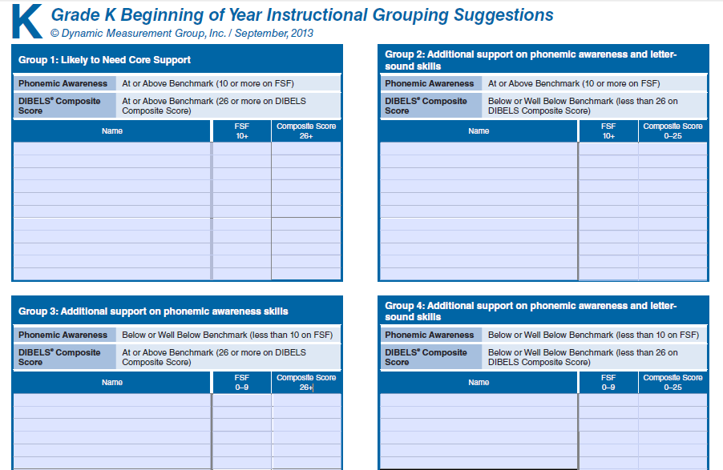
DIBELS.net users: print the Initial Grouping Suggestions Report.
  - 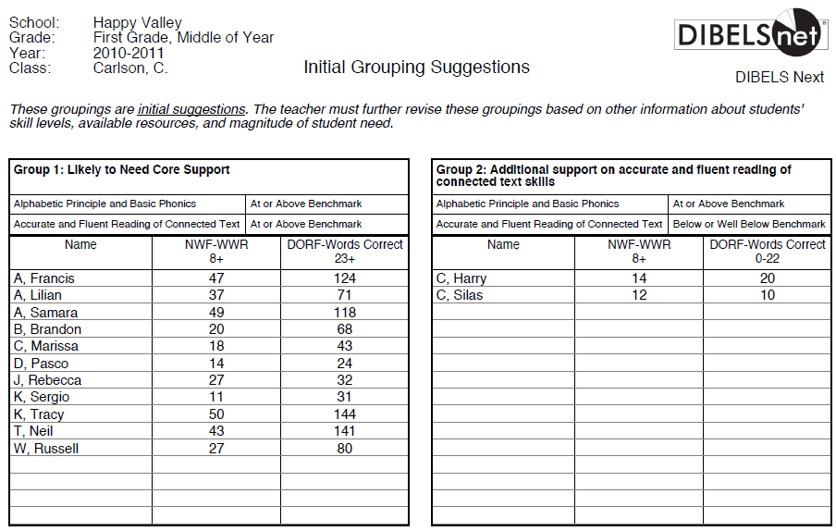
Step 7: Determine What Additional Information Is Needed and Complete Diagnostic Process
Critical Components:
Who: Grade Level Teams
What:
aimsweb: aimsweb Initial Instructional Sort Worksheet (Artifact I), aimsweb Instructional Focus Documents (Artifact J)
U of Oregon DIBELS users: DIBELS Next Instructional Grouping Suggestions Worksheets
DIBELS.net DIBELS users: Initial Grouping Suggestions Report
When: After every Universal Screening
Where: Grade Level Team meetings
Why: To assess skill needs prior to determining placement in skill based groups

Once the initial instructional sort has been completed, the diagnostic process begins. aimsweb users begin with the aimsweb Instructional Focus Documents(Artifact J) for each subtest to determine the instructional focus for each group on the aimsweb Initial Instructional Sort Worksheet (Artifact I). DIBELS Next users, the instructional focus has been determined for each group on the Grouping Suggestions Worksheet.
If the Grade Level Team is not able to determine appropriate instructional focus based on the Instructional Focus or the Grouping Suggestions, a detailed error analysis should be completed. Additionally, based on the number of skill deficits for students in Groups 3 and 4, additional diagnostic assessment may need to be given. These students should be given a phonological awareness assessment, phonics assessment, or possibly both to determine their instructional needs. These assessments are based on skills continuums. “Using phonological awareness and phonics continuums allows teachers to see that students need to master skills in a predetermined order. Whenever a student struggles with a skill that is assumed to be mastered at a set grade level, intervention is needed (Hall, 2011).
When choosing a diagnostic assessment to asses phonological awareness skills, take care to ensure the assessment measures the following components: words in a sentence, syllables, onset-rime, rhyming, phonemes: deletion, addition, substitution, blending, segmentation, isolation, identity, and categorization. If a diagnostic assessment isn’t immediately available, the following phonological awareness tests are available in the CORE Assessing Reading Multiple Measures, Second Edition: CORE Phoneme Deletion Test and CORE Phonological Segmentation Test.
When choosing a diagnostic assessment to assess phonics skills, take care to ensure the assessment measures the following components: letter sound correspondences, CVC words, consonant diagraphs, consonant blends, long vowel silent-e, predictable vowel teams, unpredictable vowel teams, vowel-r, trigraphs, silent letters, and multisyllabic words. If a diagnostic assessment isn’t immediately available, the CORE Phonics Survey is available in the CORE Assessing Reading Multiple Measures, Second Edition.
Students should be placed in an intervention group that addresses the lowest skill not yet mastered, but expected to be mastered for the student’s grade level. Mastery will be outlined within assessment guidelines. Once the student masters that skill, then the student will be taught the next skill that was missed on the continuum. This provides a seamless process from the skills continuum through the assessment scores to the instructional focus for grouping.
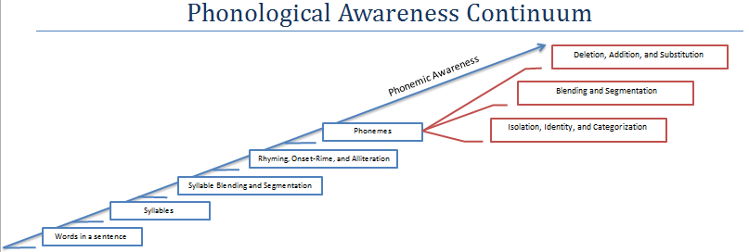

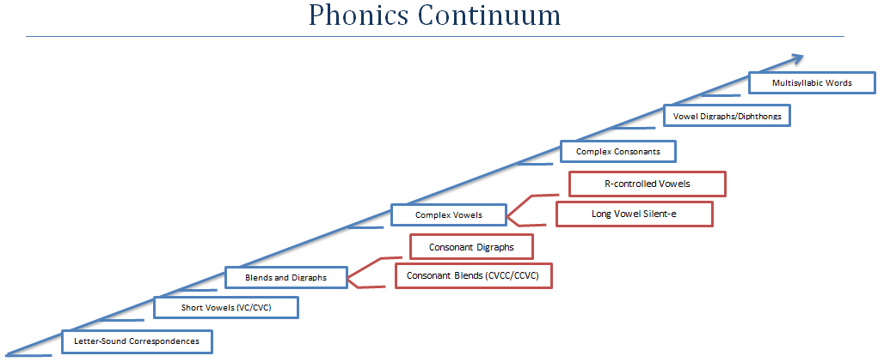

Step 8: Finalize Groupings by Determining Instructional Focus and Appropriate Materials
Critical Components:
Who: Grade Level Teams
What: Student Monitoring Form (Artifact P)
aimsweb: aimsweb Initial Instructional Sort Worksheet (Artifact I), Final Reading Student Grouping Worksheet (Artifact M/N/O)
U of Oregon DIBELS users: DIBELS Next Instructional Grouping Suggestions Worksheets
DIBELS.net DIBELS users: Initial Grouping Suggestions Report
When: After every Universal Screening
Where: Grade Level Team meetings
Why: Determine the focus of instruction for each group

After the initial grouping has been completed, groups will need to be finalized to ensure there is a match between the student’s needs and the student’s instructional level of strategic or intensive support to be provided. Also, the instructional focus of each group should be revisited to ensure that the planned intervention is aligned with the identified student needs for that group. Whenever universal screening is conducted, it is essential to revisit and refine the alignment of student needs with the levels of intervention intensity and the instructional focus of the groupings.
In terms of providing instruction, it is critical to have a good match between the knowledge of the instructors and the interventions they will teach. Grade Level Teams will make some decisions about this match based on guidance from the Building Leadership Team. Therefore, it is important to know the strengths and professional development needs of instructional providers (e.g. certified, noncertified). For example, some teachers are confident teaching advanced phonics, while others are more comfortable teaching reading comprehension. Building Leadership Teams need to consider how staff can best be used to teach intervention groups. The Building Leadership Team should plan to provide all necessary appropriate professional development to ensure that instructional staff members have the necessary skills to provide reading instruction. Instructional effectiveness depends on the use of strong research-based instruction and staff training to provide the intervention.

The most successful groupings and progress occur when specific student skill deficits are pinpointed and aligned with the appropriate instruction. Whenever universal screening is conducted, it is essential to revisit and refine the alignment of student needs with the levels of intervention intensity and the instructional focus of the groupings.

When using purchased programs, it is imperative for teachers to know how and when to use them. For students in need of Tier II interventions, it is important that the lessons contained within a program are labeled according to the skills taught and that the teacher has the flexibility to use some lessons without having to teach all lessons in a sequential manner. For groups that have gaps in their knowledge, using lessons that teach only what is missing is more effective for the students. Failure to use the data to inform instruction –placing all groups at the beginning of an interventions program and teaching every lesson-is inconsistent with the meaning of differentiated instruction (Hall, 2012).

The area that is most challenging to develop teacher-designed lessons is phonics. It is possible to design intervention lessons in phonics, but teachers need a deep knowledge to link the development of sound-letter correspondence with practice at the word and text level. The presentation of letter-sound correspondence must be systematic, and the words and books students use for applying their letter-sound knowledge must be well correlated to the sequence. Therefore, most schools choose to use a structured program for intervention lessons focused on phonics. The money invested in purchasing a good program for phonics is well spent (Hall, 2012).

Interventions should always start at the lowest skill deficit. These skills must be addressed before moving on to skills that are higher up on the continuum. For example: Students must be able to accurately read the words on the page before instruction in fluency building is addressed.

Final Student Grouping
The Final Reading Student Grouping Worksheets (Artifact M/N/O) are used to finalize intervention groups, document instructional focus of the group, and determine which progress monitoring tool to be used.

Using the Initial Instructional Sort Worksheets (Artifact I)/ DIBELS Next Instructional Grouping Suggestions Worksheets/ Initial Grouping Suggestions Report, regroup within each quadrant to ensure intervention groups are of suitable size and instruction is appropriately aligned to student need. Record the names of these students in the appropriate place on the Final Reading Student Grouping Worksheets (Artifact M/N/O).

Refer again to the Instructional Focus Documents (Artifact J) to refine the instructional focus for each intervention group, and document on the Final Reading Student Grouping Worksheets (Artifact M/N/O).

Finally, in order to ensure progress monitoring is appropriate; take care to ensure that progress monitoring matches the instructional focus for the subgroup. Step 9 will help determine which progress monitoring tool to use.

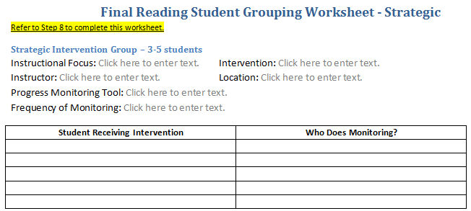

Individual Student Monitoring
One of the most common ways of keeping data visible is to transfer individual student assessment information to a student data monitoring form like the one shown below.
The individual Student Monitoring Form (Artifact P) should be used to ensure students are making appropriate progress. At a minimum, a separate Student Monitoring Form should be completed for each student receiving Strategic or Intensive intervention. Individual student information to be included: DIBELS Next or aimsweb screening information, along with the target scores for each subtest administered, diagnostic results, student skill deficits or areas of weakness, instructional focus, as well as progress monitoring information. When displaying data, it is always important to ensure that student confidentiality is protected.
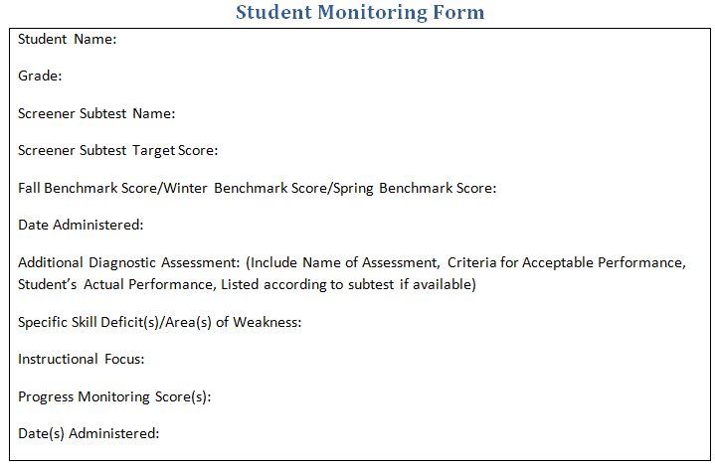

Step 9: Prepare for Progress Monitoring
Critical Components:
Who: Grade Level Teams
What: Student Progress Monitoring Reports, Student Monitoring Form (Artifact P), Intervention Documentation Worksheet (Artifact Q)
When: After every Universal Screening (and continues on an as-needed basis as instructional focus changes)
Where: Grade Level Team meetings
Why: Identify the appropriate aimsweb/DIBELS subtests that match the focus of instruction of the intervention
“Often principals try to alleviate the stress level of teachers by postponing progress monitoring. However, by postponing progress monitoring you will lose the data that motivate teachers to keep going because progress monitoring documents the improvements that students are making” (Hall, 2011 p. 3). Ongoing progress monitoring is essential for students receiving interventions to ensure that the interventions are working. Data from progress monitoring track how the student is responding to the intervention; without these data, instruction is just a best guess. The Building Leadership Team will determine the frequency of progress monitoring data collection and review for the building. When determining the frequency of progress monitoring data collection, it is important to consider (a) how quickly students typically learn the skills that are the focus of instruction and (b) how frequently the Collaborative Teams will meet to review progress monitoring data for instructional adjustments based on the decision rules of the system. The frequency of progress monitoring is influenced by how quickly instructional adjustments can be made. The recommended frequency of progress monitoring within the South Dakota MTSS framework is every other week for students receiving Strategic (Tier 2) instruction and weekly for students receiving Intensive (Tier 3) instruction.
Progress monitoring of students in intervention is critical to ensure appropriately targeted instruction leading to student growth. Students who have teachers that monitor progress regularly, and use the data to make instructional decisions, demonstrate more academic progress than students whose teachers do not monitor progress. Teachers' accuracy in judging student progress increases when progress monitoring is used consistently (Stecker & Fuchs, 2000). It is through frequent progress monitoring that the ultimate goal of returning students to less intensive instruction as soon as possible can be achieved.

The Building Leadership Team needs to train Grade Level Teams to measure student growth in several ways. Progress monitoring of students in intervention measures (a) whether growth is occurring for those students and (b) whether sufficient growth is being obtained for the students to close the achievement gap. The results will be graphed and the charts used for instructional decision making.

Some curricular materials contain measures for assessing student growth that are frequently labeled progress monitoring measures. However, these measures are actually pre- and post-assessments in that they reflect whether students are learning the skills taught by that program. They do not measure whether students are improving in all the critical skills that are measured by an integrated screening and progress monitoring data system. Progress monitoring using CBM measures can provide information about the effectiveness of the curriculum, whether students in intervention are closing the achievement gap with their grade level peers, and whether instruction needs to be adjusted. The tools recommended for progress monitoring include the CBM assessments from the universal screener that was originally used to identify students requiring interventions (Torgesen, 2006).

The subtest chosen for progress monitoring must be able to measure the skills being taught in the intervention provided to a student. If the assessment tests a skill other than the one being taught, it is not possible to accurately determine student progress. Progress monitoring the appropriate skill for the student’s instructional group will provide information regarding whether the instruction and materials are effectively enabling the student to make progress.
As part of progress monitoring for intervention, using the table below, the Grade Level Teams will identify the appropriate aimsweb/DIBELS Next subtests that match the focus of instruction of the intervention. Using this fluency/accuracy progress monitoring information allows the Grade Level Teams to make decisions as quickly as necessary.
Matching Progress Monitoring to the Focus of Instruction
Screening Measure | Basic Early Literacy Skill | Focus of Instruction
Letter Naming Fluency (LNF) | Not a basic early literacy skill | Alphabet Knowledge
First Sound Fluency (FSF) | Phonemic Awareness | Phoneme Isolation  Onset/Rime
Phoneme Segmentation Fluency (PSF) | Phonemic Awareness | Phoneme Segmentation
Nonsense Word Fluency (NWF) | Alphabetic Principle  Basic Phonics | Short Vowels
Oral Reading Fluency Passages (DORF/R-CBM)  (Accuracy Percentages) | Advanced Phonics  Word Attack Skills  Accurate Reading of Connected Text | Accuracy  (Advanced Phonics and Word Attack Skills)
Oral Reading Fluency Passages (WCPM) (DORF/R-CBM)  (Accuracy Percentages) | Fluent Reading of Connected Text  Reading Comprehension | Read at a conversational rate with a high degree of accuracy
Daze/MAZE Passages | Reading Comprehension | Comprehension

In addition, it is important for the members of the Building Leadership Team to establish and review procedures for collecting data with fidelity. Building Leadership Team members need to continually ask “How do we know?”
Any changes to an intervention should be based on the results of the progress monitoring data and documented. Both the progress monitoring graph and the intervention log should be used to document this information.
To ensure that progress monitoring data are being collected and used as planned and to aid in instructional decision making in the future, it is important to graph the data to chart the growth of individual students. Progress monitoring at this level answers two questions:
- Is the instructional intervention working?
- Does the effectiveness of the intervention warrant continued, increased, or decreased support?
The Grade Level Teams should follow the rules regarding frequency of data collection and data review determined by the South Dakota MTSS Manual. The decision rules of the system include, for example, to progress monitor students in Tier 2 every other week, and weekly for students in Tier 3.
The graphed progress monitoring data found within the DIBELS and aimsweb systems provide teachers with the information necessary to adjust instruction and instructional groups. After returning a student to less intensive instruction, progress continues to be monitored in case a need reemerges for additional supports.
Maintaining an Intervention Documentation Worksheet (Artifact Q) is critical for tracking a student’s progress in intervention. An Intervention Documentation Worksheet should be completed for each student receiving strategic or intensive interventions. Any changes made to the intervention should be based on the results of the progress monitoring data and documented on this worksheet each time they are made. This information should also be documented on the progress monitoring graph and the Student Monitoring Form (Artifact P). In addition, it is essential to continue to track the interventions that are being delivered to students.

Step 10: Determine the Instructional Level for Off Grade Level Progress Monitoring
Critical Components:
Who: Grade Level Teams
What:
aimsweb: Back Testing Worksheet (Artifact R), Progress Monitoring Probes
U of Oregon DIBELS users: DIBELS Next Survey
DIBELS.net DIBELS users: DIBELS Next Survey
When: After every Universal Screening
Where: Grade Level Team meetings
Why: Determine the focus of instruction for each group
Progress monitoring a student at the appropriate level of difficulty for oral reading fluency is critical to determine whether the correct intervention is being provided.
If a student is performing close to grade level, then the progress monitoring materials used should be at grade level. Students performing in the Well Below Benchmark/Intensive range during benchmark assessment should be back tested to determine the appropriate level of progress monitoring.
REMINDER: If more than 20% of the total number of students needs additional support to achieve goals, an important first step is to analyze the core curriculum and instruction for that classroom. Resources should be used to reinforce Tier I curriculum and instruction. Trying to deliver targeted small group interventions to more than 20% of a class puts too much strain on a system and is an inefficient use of resources.

Back Testing
For students identified as needing Intensive support on R-CBM, it is advised to back test to determine the appropriate level of progress monitoring.
DIBELS Next users should administer the DIBELS Next Survey according to manual instructions.
aimsweb Data System users: use the Back Testing Worksheet (Artifact R) and follow directions below to determine appropriate level of progress monitoring.
- If the student score falls at or below the listed WCPM score for a particular grade level at a particular time of year, that student will be back tested.
- Using progress monitoring probes, test down one grade level at a time beginning with the grade level immediately below the student’s current grade level. (Make sure to administer three progress monitoring probes for each student, and use the median score when making the determination whether or not to continue back testing.)
- Continue back testing until the student’s median score reaches the grade level end of the year benchmark and the student has met the accuracy percentage for that grade level.
- Once the student has reached end of the year benchmark at a particular grade level, the student will be progress monitored at one grade level higher.
- Once the student reaches grade level (8th grade for high school), continue to progress monitor at grade level until the end of the year benchmark and accuracy are reached for the student’s grade level.
- In some instances, back testing with some students may need to continue through NWF and PSF in order to determine the appropriate level of progress monitoring.
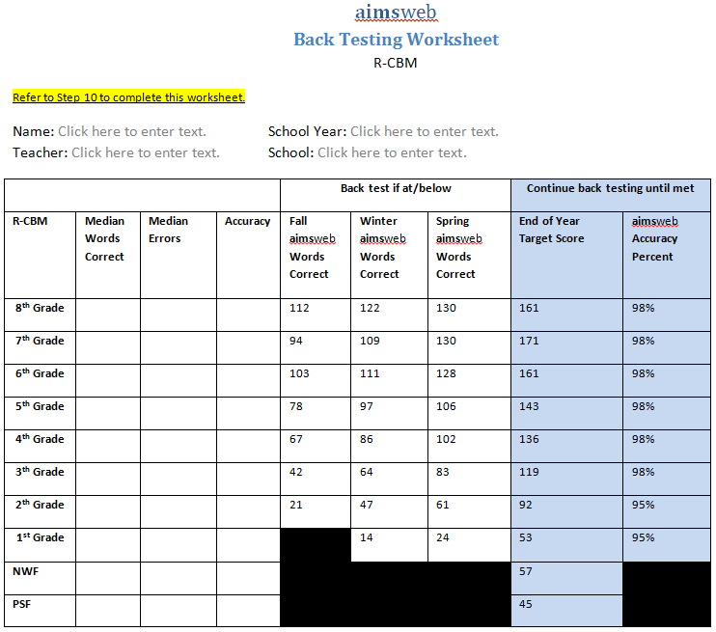

Step 11: Review Progress Monitoring Data For Instructional Decision-Making
Critical Components:
Who: Building Leadership Teams and Grade Level Teams
What: Individual Student Progress Monitoring Charts, Intervention Documentation Worksheet (Artifact Q), Research Based Instructional Practices (Artifact S), Problem Solving Worksheet (Artifact T)
When: As determined by frequency of Grade Level Team meetings
Where: Grade Level Team meetings
Why: Ensure that appropriate instructional adjustments are made in a timely manner dependent on student response to the intervention being provided

Before informed decisions can be made regarding whether students receiving interventions are making progress, it is important for the Building Leadership Team to review any issues that may be affecting the validity of the progress monitoring data. These issues were initially discussed in Step 9, and include whether the directions of the test administration were followed, if shadow scoring was used, the level of training of the staff, and whether time recommendations of the assessment were being followed.
At the same time that the Building Leadership Team is supporting the Grade Level Teams in determining whether individual students receiving interventions are making progress, the leadership team also needs to consider whether any patterns or trends can be seen across all the progress monitoring results. If most students are making progress and they are making sufficient progress, then all staff members can celebrate how well the system is succeeding. However, if many students are not making progress, then the leadership team needs to consider the effectiveness of the interventions and what might be changed to enhance their effectiveness.
As soon as progress monitoring data are collected, the information should be added to each student’s Intervention Documentation Worksheet (Artifact Q). It is important for each Grade Level Team to establish a regular routine for examining progress monitoring graphs for accuracy. The team will look to confirm that:
- The correct skills were progress monitored at the correct level.
- Sufficient data have been collected to make decisions according to the established decision rules.
- The data were correctly graphed.
Looking for and thinking about these issues provides a basic fidelity check of the process and helps ensure that decisions about instructional adjustments are accurate.
The Grade Level Teams will need to determine whether individual students receiving intervention are making progress or whether adjustments are needed to the intervention instruction. This decision is made by reviewing the data point on the progress monitoring charts and following the decision rules described below. In the examples below, a 3-data-point decision rule is used.

Three or More Consecutive Data Points Above Aim-Line.
Once a student has at least six data points to establish a trend, examine the last three consecutive scores to determine instructional success. If a student has three or more data points consecutively on or above the aim-line, the intervention is having a positive impact and progress is being made. The intervention needs to continue until the student meets these criteria. The Grade Level Teams will need to ensure that the decision rule is followed. Once the criteria for the decision rule are met, options include:
- Regroup to work on another intervention skill.
- Exit the Strategic intervention and continue core with periodic progress monitoring.

Three or More Consecutive Data Points Below the Aim-Line.
Once a student has at least six data points to establish a trend, examine the last three consecutive scores to determine instructional success. If three or more consecutive data points are below the aim-line, an adjustment to the intervention is needed. Many things can influence whether a student makes progress, so it is important to have a systemic process for analyzing the cause, starting with the most basic and easiest adjustment.

How to Adjust an Intervention
In analyzing lack of progress, the team must look into each of the following adjustments in sequence:
- First check to ensure that the skill being progress monitored is the same as the instructional focus (what is being taught).
- If the skill and the progress monitoring measure are consistent, check fidelity of instruction.
- If both the previous are happening, next consider increasing the pace of instruction. Often teachers respond to the student having difficulty in learning by slowing the pace of instruction, when in fact they need to increase it. Slowing the pace of instruction can result in lower levels of student attention and motivation, while a faster pace can keep students engaged. The pace of instruction is related to the number of student-teacher interactions per minute. For Intensive intervention with groups of three or fewer, students should be expected to provide five correct response per minute (via choral or individual responses).
- Next, consider modifying the pace of intervention. For example, the pace of intervention can be slowed by reducing the number of new skills introduced each week. If new skills are being introduced at the rate of five per week, consider introducing only 3 per week and providing a greater amount of practice on each skill before moving to the next skill.
- Ensure that the programs align. Teams need to make sure that vocabulary is used the same way in both core and interventions. Consider moving the student to a different group with a different instructional focus.
- Adjust the instructional materials. Examples include:
  - Add manipulatives
  - Use decodable text until ready for authentic text
  - Change the intervention program
- Move the student to a different intervention group.

Sufficient Progress – Continue the Intervention
The analysis of progress monitoring data is a two-step process:
- Determine whether the student is making progress and
- Determine whether the rate of growth is sufficient to close the achievement gap.
The most valid means of defining progress is through analysis of slope and level (Fuchs & Deschler, 2007). When analyzing slope, the team determines whether the student is making progress by comparing the student’s current level of performance to the identified goal. When looking at level, the team is determining whether the student’s progress is sufficient to close the achievement gap by comparing the student’s current performance to the final desired level of performance, which is typically the grade level benchmark. Thus, the analysis involves two steps:
- Determine whether progress is being achieved (slope) and
- Determine whether the achievement gap is closing (level).
The ultimate goal for students in intervention is to close the achievement gap between where the student is currently performing and the grade level performance of peers. The chart of a student who is closing the gap will show a trend line that will intersect with the goal line before then end of the year (or other monitoring period of time).
The graph below shows an example of growth in performance and growth rate by displaying a positive response by level and slope. The Tier 2 intervention is working for this student and by continuing the intervention the student should reach the benchmark goal by the end of the year.
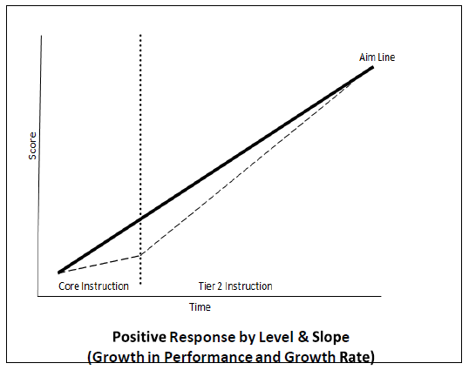

Insufficient Progress – Intensify the Intervention
The graph below shows student performance as a line parallel to but below the aim-line, meaning the student is improving, but at a rate that is insufficient to close the achievement gap with peers.
When the team determines the student is showing growth, but at an insufficient rate to close the achievement gap, then the team needs to determine how to increase the intensity of the current instruction.
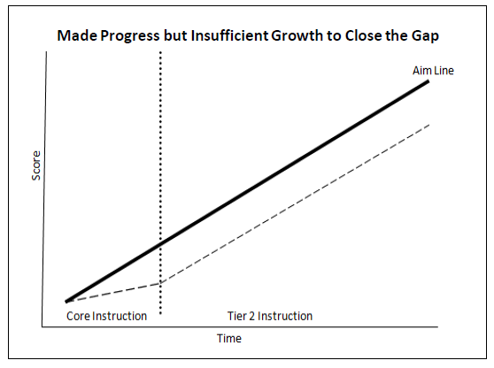

How to Intensify Instruction
- Increase the number of student responses in a minute by reducing group size.
- Increase the number of questions and error corrections the student receives in a minute.
- Increase the scaffolding by breaking the task down more or providing more structure so that the student can succeed.
- Spend more time modeling the “I do” and “We do” guided practice before the student practices independently.
- Increase the number of repetition cycles on each skill before moving on to determine whether mastery is achieved with more practice.
- Use a more systematic curriculum so that skills are taught in a prescribed manner, with the teacher asking questions and cueing with the same language for each routine.
(Hall, 2008)
What to Do if a Student Is Not Making Progress – Use Problem-Solving to Customize the Intervention
When a student receiving intervention fails to show progress, teams should consider issues related to the instruction, curriculum, environment and the learner when reviewing student progress monitoring data. The chart below lists research-based instructional practices (Artifact S) that offer a way for teams to discuss underlying causes of the student’s lack of progress.

Research Based Instructional Practices
Instruction | Curriculum
- Fidelity of instruction  - Modeling and guided practice prior to independent practice (I Do, We Do, You Do)  - Explicit teaching  - Pace of instruction  - Opportunities to respond  - Time allocated  - Intervention in addition to core  - Intervention time (daily)  - More intervention time needed  - Sufficient questioning, checks for understanding  - Clear directions  - Sufficient practice, application, and review | - Appropriate match between learner and intervention  - Accuracy, fluency, or comprehension  - Appropriate rate of progress to reach goal/benchmark  - Most important instructional focus for time of year/grade  - Progress monitored on the appropriate skill:  - What is being taught?  - NWF? ORF?  - Relation to post-school outcomes and student interests  - Variety of activities  - Skills taught to mastery  - Explicit approach to teaching  - Appropriate independent work activities
Environment | Learner
- Classroom routines and behavior management designed to support learning  - Appropriate person teaching the intervention group  - Group arrangements for instruction  - Size of group  - Student placement in appropriate group  - Movement to group using decision rules  - Infrequent interruptions to class  - High academic learning time  - Short and brief transitions  - Time devoted to homework with monitoring | - Motivation  - Task persistence  - Social skills/peer relationships  - Commitment to school  - Self-efficacy  - Attendance  - Learning strengths  - Pattern of performance errors reflects skill deficits  - Connection with school, community, adults, and family  - Home-based literacy activities (no new learning, sight-word practice)

When the student progress monitoring data reveals a nonresponse by level and slope, then teams should consider customizing the intervention.
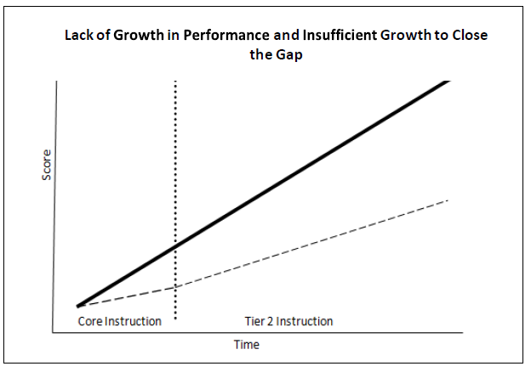
When a student receiving intensive services fails to show progress despite data-based adjustments to the intervention being provided, teams must consider the need for individual student problem-solving to customize the intervention provided to the student. Teams will need to analyze all the data available regarding the student and develop hypotheses about the underlying causes of the student’s lack of progress, so that a more individually customized intervention plan can be developed and implemented. The Building Leadership team should complete the Problem Solving Worksheet (Artifact T).

How to Customize an Intervention
- Ensure that the student is receiving an intensive protocol intervention with fidelity (Problem Identification).
- Determine whether a revision to the program is needed to boost the student’s rate of improvement (Problem Analysis).
- Add on researched instructional practice to the protocol intervention (Intervention Implementation).
- Analyze the progress monitoring data on the added instructional practice before adding another instructional practice (Response to Instruction/Intervention).

Determine the Short-Term Goals for Students Not Making Progress
At the very least, the goal for a student who is behind multiple grade levels should be the end-of-year benchmark of the grade level at which the student is being progress monitored. Most universal screening assessment systems (e.g. DIBELS, aimsweb) provide end-of-year benchmarks for the primary reading skills being assessed at the grade level. Once a student meets the end-of-year benchmark, instruction and progress monitoring can be increased to the next grade level. The determination about how many times a student needs to attain that goal before increasing it to the next grade level will be the responsibility of the Building Leadership Team. This process is repeated by continually increasing the level of instruction based on progress monitoring results until the student’s progress has closed the achievement gap with peers.
Once the student closes this gap, decreasing the amount of support provided to the student should be considered. Continued progress monitoring will indicate whether decreased support is sufficient for student growth to continue. Once the team has determined whether the student is on track, the team should consider regrouping to work on another intervention skill or exit the Strategic intervention and continue core with periodic progress monitoring.
For students who are below benchmark in reading skills and not making sufficient progress, it is beneficial to set short-term goals. Before setting short-term goals, teams should determine the student’s actual rate of progress and desired rate of progress as part of the completion of the Problem Solving Worksheet (Artifact T). Keep in mind, students monitored in out-of-grade materials need to have rates of progress greater than students who are performing at grade level in order to have adequate gains to meet subsequent important reading goals. For example, students monitored in out of grade level materials should be expected to reach end of the year goals in half the time as typically achieved. Based on the desired rate of progress, teams will set short-term goals.
When setting goals, it is more effective to involve students in setting their own goals and in monitoring their own progress (Chappuis, 2005). Research has indicated that ambitious goals produce better results than lower goals (McCook, 2006). Without ambitious goals, students in interventions can make progress, but continue to lag behind grade level without closing the achievement gap between themselves and their peers who are receiving high-quality interventions. It is appropriate to expect more than a year’s growth in a year’s time, even if the student has not achieved that rate of growth in the past. Fuchs, Fuchs, and Deno (1985) found that when teachers and students set high goals and increased them based on data, student progress was more rapid than for students who had lower performance goals that remained fixed.
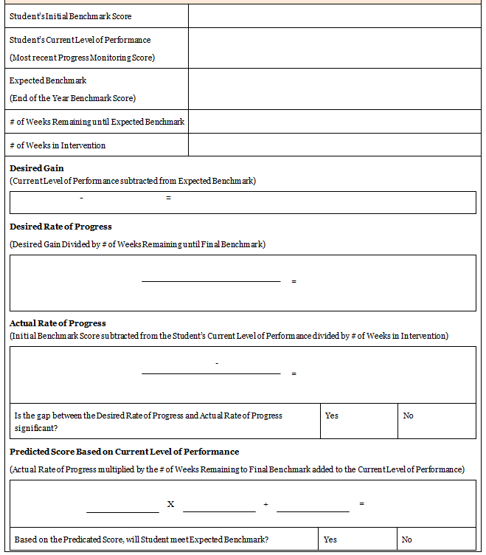

Example of Setting Short-Term Goals
- Carl is a 4th grade student. He read 37 wcpm in the fall on a 4th grade passage. His instructional level is 2nd grade, and has been progress monitored at this level because he has not yet met the EOY target score for this grade level. He read 40 wcpm in the fall on a 2nd grade passage.
Carl has participated in 4 weeks of intervention based on his greatest area of need. His current level of performance based on his most recent progress monitoring score was 47 wcpm, making a gain of 1.75 wcpm. At this rate, he is expected to reach the EOY target of 92 wcpm (2nd grade EOY target score) by the end of the year, but the team would like to see a more accelerated rate of progress. They would like to see Carl meet the EOY target score mid-year, so they can begin working toward the 3rd grade EOY target, and working toward closing the gap.
expected benchmark-current level=desired gain (92-47=45 wcpm)
desired gain/# of weeks remaining=desired rate of progress (45/14=3.21 wcpm/week)
current level-initial benchmark=actual gain/# of weeks in intervention=actual rate of progress (47-40=7/4=1.75 wcpm)
1.75<3.21, significant? Yes
actual rate of progress x # of weeks remaining + current level=predicted score (at mid-year) (1.75x14+47=71.5 wcpm)
71.5<92, reach EOY benchmark? No
- The team has determined that if Carl remains at his current rate of progress, he will not make enough gain to meet the 2nd grade EOY target by mid-year. They will need to increase his rate of progress when setting the short-term goal in order to make sufficient gains.
- The team decides to set his 3-week short term goal at 57 wcpm.
# of weeks to mid-year x desired rate of progress=mid-year increase (14*3.21=44.92 wcpm)
current level+mid year increase=mid-year goal (47+45=92 wcpm)
current level+current rate (x3)=3-week short-term goal (47+9.63=56.63 wcpm)
- If Carl is able to maintain this high rate of progress, he will meet the EOY 2nd grade target mid-year.
  - 1st 3-week short-term goal: 57 wcpm
  - 2nd 3-week short term goal: 66 wcpm
  - 3rd 3-week short-term goal: 76 wcpm
  - 4th 3-week short-term goal: 86 wcpm
  - 5th 3-week short-term goal: 95 wcpm
- Given the predicted outcome for Carl by mid-year, the team will work with him toward the 3rd grade EOY target to continue closing the gap.

The student Intervention Documentation Worksheet (Artifact Q) is beneficial for establishing short-term goals and tracking student information. Information regarding the student progress monitoring data and short-term goals can be documented on the Intervention Documentation Worksheet.
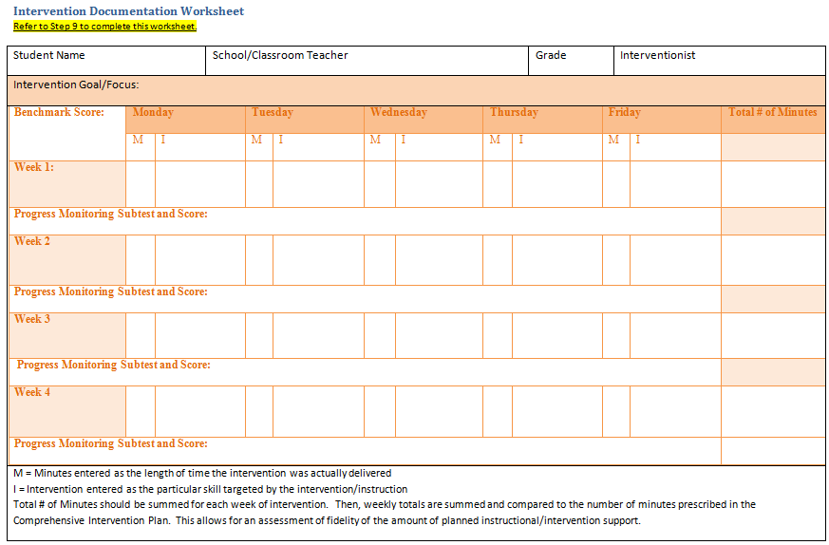

Step 12: Continual Student Information Updating
Critical Components:
Who: Building Leadership Teams and Grade Level Teams
What: Intervention Documentation Worksheet (Artifact Q)
When: As determined by frequency of Grade Level Team meetings
Where: Grade Level Team meetings
Why: Ensure student data is being documented and remains current in regard to interventions being provided and the progress being made by individual students
Once any instructional adjustments have been completed, instruction and progress monitoring of student skill growth continues as described in previous steps. The Intervention Documentation Worksheet (Artifact Q) and the progress monitoring graph need to be consistently updated so that an accurate record of the interventions and their results can be maintained. It is critical for teachers to document both the instruction that they are providing and the intervention sessions that each student actually attends. This documentation is critical as a source of information when analyzing student growth. This cycle of assessment, adjustment, and adding to the graph or log continues as long as a student requires intervention. To summarize, all students in intervention need:
- Accurate record of interventions
- An accurate record of actual student participation in intervention instruction
- An accurate record of progress monitoring results
- Ongoing regular data review meetings with instructional adjustments made according to decision rules.
Steps 1 through 12 will be repeated during this year and the following years as the Building Leadership Team and Grade Level Teams continue to collect and analyze data. Teams will become more adept at the process with practice, but it is important to periodically review the process as described in this workbook to maintain fidelity to the process.
It’s important to note that the individual student problem-solving process is what schools have traditionally used for general education interventions, often conducted by Student Assistance Teams (also known as SATs or TATs, etc.). Within the SD MTSS model, the Grade Level Teams conduct the work of the Student Assistance Teams (SATs). Teams working to customize intervention for a student may decide that the data indicate that the student needs to be referred for evaluation for special education services. At any time when the team suspects a student may have a disability, it must refer the student for an initial evaluation.
As per 34 CFR § 300.311, parents must be notified if their child has participated in a process that assesses the child’s performance and response to scientific, research-based intervention, and the data collected around the instructional strategies that were provided in order to increase the child’s rate of learning. Any parent request for special education evaluation must be reported to the building administrator or to the appropriate staff person, as designated by district special education procedures.
The implementation of the SD MTSS should not delay a student from receiving a special education evaluation. A student does not have to move through all the tiers before a referral for a special education evaluation is made. Conversely, having received all tiers of instruction or needing Tier 3 instruction does not indicate in and of itself that a student should be referred for a special education evaluation.

Secondary Level Implementation Supplement

The South Dakota MTSS Reading assessment procedure at the secondary level varies slightly from the procedure at the elementary level. In an effort to provide guidance to teams who will evaluate data at this level, and based on the current research, the procedure is outlined below.

Building and Grade Level Status

aimsweb users:
Grades 7 & 8, building level status is determined by the percent of students at Benchmark, Strategic, and Intensive levels, as reported by the MAZE assessment. These scores are recorded for fall, winter and spring benchmarks on the Building Level Status Worksheet (Artifact A)/Grade Level Status Worksheet (Artifact C).

At the high school level, data from a grade level comprehension assessment (e.g. NWEA MAP, Renaissance Learning), usually given only in the fall, will be used to determine the Building Level Status. The Building Leadership Team will determine how the percentages for each category will be recorded, which will be dependent on what assessment is used and the criteria that have been established by the assessment publisher.
If a grade level comprehension assessment is unavailable at the high school level, building level status will be determined by the percent of students at Benchmark, Strategic and Intensive levels, as indicated on the MAZE assessment.
DIBELS CARI users:
Please note that when DIBELS CARI is released in its final form this workbook will be updated to reflect appropriate procedures for DIBELS CARI users.
Classroom Level Status
A middle school or secondary level team may view the classroom level report as something only to be used at the elementary level. However, both classroom level status and grouping worksheets can be very beneficial for content area teachers, especially if the data can be disaggregated by each hour of the day. When data is analyzed in this way, teachers can differentiate for individual class periods. For example, if 40% of a fourth hour chemistry class is not reading at grade level, this may change how the teacher presents textbook material and where differentiation may be required. Instead of asking the class to read silently, he may choose to partner students up to read the textbook, placing a slightly stronger reader with a struggling reader. He might also choose to read the text aloud to students who are in Group 3 and requiring intensive intervention, allowing them the opportunity to gain knowledge of the text through listening comprehension. The math teacher may be more explicit when she teaches the vocabulary to her second hour algebra class than she would be to her fifth hour class because of a high percentage of struggling readers during the second hour.

If the Building Leadership Team has a tech-savvy team member, an Excel spreadsheet could be developed and, using the school’s enrollment database, provide this type of information to each content area teacher in a fairly efficient manner. Some schools’ data management systems have optional fields that could be filled with a student’s grouping assignment or tier of intervention required.

Grouping Worksheets
The Initial Instructional Sort Worksheets (Artifact I) are used a little differently in grades 7 and up.
For students in grades 7 and 8, the primary skill indicator is the MAZE assessment. Students may exhibit difficulty with reading comprehension on the MAZE for a variety of underlying reasons. For example, a student may score low on the MAZE because of difficulty with comprehension, vocabulary, fluency, or accuracy. Therefore, students who do not reach the target score on the MAZE assessment should be given an oral reading fluency measure to determine whether the student has difficulty with accuracy and/or fluency.

Steps for Grouping Grades 7 & 8 are:
1. Locate Class Distribution report for the MAZE assessment.
2. Administer an R-CBM measure to students who do not meet the benchmark or target score on the MAZE assessment.
3. Group these students into the R-CBM Initial Instructional Sort Worksheets (Artifact I). Students who meet the target score on the MAZE assessment are not recorded on this sheet.
4. Once these students are placed into four groups, locate and record the MAZE score for students in Group 1.
5. For students in Group 1, use a yellow or pink highlighter to highlight the names of the students who need Strategic or Intensive support, as indicated by the MAZE report.
6. For students in Groups 2 or 3, use a yellow or pink highlighter to highlight the names of students who need Strategic or Intensive support as indicated by the R-CBM report.
7. For students in Group 4, re-assess, directing the student to attend to accuracy. If accuracy falls at 98% or above, the student should be re-assigned to Group 1 and color coded based on the MAZE score. If accuracy is below 98%, provide instruction in self-monitoring strategies. If improvement still does not occur, follow recommendations for Group 3.
8. Conduct additional assessments using a phonics screener, or possibly a phonological awareness assessment for students who are in Group 3.

Steps for Grouping in Grades 9-12:
Published grade level MAZE assessments for grades 9-12 are not available, so a multi-step gating process is necessary to determine a student’s instructional focus for students in grades 9-12.

aimsweb users:
1. Once a year, a grade level comprehension assessment (e.g. NWEA MAP or Renaissance Learning STAR) is given to all students in grades 9-12. Students who score at grade level on this assessment are not recorded on the Initial Instructional Sort Worksheets (Artifact I). For students who score at grade level, the screening process is complete, and no other screening procedure is required. **If a grade level comprehension assessment is not available, begin the 9-12th grade grouping process with Step 2.

2. Students who are not reading at grade level on the comprehension assessment (e.g. NWEA MAP or Renaissance Learning STAR) are given an eighth grade level MAZE. Those who score at benchmark on the MAZE are recorded in Group 1. Although these students met the benchmark score on the eighth grade MAZE assessment, they did not meet the criteria on their grade level comprehension assessment. They will need intervention or extra support on grade level comprehension and vocabulary strategies.

3. Students scoring below the target score on eighth grade level MAZE passages are given eighth grade level oral reading fluency passages (R-CBM). Once the oral reading fluency scores are entered in the web-based data management system, follow the previous steps (Grades 7 & 8) for the oral reading fluency grouping method (i.e. step 2, 6, 7 & 8).

Flow charts outlining this process for Grades 7 & up and Initial Instructional Sort Worksheets (Artifact I) are located in the Appendix of this workbook.

Content teachers can also benefit from seeing a grouping sheet for each hour they teach. It is helpful to know which students are dysfluent, which struggle with comprehension of text, which are not accurate readers, when determining how to differentiate for students.

Sufficient Progress
When considering the students with the most intense reading needs, it is important to know a reasonable expected rate of growth. Secondary readers in particular benefit from monitoring their own progress, utilizing the progress monitoring aimline will be critical to maintain motivation. For students who are below benchmark in reading skills and not making sufficient progress, it is beneficial to set short-term goals.

Appropriate goals for weekly improvement on first readings can be estimated on the basis of curriculum-based measurement research (Fuchs, Fuchs, Hamlett, Walz, & Germann, 1993). While there are many factors to consider, a good starting place for setting a goal is to start with the goal that corresponds to the student’s instructional reading level, rather than their current grade level.

Communication and transparency between the teacher and student at the secondary level is crucial. Students need to understand why they are being placed in the particular groups, and the criteria required for moving out of each group. Being straightforward with secondary students about their reading and where the deficits in reading occur is helpful in gaining a mutual understanding with the student as well as provide motivation. These students need to see the big picture for the reading process and where they have deficits and strengths (accuracy, fluency, vocabulary, how that impacts comprehension, etc.). For example, once accuracy is achieved, explaining the connections between fluency, vocabulary, and comprehension, motivates student efforts and assists in determining goals for themselves. Students are more likely to take ownership for their learning if they are able to participate in setting their goals and charting their progress, rather than being placed in ambiguous reading groups.

Research has shown that adolescents can benefit from targeted, explicit, and systematic instruction. Given the appropriate instruction and amount of time, adolescent readers can develop the necessary skills for proficient reading that will continue beyond their school years.

References
95 Percent Group, Inc. (2007). Error pattern analysis worksheets. Retrieved from 95 Percent Group, Inc.: http://www.95percentgroup.com/rti_content/downloads.aspx.
Chappuis, J. (2005). Helping students understand assessment. Educational Leadership, 63 (3), 39-43.
Cummings, K.D., & Good III, R. H. (2007). Progress monitoring and response to intervention in an outcomes-driven model. Retrieved from Dynamic Measurement Group: http://www.dibels.org/papers/PM_PM_030707.pdf.
Davidson, M., Allen, D., & Farrell, L. (2008). The role of accuracy in reading rate and accuracy measures. Submitted for publication.
Farrell, L., Hancock, C., & Smartt, S. (2006). DIBELS (Dynamic Indicators of Basic Early Literacy Skills): The practices manual. Boston, MA: Sopris West.
Fuchs, D., & Deshler, D. D. (2007). What we need to know about responsiveness to intervention (and shouldn’t be afraid to ask). Learning Disabilities Research & Practice, 22 (2), 129-136.

Fuchs, L. S., Fuchs, D., & Deno, S. L. (1985). Importance of goal ambitiousness and goal mastery to student achievement. Exceptional Children, 52 (1), 63-71.
Fuchs, L. S., Fuchs, D., & Hamlett, C. L., Walz, L., & Germann, G. (1993). Formative evaluation of academic progress: How much growth can we expect? School Psychology Review, 22, 27-48.

Hall, S. (2008). Implementing response to intervention: A principal’s guide. Thousand Oaks, CA: Corwin Press.

Hall, S. (2011). Jumpstart RTI. Thousand Oaks, CA: Corwin Press.

Hall, S. (2012). I’ve DIBEL’d, Now What? Next Edition. Longmont, CO: Cambium Learning Sopris.

Hosp, M. K., & Robinson, W. (2008, September 11-13). Curriculum based evaluation in reading. National Innovations Conference. Salt Lake City, UT.

Howell, K., & Nollet, V. (1999). Curriculum based evaluation: Teaching and decision making. Florence, KY: Wadsworth Publishing.

McCook, J. E. (2006). The RTI guide: Developing and implementing a model in your schools. Arlington, VA: LRP Publications.

MiBLSi. (2010). Retrieved from Michigan’s Integrated Behavior and Learning Support Initiative.

Milsom, A. (2007). Interventions to assist students with disabilities through school transitions. Professional School Counseling, 10(3), 273-278.

Rockley, J. (2012). Rockly Consulting Group.

Stecker, P., & Fuchs, L. (2000). Effecting superior achievement using curriculum-based measurement: The importance of individual progress monitoring. Learning Disabilities Research and Practice, 128-134.

Torgesen, J. K. (2006). Intensive reading intervention for struggling readers in early elementary school: A principal’s guide. Portsmouth, NH: RMC Research Corporation, Center on Instruction.

Building Level Status Worksheet
aimsweb users should use data from the Tier Transition Report.
U of Oregon DIBELS users should use data from the Distribution Report
DIBELS.net DIBELS users should use the School Overview Report.
Refer to Step 2 for calculating composite scores to fill in the tables on this worksheet for each grade level.

Grade | % Benchmark | % Strategic | % Intensive |  | Grade | % Benchmark | % Strategic | % Intensive
Fall |  |  |  |  | Fall
Winter |  |  |  |  | Winter
Spring |  |  |  |  | Spring

Grade | % Benchmark | % Strategic | % Intensive |  | Grade | % Benchmark | % Strategic | % Intensive
Fall |  |  |  |  | Fall
Winter |  |  |  |  | Winter
Spring |  |  |  |  | Spring

Grade | % Benchmark | % Strategic | % Intensive |  | Grade | % Benchmark | % Strategic | % Intensive
Fall |  |  |  |  | Fall
Winter |  |  |  |  | Winter
Spring |  |  |  |  | Spring

Grade | % Benchmark | % Strategic | % Intensive |  | Grade | % Benchmark | % Strategic | % Intensive
Fall |  |  |  |  | Fall
Winter |  |  |  |  | Winter
Spring |  |  |  |  | Spring

Grade Level Need for Support Worksheet

Identify the Need for Support By Grade Level
Using the appropriate report listed in the Critical Components section of Step 3, provide a response to each question for each grade level.
 | Grade Level:  Kindergarten | Grade Level:  First | Grade Level:  Second | Grade Level:  Third | Grade Level:  Fourth | Grade Level:  Fifth | Grade Level:  Sixth | Grade Level:  __________
Approximately how many students may need additional instructional support?
(Identify Student Population & Analyze Data and Develop Baseline)
On which basic early literacy skills might students need support?
(Prioritize Learning Content)
What are the implications for curriculum and instruction?
(Prioritize Learning Content)
What additional supports or resources are necessary to achieve learner goals?
(Learning Strategies)

*If more than 20% of the total number of students needs additional support to achieve goals, an important first step is to analyze the core curriculum and instruction.

Grade Level Status Worksheet
aimsweb users should use data from the Instructional Recommendation Report (Criterion Referenced)
U of Oregon DIBELS users should use data from the Distribution Report
DIBELS.net DIBELS users should use the School Overview Report
Refer to Step 3 for calculating composite scores to fill in the tables on this worksheet for the appropriate grade level.

Grade | % Benchmark | % Strategic | % Intensive
Fall
Winter
Spring

Grade Level Goal Setting Worksheet
aimsweb Users
Refer to Step 4 to complete this worksheet.
Kindergarten |  |  | Benchmark Period: (Circle One) | BOY | MOY | EOY
Measure |  |  | Basic Early Literacy/Reading Skill | Benchmark% | Goals
Composite
Letter Naming Fluency
Letter Sound Fluency |  |  | Basic Phonics: Letter Sounds
Phoneme Segmentation Fluency |  |  | Phonemic Awareness
Nonsense Word Fluency |  | Correct Letter Sound | Basic Phonics: Letter Sounds
First Grade |  |  | Benchmark Period: (Circle One) | BOY | MOY | EOY
Measure |  |  | Basic Early Literacy/Reading Skill | Benchmark% | Goals
Composite
Letter Naming Fluency
Letter Sound Fluency |  |  | Basic Phonics
Phoneme Segmentation Fluency |  |  | Phonemic Awareness
Nonsense Word Fluency |  |  | Basic Phonics: Blending/Decoding
R-CBM | Words Correct |  | Advanced Phonics and Word Attack Skills
R-CBM | Accuracy |  | Accurate and Fluent Reading of Connected Text
Second Grade |  |  | Benchmark Period: (Circle One) | BOY | MOY | EOY
Measure |  |  | Reading Skill | Benchmark% | Goals
R-CBM | Words Correct |  | Advanced Phonics and Word Attack Skills
R-CBM | Accuracy |  | Accurate and Fluent Reading of Connected Text
Third/Fourth/Fifth/Sixth Grade |  |  | Benchmark Period: (Circle One) | BOY | MOY | EOY
Measure |  |  | Reading Skill | Benchmark% | Goals
Composite
R-CBM | Words Correct |  | Advanced Phonics and Word Attack Skills
R-CBM | Accuracy |  | Accurate and Fluent Reading of Connected Text
MAZE | Number Correct |  | Reading Comprehension
MAZE | Accuracy |  | Reading Comprehension

Grade Level Goal Setting Worksheet
DIBELS Next Users
Refer to Step 4 to complete this worksheet.
Kindergarten |  |  |  | Benchmark Period: (Circle One) | BOY | MOY | EOY
Measure |  |  |  | Basic Early Literacy/Reading Skill | Benchmark% | Goals
Composite
First Sound Fluency |  |  |  | Phonemic Awareness
Phoneme Segmentation Fluency |  |  |  | Phonemic Awareness
Nonsense Word Fluency |  |  | Correct Letter Sound | Basic Phonics: Letter Sounds
First Grade |  |  |  | Benchmark Period: (Circle One) | BOY | MOY | EOY
Measure |  |  |  | Basic Early Literacy/Reading Skill | Benchmark% | Goals
Composite
Phoneme Segmentation Fluency |  |  |  | Phonemic Awareness
Nonsense Word Fluency | Correct Letter Sound |  |  | Basic Phonics: Letter Sounds
Nonsense Word Fluency | Whole Words Read |  |  | Basic Phonics: Blending/Decoding
DORF | Words Correct |  |  | Accurate and Fluent Reading of Connected Text
DORF | Accuracy |  |  | Accurate and Fluent Reading of Connected Text &  Advanced Phonics and Word Attack Skills
DORF | Retell |  |  | Reading Comprehension
Second Grade |  |  |  | Benchmark Period: (Circle One) | BOY | MOY | EOY
Measure |  |  |  | Basic Early Literacy/Reading Skill | Benchmark% | Goals
Composite
Nonsense Word Fluency | Correct Letter Sound |  |  | Basic Phonics: Letter Sounds
Nonsense Word Fluency | Whole Words Read |  |  | Basic Phonics: Blending/Decoding
DORF | Words Correct |  |  | Accurate and Fluent Reading of Connected Text
DORF | Accuracy |  |  | Accurate and Fluent Reading of Connected Text &  Advanced Phonics and Word Attack Skills
DORF | Retell |  |  | Reading Comprehension
DORF | Retell Quality of Response |  |  | Reading Comprehension
Third/Fourth/Fifth/Sixth Grade |  |  |  | Benchmark Period: (Circle One) | BOY | MOY | EOY
Measure |  |  |  | Reading Skill | Benchmark% | Goals
Composite
DORF | Words Correct |  |  | Accurate and Fluent Reading of Connected Text
DORF | Accuracy |  |  | Accurate and Fluent Reading of Connected Text &  Advanced Phonics and Word Attack Skills
DORF | Retell |  |  | Reading Comprehension
DORF | Retell Quality of Response |  |  | Reading Comprehension
DAZE Adjusted Composite |  |  |  | Reading Comprehension

Student Level Support Worksheet
aimsweb: Instructional Recommendation (Criterion Referenced)
U of Oregon DIBELS: Class List Report (select Former Goals from Need for Support drop-down)
DIBELS.net DIBELS: Classroom Report
Refer to Step 5A to complete this worksheet.
 | Grade Level:  Kindergarten | Grade Level:  First | Grade Level:  Second | Grade Level:  Third | Grade Level:  Fourth | Grade Level:  Fifth | Grade Level:  Sixth | Grade Level:  __________
DIBELS Next users only:
Which students are below or well below the benchmark goal on the DIBELS Next Composite Score?
DIBELS Next and aimsweb users:
Which students are below or well below the benchmark goals on one or more of the measures given at this time of the year?
Are there any other students you are concerned about (e.g. children just above the cutoff, children who perform inconsistently in class)?

Support Effectiveness (to be used during winter data analysis - MOY)
Refer to Step 5B to complete this worksheet.
Tier I Support | Meets the needs of 80% of all students in school.  Supports 95-100% of students receiving Benchmark support to make adequate progress and achieve the benchmark goal.
Of the students who started the year with scores at/above benchmark
What portion of students scored at/above the benchmark at MOY? |  | Percent | Number
Did 95-100% of students receiving Tier I support remain at that level? |  | Yes | No
What portion of students scored in the Strategic category at MOY? |  | Percent | Number
What portion of students scored in the Intensive category at MOY? |  | Percent | Number
How effective is the system of support for students who received Tier I support?
Tier II Support | Meets the needs of students in school who will need more support than the core curriculum and instruction can provide.  Supports 80-100% of students receiving Strategic support to achieve the benchmark goal.
Of the students who started the year with scores in the Strategic category
What portion of students scored at/above the benchmark at MOY? |  | Percent | Number
Did 80-100% of students receiving Tier II support achieve benchmark? |  | Yes | No
What portion of students scored in the Strategic category at MOY? |  | Percent | Number
What portion of students scored in the Intensive category at MOY? |  | Percent | Number
How effective is the system of support for students who received Tier II support?
**80-100% of students need to move out of Strategic into Benchmark to be on track.**
**If the core is working, interventions will allow this to happen.**
Tier III Support | Meets the needs of students in school who will need very intensive support to achieve benchmark.  Supports 80-100% of students receiving Intensive support to reduce the risk of academic difficulty or achieve the benchmark goal.  * For students with scores in the Intensive range who are receiving support and being progress monitored in materials below their grade level, it will be necessary to look at the individual student’s progress monitoring graph to determine if the student is making adequate progress toward his/her individual goal.
Of the students who started the year with scores in the Intensive category
What portion of students scored at/above the benchmark at MOY? |  | Percent | Number
Did 80-100% of students receiving Tier III support achieve benchmark? |  | Yes | No
What portion of students scored in the Strategic category at MOY? |  | Percent | Number
What portion of students scored in the Intensive category at MOY? |  | Percent | Number
How effective is the system of support for students who received Tier III support?
**80-100% of students need to move out of Intensive into Strategic or Benchmark to be on track.**
** If the core is working, interventions will allow this to happen.**
(Adapted from Dynamic Measurement Group, 2012)

Support Effectiveness (to be used during spring data analysis - EOY)
Refer to Step 5B to complete this worksheet.
Tier I Support | Meets the needs of 80% of all students in school.  Supports 95-100% of students receiving Benchmark support to make adequate progress and achieve the benchmark goal.
Of the students in the MOY with scores at/above benchmark
What portion of students scored at/above the benchmark at EOY? |  | Percent | Number
Did 95-100% of students receiving Tier I support remain at that level? |  | Yes | No
What portion of students scored in the Strategic category at EOY? |  | Percent | Number
What portion of students scored in the Intensive category at EOY? |  | Percent | Number
How effective is the system of support for students who received Tier I support?
Tier II Support | Meets the needs of students in school who will need more support than the core curriculum and instruction can provide.  Supports 80-100% of students receiving Strategic support to achieve the benchmark goal.
Of the students in the MOY with scores in the Strategic category
What portion of students scored at/above the benchmark at EOY? |  | Percent | Number
Did 80-100% of students receiving Tier II support achieve benchmark? |  | Yes | No
What portion of students scored in the Strategic category at EOY? |  | Percent | Number
What portion of students scored in the Intensive category at EOY? |  | Percent | Number
How effective is the system of support for students who received Tier II support?
**80-100% of students need to move out of Strategic into Benchmark to be on track.**
**If the core is working, interventions will allow this to happen.**
Tier III Support | Meets the needs of students in school who will need very intensive support to achieve Benchmark.  Supports 80-100% of students receiving Intensive support to reduce the risk of academic difficulty or achieve the benchmark goal.  * For students with scores in the Intensive range who are receiving support and being progress monitored in materials below their grade level, it will be necessary to look at the individual student’s progress monitoring graph to determine if the student is making adequate progress toward his/her individual goal.
Of the students in the MOY with scores in the Intensive category
What portion of students scored at/above the benchmark at EOY? |  | Percent | Number
Did 80-100% of students receiving Tier III support achieve benchmark? |  | Yes | No
What portion of students scored in the Strategic category at EOY? |  | Percent | Number
What portion of students scored in the Intensive category at EOY? |  | Percent | Number
How effective is the system of support for students who received Tier III support?
**80-100% of students need to move out of Intensive into Strategic or Benchmark to be on track.**
** If the core is working, interventions will allow this to happen.**
(Adapted from Dynamic Measurement Group, 2012)

Beginning of the Year Initial Sort Worksheets
Grade 1 – PSF
Grade 1 – NWF
Grade 2 – R-CBM
Grade 3 – R-CBM
Grade 4 – R-CBM
Grade 5 – R-CBM
Grade 6 – R-CBM
Grade 7 – R-CBM
Grade 8 – R-CBM
Grade 9 -12 – R-CBM

Phoneme Segmentation Fluency (PSF) Initial Instructional Sort
aimsweb
Group 1 Accurate and Fluent |  |  |  | Group 2 Accurate but Not Fluent
 | SCORE | % ACC |  |  | SCORE | % ACC
Name | 35 + | 95% + |  | Name | - 35 | 95% +
Group 3 Inaccurate and Not Fluent |  |  |  | Group 4 Inaccurate but Fluent
 | SCORE | % ACC |  |  | SCORE | % ACC
Name | - 35 | - 95% |  | Name | 35 + | - 95%
*Regroup within each quadrant to ensure instructional groups are of appropriate size and instruction is appropriately focused on student needs. Use PSF Instructional Focus sheet to determine appropriate instructional focus for each subgroup.
Nonsense Word Fluency (NWF) Initial Instructional Sort
aimsweb
Group 1 Accurate and Fluent |  |  |  | Group 2 Accurate but Not Fluent
 | SCORE | % ACC |  |  | SCORE | % ACC
Name | 27 + | 95% + |  | Name | - 27 | 95% +
Group 3 Inaccurate and Not Fluent |  |  |  | Group 4 Inaccurate but Fluent
 | SCORE | % ACC |  |  | SCORE | % ACC
Name | - 27 | - 95% |  | Name | 27 + | - 95%
*Regroup within each quadrant to ensure instructional groups are of appropriate size and instruction is appropriately focused on student needs. Use NWF Instructional Focus sheet to determine appropriate instructional focus for each subgroup.
R-CBM Initial Instructional Sort
aimsweb
Group 1 Accurate and Fluent |  |  |  | Group 2 Accurate but Not Fluent
 | SCORE | % ACC |  |  | SCORE | % ACC
Name | 55 + | 95% + |  | Name | - 55 | 95% +
Group 3 Inaccurate and Not Fluent |  |  |  | Group 4 Inaccurate but Fluent
 | SCORE | % ACC |  |  | SCORE | % ACC
Name | - 55 | - 95% |  | Name | 55 + | - 95%
*Regroup within each quadrant to ensure instructional groups are of appropriate size and instruction is appropriately focused on student needs. Use R-CBM Instructional Focus sheet to determine appropriate instructional focus for each subgroup.

R-CBM Initial Instructional Sort
aimsweb
Group 1 Accurate and Fluent |  |  |  | Group 2 Accurate but Not Fluent
 | SCORE | % ACC |  |  | SCORE | % ACC
Name | 77 + | 98% + |  | Name | - 77 | 98% +
Group 3 Inaccurate and Not Fluent |  |  |  | Group 4 Inaccurate but Fluent
 | SCORE | % ACC |  |  | SCORE | % ACC
Name | - 77 | - 98% |  | Name | 77 + | - 98%
*Regroup within each quadrant to ensure instructional groups are of appropriate size and instruction is appropriately focused on student needs. Use R-CBM Instructional Focus sheet to determine appropriate instructional focus for each subgroup.

R-CBM Initial Instructional Sort
aimsweb
Group 1 Accurate and Fluent |  |  |  | Group 2 Accurate but Not Fluent
 | SCORE | % ACC |  |  | SCORE | % ACC
Name | 105+ | 98% + |  | Name | - 105 | 98% +
Group 3 Inaccurate and Not Fluent |  |  |  | Group 4 Inaccurate but Fluent
 | SCORE | % ACC |  |  | SCORE | % ACC
Name | - 105 | - 98% |  | Name | 105 + | - 98%
*Regroup within each quadrant to ensure instructional groups are of appropriate size and instruction is appropriately focused on student needs. Use R-CBM Instructional Focus sheet to determine appropriate instructional focus for each subgroup.

R-CBM Initial Instructional Sort
aimsweb
Group 1 Accurate and Fluent |  |  |  | Group 2 Accurate but Not Fluent
 | SCORE | % ACC |  |  | SCORE | % ACC
Name | 114 + | 98% + |  | Name | - 114 | 98% +
Group 3 Inaccurate and Not Fluent |  |  |  | Group 4 Inaccurate but Fluent
 | SCORE | % ACC |  |  | SCORE | % ACC
Name | - 114 | - 98% |  | Name | 114 + | - 98%
*Regroup within each quadrant to ensure instructional groups are of appropriate size and instruction is appropriately focused on student needs. Use R-CBM Instructional Focus sheet to determine appropriate instructional focus for each subgroup.

R-CBM Initial Instructional Sort
aimsweb
Group 1 Accurate and Fluent |  |  |  | Group 2 Accurate but Not Fluent
 | SCORE | % ACC |  |  | SCORE | % ACC
Name | 136 + | 98% + |  | Name | - 136 | 98% +
Group 3 Inaccurate and Not Fluent |  |  |  | Group 4 Inaccurate but Fluent
 | SCORE | % ACC |  |  | SCORE | % ACC
Name | - 136 | - 98% |  | Name | 136 + | - 98%
*Regroup within each quadrant to ensure instructional groups are of appropriate size and instruction is appropriately focused on student needs. Use R-CBM Instructional Focus sheet to determine appropriate instructional focus for each subgroup.

R-CBM Initial Instructional Sort
aimsweb
Group 1 Accurate and Fluent |  |  |  |  |  | Group 2 Accurate but Not Fluent
 |  | SCORE | % ACC | MAZE |  |  | SCORE | % ACC
Name |  | 136 + | 98% + |  |  | Name | - 136 | 98% +
Group 3 Inaccurate and Not Fluent |  |  |  |  | Group 4 Inaccurate but Fluent
 |  | SCORE | % ACC |  |  |  | SCORE | % ACC
Name |  | - 136 | - 98% |  | Name |  | 136 + | - 98%
*Regroup within each quadrant to ensure instructional groups are of appropriate size and instruction is appropriately focused on student needs. Use R-CBM Instructional Focus sheet to determine appropriate instructional focus for each subgroup.

R-CBM Initial Instructional Sort
aimsweb
Group 1 Accurate and Fluent |  |  |  |  | Group 2 Accurate but Not Fluent
 |  | SCORE | % ACC | MAZE |  | SCORE | % ACC
Name |  | 138 + | 98% + |  | Name | - 138 | 98% +
Group 3 Inaccurate and Not Fluent |  |  |  |  | Group 4 Inaccurate but Fluent
 |  | SCORE | % ACC |  |  | SCORE | % ACC
Name |  | - 138 | - 98% |  | Name | 138 + | - 98%
*Regroup within each quadrant to ensure instructional groups are of appropriate size and instruction is appropriately focused on student needs. Use R-CBM Instructional Focus sheet to determine appropriate instructional focus for each subgroup.

R-CBM Initial Instructional Sort
aimsweb
Group 1 Accurate and Fluent |  |  |  | Group 2 Accurate but Not Fluent
 |  |  | MAZE |  |  |  | SCORE | % ACC
Name |  |  | 23 + | Name |  |  | -138 | 98% +
Group 3 Inaccurate and Not Fluent |  |  |  | Group 4 Inaccurate but Fluent
 | SCORE | % ACC |  |  | SCORE | % ACC
Name | -138 | - 98% |  | Name | 138 + | - 98%
*Regroup within each quadrant to ensure instructional groups are of appropriate size and instruction is appropriately focused on student needs. Use R-CBM Instructional Focus sheet to determine appropriate instructional focus for each subgroup.

Middle of the Year Initial Sort Worksheets
Kindergarten – PSF
Kindergarten - NWF
Grade 1 – PSF
Grade 1 – NWF
Grade 1 – R- CBM
Grade 2 – R-CBM
Grade 3 – R-CBM
Grade 4 – R-CBM
Grade 5 – R-CBM
Grade 6 – R-CBM
Grade 7 – R-CBM
Grade 8 – R-CBM
Grade 9-12 – R-CBM

Phoneme Segmentation Fluency (PSF) Initial Instructional Sort
aimsweb
Group 1 Accurate and Fluent |  |  |  | Group 2 Accurate but Not Fluent
 | SCORE | % ACC |  |  | SCORE | % ACC
Name | 18 + | 95% + |  | Name | - 18 | 95% +
Group 3 Inaccurate and Not Fluent |  |  |  | Group 4 Inaccurate but Fluent
 | SCORE | % ACC |  |  | SCORE | % ACC
Name | - 18 | - 95% |  | Name | 18 + | - 95%
*Regroup within each quadrant to ensure instructional groups are of appropriate size and instruction is appropriately focused on student needs. Use PSF Instructional Focus sheet to determine appropriate instructional focus for each subgroup.
Nonsense Word Fluency (NWF) Initial Instructional Sort
aimsweb
Group 1 Accurate and Fluent |  |  | Group 2 Accurate but Not Fluent
 | SCORE | % ACC |  |  | SCORE | % ACC
Name | 19 + | 95% + | Name |  | - 19 | 95% +
Group 3 Inaccurate and Not Fluent |  |  |  | Group 4 Inaccurate but Fluent
 | SCORE | % ACC |  |  | SCORE | % ACC
Name | - 19 | - 95% |  | Name | 19 + | - 95%
*Regroup within each quadrant to ensure instructional groups are of appropriate size and instruction is appropriately focused on student needs. Use NWF Instructional Focus sheet to determine appropriate instructional focus for each subgroup.

Phoneme Segmentation Fluency (PSF) Initial Instructional Sort
aimsweb
Group 1 Accurate and Fluent |  |  | Group 2 Accurate but Not Fluent
 | SCORE | % ACC |  | SCORE | % ACC
Name | 45 + | 95% + | Name | - 45 | 95% +
Group 3 Inaccurate and Not Fluent |  |  | Group 4 Inaccurate but Fluent
 | SCORE | % ACC |  | SCORE | % ACC
Name | - 45 | - 95% | Name | 45 + | - 95%
*Regroup within each quadrant to ensure instructional groups are of appropriate size and instruction is appropriately focused on student needs. Use PSF Instructional Focus sheet to determine appropriate instructional focus for each subgroup.
Nonsense Word Fluency (NWF) Initial Instructional Sort
aimsweb
Group 1 Accurate and Fluent |  |  | Group 2 Accurate but Not Fluent
 | SCORE | % ACC |  | SCORE | % ACC
Name | 45 + | 95% + | Name | - 45 | 95% +
Group 3 Inaccurate and Not Fluent |  |  | Group 4 Inaccurate but Fluent
 | SCORE | % ACC |  | SCORE | % ACC
Name | - 45 | - 95% | Name | 45 + | - 95%
*Regroup within each quadrant to ensure instructional groups are of appropriate size and instruction is appropriately focused on student needs. Use NWF Instructional Focus sheet to determine appropriate instructional focus for each subgroup.
R-CBM Initial Instructional Sort
aimsweb
Group 1 Accurate and Fluent |  |  | Group 2 Accurate but Not Fluent
 | SCORE | % ACC |  | SCORE | % ACC
Name | 30 + | 95% + | Name | - 30 | 95% +
Group 3 Inaccurate and Not Fluent |  |  | Group 4 Inaccurate but Fluent
 | SCORE | % ACC |  | SCORE | % ACC
Name | - 30 | - 95% | Name | 30 + | - 95%
*Regroup within each quadrant to ensure instructional groups are of appropriate size and instruction is appropriately focused on student needs. Use R-CBM Instructional Focus sheet to determine appropriate instructional focus for each subgroup.
R-CBM Initial Instructional Sort
aimsweb
Group 1 Accurate and Fluent |  |  | Group 2 Accurate but Not Fluent
 | SCORE | % ACC |  | SCORE | % ACC
Name | 80 + | 95% + | Name | - 80 | 95% +
Group 3 Inaccurate and Not Fluent |  |  | Group 4 Inaccurate but Fluent
 | SCORE | % ACC |  | SCORE | % ACC
Name | - 80 | - 95% | Name | 80 + | - 95%
*Regroup within each quadrant to ensure instructional groups are of appropriate size and instruction is appropriately focused on student needs. Use R-CBM Instructional Focus sheet to determine appropriate instructional focus for each subgroup.
R-CBM Initial Instructional Sort
aimsweb
Group 1 Accurate and Fluent |  |  | Group 2 Accurate but Not Fluent
 | SCORE | % ACC |  | SCORE | % ACC
Name | 105 + | 98% + | Name | - 105 | 98% +
Group 3 Inaccurate and Not Fluent |  |  | Group 4 Inaccurate but Fluent
 | SCORE | % ACC |  | SCORE | % ACC
Name | - 105 | - 98% | Name | 105 + | - 98%
*Regroup within each quadrant to ensure instructional groups are of appropriate size and instruction is appropriately focused on student needs. Use R-CBM Instructional Focus sheet to determine appropriate instructional focus for each subgroup.

R-CBM Initial Instructional Sort
aimsweb
Group 1 Accurate and Fluent |  |  | Group 2 Accurate but Not Fluent
 | SCORE | % ACC |  | SCORE | % ACC
Name | 120+ | 98% + | Name | - 120 | 98% +
Group 3 Inaccurate and Not Fluent |  |  | Group 4 Inaccurate but Fluent
 | SCORE | % ACC |  | SCORE | % ACC
Name | - 120 | - 98% | Name | 120 + | - 98%
*Regroup within each quadrant to ensure instructional groups are of appropriate size and instruction is appropriately focused on student needs. Use R-CBM Instructional Focus sheet to determine appropriate instructional focus for each subgroup.

R-CBM Initial Instructional Sort
aimsweb
Group 1 Accurate and Fluent |  |  | Group 2 Accurate but Not Fluent
 | SCORE | % ACC |  | SCORE | % ACC
Name | 129 + | 98% + | Name | - 129 | 98% +
Group 3 Inaccurate and Not Fluent |  |  | Group 4 Inaccurate but Fluent
 | SCORE | % ACC |  | SCORE | % ACC
Name | - 129 | - 98% | Name | 129 + | - 98%
*Regroup within each quadrant to ensure instructional groups are of appropriate size and instruction is appropriately focused on student needs. Use R-CBM Instructional Focus sheet to determine appropriate instructional focus for each subgroup.

R-CBM Initial Instructional Sort
aimsweb
Group 1 Accurate and Fluent |  |  | Group 2 Accurate but Not Fluent
 | SCORE | % ACC |  | SCORE | % ACC
Name | 149 + | 98% + | Name | - 149 | 98% +
Group 3 Inaccurate and Not Fluent |  |  | Group 4 Inaccurate but Fluent
 | SCORE | % ACC |  | SCORE | % ACC
Name | - 149 | - 98% | Name | 149 + | - 98%
*Regroup within each quadrant to ensure instructional groups are of appropriate size and instruction is appropriately focused on student needs. Use R-CBM Instructional Focus sheet to determine appropriate instructional focus for each subgroup.

R-CBM Initial Instructional Sort
aimsweb
Group 1 Accurate and Fluent |  |  |  |  | Group 2 Accurate but Not Fluent
 |  | SCORE | % ACC | MAZE |  | SCORE | % ACC
Name |  | 150 + | 98% + |  | Name | - 150 | 98% +
Group 3 Inaccurate and Not Fluent |  |  |  |  | Group 4 Inaccurate but Fluent
 |  | SCORE | % ACC |  |  | SCORE | % ACC
Name |  | - 150 | - 98% |  | Name | 150 + | - 98%
*Regroup within each quadrant to ensure instructional groups are of appropriate size and instruction is appropriately focused on student needs. Use R-CBM Instructional Focus sheet to determine appropriate instructional focus for each subgroup.

R-CBM Initial Instructional Sort
aimsweb
Group 1 Accurate and Fluent |  |  |  |  | Group 2 Accurate but Not Fluent
 |  | SCORE | % ACC | MAZE |  |  | SCORE |  | % ACC
Name |  | 151 + | 98% + |  | Name |  | - 151 |  | 98% +
Group 3 Inaccurate and Not Fluent |  |  |  |  | Group 4 Inaccurate but Fluent
 |  | SCORE | % ACC |  |  | SCORE |  | % ACC
Name |  | - 151 | - 98% |  | Name | 151 + |  | - 98%
*Regroup within each quadrant to ensure instructional groups are of appropriate size and instruction is appropriately focused on student needs. Use R-CBM Grouping Summary sheet to determine appropriate instructional focus for each subgroup.

R-CBM Initial Instructional Sort
aimsweb
Group 1 Accurate and Fluent |  |  |  | Group 2 Accurate but Not Fluent
 |  |  | MAZE |  |  | SCORE |  | % ACC
Name |  |  | 21 + | Name |  | -151 |  | 98% +
Group 3 Inaccurate and Not Fluent |  |  |  | Group 4 Inaccurate but Fluent
 | SCORE | % ACC |  |  | SCORE |  | % ACC
Name | -151 | - 98% |  | Name | 151+ |  | - 98%
*Regroup within each quadrant to ensure instructional groups are of appropriate size and instruction is appropriately focused on student needs. Use R-CBM Instructional Focus sheet to determine appropriate instructional focus for each subgroup.

End of the Year Initial Sort Worksheets
Kindergarten – PSF
Kindergarten - NWF
Grade 1 – NWF
Grade 1 – R- CBM
Grade 2 – R-CBM
Grade 3 – R-CBM
Grade 4 – R-CBM
Grade 5 – R-CBM
Grade 6 – R-CBM
Grade 7 – R-CBM
Grade 8 – R-CBM
Grade 9-12 – R-CBM
Phoneme Segmentation Fluency (PSF) Initial Instructional Sort
aimsweb
Group 1 Accurate and Fluent |  |  | Group 2 Accurate but Not Fluent
 | SCORE | % ACC |  |  | SCORE | % ACC
Name | 41 + | 95% + | Name |  | - 41 | 95% +
Group 3 Inaccurate and Not Fluent |  |  |  | Group 4 Inaccurate but Fluent
 | SCORE | % ACC |  |  | SCORE | % ACC
Name | - 41 | - 95% |  | Name | 41 + | - 95%
*Regroup within each quadrant to ensure instructional groups are of appropriate size and instruction is appropriately focused on student needs. Use PSF Instructional Focus sheet to determine appropriate instructional focus for each subgroup.

Nonsense Word Fluency (NWF) Initial Instructional Sort
aimsweb
Group 1 Accurate and Fluent |  |  | Group 2 Accurate but Not Fluent
 | SCORE | % ACC |  | SCORE | % ACC
Name | 33 + | 95% + | Name | - 33 | 95% +
Group 3 Inaccurate and Not Fluent |  |  | Group 4 Inaccurate but Fluent
 | SCORE | % ACC |  | SCORE | % ACC
Name | - 33 | - 95% | Name | 33 + | - 95%
*Regroup within each quadrant to ensure instructional groups are of appropriate size and instruction is appropriately focused on student needs. Use NWF Instructional Focus sheet to determine appropriate instructional focus for each subgroup.

Nonsense Word Fluency (NWF) Initial Instructional Sort
aimsweb
Group 1 Accurate and Fluent |  |  | Group 2 Accurate but Not Fluent
 | SCORE | % ACC |  | SCORE | % ACC
Name | 57 + | 95% + | Name | - 57 | 95% +
Group 3 Inaccurate and Not Fluent |  |  | Group 4 Inaccurate but Fluent
 | SCORE | % ACC |  | SCORE | % ACC
Name | - 57 | - 95% | Name | 57 + | - 95%
*Regroup within each quadrant to ensure instructional groups are of appropriate size and instruction is appropriately focused on student needs. Use NWF Instructional Focus sheet to determine appropriate instructional focus for each subgroup.
R-CBM Initial Instructional Sort
aimsweb
Group 1 Accurate and Fluent |  |  | Group 2 Accurate but Not Fluent
 | SCORE | % ACC |  | SCORE | % ACC
Name | 53 + | 95% + | Name | - 53 | 95% +
Group 3 Inaccurate and Not Fluent |  |  | Group 4 Inaccurate but Fluent
 | SCORE | % ACC |  | SCORE | % ACC
Name | - 53 | - 95% | Name | 53 + | - 95%
*Regroup within each quadrant to ensure instructional groups are of appropriate size and instruction is appropriately focused on student needs. Use R-CBM Instructional Focus sheet to determine appropriate instructional focus for each subgroup.
R-CBM Initial Instructional Sort
aimsweb
Group 1 Accurate and Fluent |  |  | Group 2 Accurate but Not Fluent
 | SCORE | % ACC |  | SCORE | % ACC
Name | 92 + | 95% + | Name | - 92 | 95% +
Group 3 Inaccurate and Not Fluent |  |  | Group 4 Inaccurate but Fluent
 | SCORE | % ACC |  | SCORE | % ACC
Name | - 92 | - 95% | Name | 92 + | - 95%
*Regroup within each quadrant to ensure instructional groups are of appropriate size and instruction is appropriately focused on student needs. Use R-CBM Instructional Focus sheet to determine appropriate instructional focus for each subgroup.
R-CBM Initial Instructional Sort
aimsweb
Group 1 Accurate and Fluent |  |  | Group 2 Accurate but Not Fluent
 | SCORE | % ACC |  |  | SCORE | % ACC
Name | 119 + | 98% + | Name |  | - 119 | 98% +
Group 3 Inaccurate and Not Fluent |  |  | Group 4 Inaccurate but Fluent
 | SCORE | % ACC |  | SCORE |  | % ACC
Name | - 119 | - 98% | Name | 119 + |  | - 98%
*Regroup within each quadrant to ensure instructional groups are of appropriate size and instruction is appropriately focused on student needs. Use R-CBM Instructional Focus sheet to determine appropriate instructional focus for each subgroup.

R-CBM Initial Instructional Sort
aimsweb
Group 1 Accurate and Fluent |  |  | Group 2 Accurate but Not Fluent
 | SCORE | % ACC |  | SCORE | % ACC
Name | 136 + | 98% + | Name | - 136 | 98% +
Group 3 Inaccurate and Not Fluent |  |  | Group 4 Inaccurate but Fluent
 | SCORE | % ACC |  | SCORE | % ACC
Name | - 136 | - 98% | Name | 136 + | - 98%
*Regroup within each quadrant to ensure instructional groups are of appropriate size and instruction is appropriately focused on student needs. Use R-CBM Instructional Focus sheet to determine appropriate instructional focus for each subgroup.

R-CBM Initial Instructional Sort
aimsweb
Group 1 Accurate and Fluent |  |  | Group 2 Accurate but Not Fluent
 | SCORE | % ACC |  | SCORE | % ACC
Name | 143 + | 98% + | Name | - 143 | 98% +
Group 3 Inaccurate and Not Fluent |  |  | Group 4 Inaccurate but Fluent
 | SCORE | % ACC |  | SCORE | % ACC
Name | - 143 | - 98% | Name | 143 + | - 98%
*Regroup within each quadrant to ensure instructional groups are of appropriate size and instruction is appropriately focused on student needs. Use R-CBM Instructional Focus sheet to determine appropriate instructional focus for each subgroup.

R-CBM Initial Instructional Sort
aimsweb
Group 1 Accurate and Fluent |  |  | Group 2 Accurate but Not Fluent
 | SCORE | % ACC |  | SCORE | % ACC
Name | 161 + | 98% + | Name | - 161 | 98% +
Group 3 Inaccurate and Not Fluent |  |  | Group 4 Inaccurate but Fluent
 | SCORE | % ACC |  | SCORE | % ACC
Name | - 161 | - 98% | Name | 161 + | - 98%
*Regroup within each quadrant to ensure instructional groups are of appropriate size and instruction is appropriately focused on student needs. Use R-CBM Instructional Focus sheet to determine appropriate instructional focus for each subgroup.

R-CBM Initial Instructional Sort
aimsweb
Group 1 Accurate and Fluent |  |  |  |  | Group 2 Accurate but Not Fluent
 |  | SCORE | % ACC | MAZE |  | SCORE | % ACC
Name |  | 171 + | 98% + |  | Name | - 171 | 98% +
Group 3 Inaccurate and Not Fluent |  |  |  |  | Group 4 Inaccurate but Fluent
 |  | SCORE | % ACC |  |  | SCORE | % ACC
Name |  | - 171 | - 98% |  | Name | 171 + | - 98%
*Regroup within each quadrant to ensure instructional groups are of appropriate size and instruction is appropriately focused on student needs. Use R-CBM Instructional Focus sheet to determine appropriate instructional focus for each subgroup.

R-CBM Initial Instructional Sort
aimsweb
Group 1 Accurate and Fluent |  |  |  |  | Group 2 Accurate but Not Fluent
 |  | SCORE | % ACC | MAZE |  | SCORE | % ACC
Name |  | 161 + | 98% + |  | Name | - 161 | 98% +
Group 3 Inaccurate and Not Fluent |  |  |  |  | Group 4 Inaccurate but Fluent
 |  | SCORE | % ACC |  |  | SCORE | % ACC
Name |  | - 161 | - 98% |  | Name | 161 + | - 98%
*Regroup within each quadrant to ensure instructional groups are of appropriate size and instruction is appropriately focused on student needs. Use R-CBM Instructional Focus sheet to determine appropriate instructional focus for each subgroup.

R-CBM Initial Instructional Sort
aimsweb
Group 1 Accurate and Fluent |  |  |  | Group 2 Accurate but Not Fluent
 | MAZE |  |  |  |  | SCORE | % ACC
Name | 27 + |  |  |  | Name | -161 | 98% +
Group 3 Inaccurate and Not Fluent |  |  |  |  | Group 4 Inaccurate but Fluent
 |  | SCORE | % ACC |  |  | SCORE | % ACC
Name |  | -161 | - 98% |  | Name | 161+ | - 98%
*Regroup within each quadrant to ensure instructional groups are of appropriate size and instruction is appropriately focused on student needs. Use R-CBM Instructional Focus sheet to determine appropriate instructional focus for each subgroup.

Phoneme Segmentation Fluency (PSF)
Instructional Focus: Phonemic Awareness
Group 1: Accurate and Fluent | Group 2:Accurate but Not Fluent
- Student segments all phonemes including phonemes in blends with good speed and accuracy  - Focus instruction on short vowels or CVC words and progress monitor using Nonsense Word Fluency  - Student reaches target score but has difficulty segmenting blends  - Focus instruction on teaching  complete phoneme segmentation. | - Student segments phonemes with good accuracy but does not achieve the target score  - Focus instruction on automaticity of complete segmentation.
Group 3: Inaccurate and Not Fluent | Group 4: Inaccurate but Fluent
- Student attempts to segment sounds or word parts, but is often incorrect  - Identify as initial, final, or vowel phonemes  - Focus instruction on identifying specific phonemes (initial, final, vowel).  - Student segments only partially.  - Does not segment blends  - Produces onset and rime  - Focus instruction on teaching single phoneme segmentation.  - Student makes few or no attempts to segment sounds or word parts; may repeat entire word  - Administer a phonological awareness assessment to determine if student can identify words or syllables and focus instruction on specific skills from phonological awareness assessment. | - Student segments sounds very quickly but produces inaccurate sounds  - Examiner should cue the student to slow down and re-test.  - If accuracy does not improve then administer a phonological awareness assessment to determine if student can identify words or syllables and focus instruction on specific skills from phonological awareness assessment.

Nonsense Word Fluency (NWF)
Instructional Focus: Basic Phonics
Group 1: Accurate and Fluent | Group 2: Accurate but Not Fluent
- Student reads correct letter sounds of words at appropriate pace with a high degree of accuracy  - If student reads nonsense words sound by sound, focus instruction on reading words as whole words.  - Focus instruction on blending fluency at the word level.  - Work towards mastery of reading whole words correctly on the first attempt.  - Student reads some or most words as whole words on first attempt  - If student accurately reads nonsense words as whole words, focus instruction on accuracy and fluency in connected text. | - Student reads letter sounds/ whole words with accuracy but also has hesitations, repetitions, self-corrections and slow pace  - Focus instruction on blending fluency practice at the word level.  - Provide instruction in “reading words automatically.”  - As skill develops, focus on accuracy and fluency in connected text.
Group 3: Inaccurate and Not Fluent | Group 4: Inaccurate but Fluent
- Student makes many errors and/or is prompted by the examiner to move on to the next letter sound.  - Focus instruction on accuracy at the letter-sound level.  - Identify known and unknown letter-sound combinations.  - Student doesn’t respond  - Analyze Phoneme Segmentation Fluency – instruction may need to focus on phonological awareness skills. | - Student reads letter sound correspondences with automaticity but makes many sound blending or substitution errors.  - Student tries to read words as “real words.”  - Focus on accuracy instruction at the letter-sound level and then accuracy instruction at the blending level.
* When delivering instruction with a focus on individual skills, make sure skills are not practiced exclusively in isolation. As the individual skills develop, scaffold the instruction and be sure to give students sufficient practice in applying the skills to appropriately leveled text and then to grade level text.
Curriculum Based Measurement (R-CBM)
Instructional Focus: Accurate and Fluent Reading of Connected Text
Group 1: Accurate and Fluent Reader | Group 2:  - Accurate but Not Fluent  - Lacks automaticity
Instructional Focus: Comprehension  Question: Are student’s comprehension and vocabulary skills on grade level?  If yes, continue to provide strong initial instruction (Tier 1).  If no, determine instructional needs in the areas of grade level comprehension and/or vocabulary skills.  Plan of Action:  - Instruction on monitoring for meaning  - Instruction on determining main ideas  - Instruction on fix-up strategies  - Instruction on specific words and word learning strategies | Instructional Focus: Fluency  Plan of Action:  - Instruction on automaticity at the word, phrase, sentence, and passage level  - Repeated and assisted reading of passages  - Instruction on grouping words to make meaning, pacing, and attention to punctuation  - Use of both narrative and informational texts
Group 3:  - Inaccurate and Not Fluent  - Reads at a slow pace with many hesitations, makes frequent errors. | Group 4:  - Inaccurate but Fluent  - Reads at an appropriate pace / or reads rapidly making numerous errors.
Instructional Focus:  - Provide specific, phonics or phonological awareness skills instruction and practice.  - Provide instruction and practice with sight words.  - Instructional focus is dependent on careful analysis of student error patterns and/or further assessments.  Plan of Action:  - Instruction on missing decoding skills  - Instruction on missing sight words  - Work on applying skills to connected text at instructional level  - Work on fluent reading at independent level using decodable text | Instructional Focus:  - Depends on student’s response to self-monitoring strategy and further assessments, if needed.  Question: If cued to do best reading, does student’s accuracy improve?  Plan of Action:  - Instruction on self-monitoring strategy  - Table tap when student makes an error to help student read more carefully and more accurately  - Challenge student to read a portion of the text with 2 or fewer errors  - Teach student to adjust rate of reading to type of text and purpose for reading

Phonological Awareness Continuum
Syllable Blending and Segmentation
Isolation, Identity, and Categorization
Blending and Segmentation
Deletion, Addition, and Substitution
Phonemes
Rhyming, Onset-Rime, and Alliteration
Syllables
Words in a sentence

Phonemic Awareness

Phonics Continuum
Letter-Sound Correspondences
Complex Consonants
Vowel Digraphs/Diphthongs
Multisyllabic Words
R-controlled Vowels
Long Vowel Silent-e
Complex Vowels
Consonant Blends (CVCC/CCVC)
Consonant Digraphs
Blends and Digraphs
Short Vowels (VC/CVC)

Final Reading Student Grouping Worksheet - Strategic
Refer to Step 8 to complete this worksheet.

Strategic Intervention Group – 3-5 students
Instructional Focus: Click here to enter text. Intervention: Click here to enter text.
Instructor: Click here to enter text. Location: Click here to enter text.
Progress Monitoring Tool: Click here to enter text.
Frequency of Monitoring: Click here to enter text.
Student Receiving Intervention | Who Does Monitoring?

Final Reading Student Grouping Worksheet - Intensive
Refer to Step 8 to complete this worksheet.

Lowest Intensive Intervention Group – 3 or fewer students
Instructional Focus: Click here to enter text. Intervention: Click here to enter text.
Instructor: Click here to enter text. Location: Click here to enter text.
Progress Monitoring Tool: Click here to enter text.
Frequency of Monitoring: Click here to enter text.
Student Receiving Intervention | Who Does Monitoring?

Final Reading Student Grouping Worksheet - Other
Refer to Step 8 to complete this worksheet.

Other Intervention Group
Instructional Focus: Click here to enter text. Intervention: Click here to enter text.
Instructor: Click here to enter text. Location: Click here to enter text.
Progress Monitoring Tool: Click here to enter text.
Frequency of Monitoring: Click here to enter text.
Student Receiving Intervention | Who Does Monitoring?

Student Monitoring Form
Refer to Step 8 to complete this worksheet.
Student Name:
Grade:
Screener Subtest Name:
Screener Subtest Target Score:
Fall Benchmark Score/Winter Benchmark Score/Spring Benchmark Score:
Date Administered:
Additional Diagnostic Assessment: (Include Name of Assessment, Criteria for Acceptable Performance, Student’s Actual Performance, Listed according to subtest if available)
Specific Skill Deficit(s)/Area(s) of Weakness:
Instructional Focus:
Progress Monitoring Score(s):
Date(s) Administered:

Intervention Documentation Worksheet
Refer to Step 9 to complete this worksheet.
Student Name | School/Classroom Teacher | Grade | Interventionist
Intervention Goal/Focus:
Benchmark Score: | Monday |  | Tuesday |  | Wednesday |  | Thursday |  | Friday |  | Total # of Minutes
Benchmark Score: | M | I | M | I | M | I | M | I | M | I
Week 1:
Progress Monitoring Subtest and Score:
Week 2
Progress Monitoring Subtest and Score:
Week 3
Progress Monitoring Subtest and Score:
Week 4
Progress Monitoring Subtest and Score:

M = Minutes entered as the length of time the intervention was actually delivered
I = Intervention entered as the particular skill targeted by the intervention/instruction
Total # of Minutes should be summed for each week of intervention. Then, weekly totals are summed and compared to the number of minutes prescribed in the Comprehensive Intervention Plan. This allows for an assessment of fidelity of the amount of planned instructional/intervention support.

aimsweb
Back Testing Worksheet
R-CBM
Refer to Step 10 to complete this worksheet.
Name: Click here to enter text. School Year: Click here to enter text.
Teacher: Click here to enter text. School: Click here to enter text.
 |  |  |  | Back test if at/below |  |  | Continue back testing until met
R-CBM | Median Words Correct | Median Errors | Accuracy | Fall aimsweb  Words Correct | Winter aimsweb  Words Correct | Spring aimsweb  Words Correct | End of Year Target Score | aimsweb Accuracy Percent
8th Grade |  |  |  | 112 | 122 | 130 | 161 | 98%
7th Grade |  |  |  | 94 | 109 | 130 | 171 | 98%
6th Grade |  |  |  | 103 | 111 | 128 | 161 | 98%
5th Grade |  |  |  | 78 | 97 | 106 | 143 | 98%
4th Grade |  |  |  | 67 | 86 | 102 | 136 | 98%
3th Grade |  |  |  | 42 | 64 | 83 | 119 | 98%
2th Grade |  |  |  | 21 | 47 | 61 | 92 | 95%
1st Grade |  |  |  |  | 14 | 24 | 53 | 95%
NWF |  |  |  |  |  |  | 57
PSF |  |  |  |  |  |  | 45
Grade Level Teams will need to take the following steps to determine appropriate progress monitoring for each student in the Intensive category:
- If the student score falls at or below the listed WCPM score for a particular grade level at a particular time of year, that student will be back tested.
- Using progress monitoring probes, test down one grade level at a time beginning with the grade level immediately below the student’s current grade level. (Make sure to administer three progress monitoring probes for each student, and use the median score when making the determination whether or not to continue back testing.)
- Continue back testing until the student’s median score reaches the grade level end of the year benchmark and the student has met the accuracy percentage for that grade level.
- Once the student has reached benchmark at a particular grade level, the student will be progress monitored at one grade level higher.
- Once the student reaches grade level (8th grade for high school), continue to progress monitor at grade level until the end of the year benchmark and accuracy are reached for the student’s grade level.
- In some instances, back testing with some students may need to continue through NWF and PSF in order to determine the appropriate level of progress monitoring.
(Adapted from the Kansas MTSS Building Leadership Implementation Guide Reading, 2013)

Research Based Instructional Practices
Instruction | Curriculum
- Fidelity of instruction  - Modeling and guided practice prior to independent practice (I Do, We Do, You Do)  - Explicit teaching  - Pace of instruction  - Opportunities to respond  - Time allocated  - Intervention in addition to core  - Intervention time (daily)  - More intervention time needed  - Sufficient questioning, checks for understanding  - Clear directions  - Sufficient practice, application, and review | - Appropriate match between learner and intervention  - Accuracy, fluency, or comprehension  - Appropriate rate of progress to reach goal/benchmark  - Most important instructional focus for time of year/grade  - Progress monitored on the appropriate skill:  - What is being taught?  - NWF? ORF?  - Relation to post-school outcomes and student interests  - Variety of activities  - Skills taught to mastery  - Explicit approach to teaching  - Appropriate independent work activities
Environment | Learner
- Classroom routines and behavior management designed to support learning  - Appropriate person teaching the intervention group  - Group arrangements for instruction  - Size of group  - Student placement in appropriate group  - Movement to group using decision rules  - Infrequent interruptions to class  - High academic learning time  - Short and brief transitions  - Time devoted to homework with monitoring | - Motivation  - Task persistence  - Social skills/peer relationships  - Commitment to school  - Self-efficacy  - Attendance  - Learning strengths  - Pattern of performance errors reflects skill deficits  - Connection with school, community, adults, and family  - Home-based literacy activities (no new learning, sight-word practice)

(Adapted from the Kansas MTSS Building Leadership Team Implementation Guide Reading)

South Dakota Multi-Tiered System of Support (MTSS)
Problem-Solving Worksheet
Refer to Step 11 to complete this worksheet.
Date | Student Name
School | Grade | Teacher
Description of academic or behavioral concern (skill specific):
Step 1: Problem Identification – What is the problem?
A: Explain the benchmark/expected level of performance?
B: Describe the student’s current level of performance? Please include data that directly assesses the target skill(s) you want the student to perform
C: Explain the peer level of performance?

D: What percentage of students in the classroom demonstrates this discrepancy?
E: Gap Analysis:
Student’s Initial Benchmark Score
Student’s Current Level of Performance
(Most recent Progress Monitoring Score)
Expected Benchmark
(End of the Year Benchmark Score)
# of Weeks Remaining until Expected Benchmark
# of Weeks in Intervention
Desired Gain
(Current Level of Performance subtracted from Expected Benchmark)
- =
Desired Rate of Progress
(Desired Gain Divided by # of Weeks Remaining until Final Benchmark)
=

Actual Rate of Progress
(Initial Benchmark Score subtracted from the Student’s Current Level of Performance divided by # of Weeks in Intervention)
-=
=
Is the gap between the Desired Rate of Progress and Actual Rate of Progress significant? | Yes | No
Predicted Score Based on Current Level of Performance
(Actual Rate of Progress multiplied by the # of Weeks Remaining to Final Benchmark added to the Current Level of Performance)
=
X=
+=
Based on the Predicated Score, will Student meet Expected Benchmark? | Yes | No

F: What is the replacement behavior or target skill? Must be measurable, observable, and reportable.
G: At what tier will this problem be addressed? Circle one.
Tier I | Tier II |  | Tier III
H: Do we have enough information to complete Problem Identification? If yes, go to Problem Analysis. If no, what information is still needed?
The next meeting will be held:

Step 2: Problem Analysis – Why is it occurring?
A: Replacement behavior or target skill. Review F from Step 1: Problem Identification.
B: Based on available data (gathered through review, interview, observation, and testing), why do you think the replacement behavior is not occurring and what is the predicted result of actions you might take?
C: Record each hypothesis for why the replacement behavior is not occurring along with its matched prediction statement. Provide any data used to validate or refute each hypothesis.
Use the following format – “The problem is occurring because _____.” “If _____ would occur, then the problem would be reduced.”
Hypothesis: What are the most likely reasons this problem is occurring? Address potential domains of instruction, curriculum, environment, learner.
Prediction Statement: Based upon what you’ve learned, what could be changed about the instruction, curriculum, and/or environment in order to enable the student to learn?
Hypothesis 1:
Prediction Statement 1:
Relevant Data:

Does the data support the hypothesis?
Yes | No
Hypothesis 2:
Prediction Statement 2:
Relevant Data:

Does the data support the hypothesis?
Yes | No
Hypothesis 3:
Prediction Statement 3:
Relevant Data:

Does the data support the hypothesis?
Yes | No
Hypothesis 4:
Prediction Statement 4:
Relevant Data:

Does the data support the hypothesis?
Yes | No

D: Do we have enough information to complete Problem Analysis? If yes, go to Intervention Implementation. If no, what information is still needed?
The next meeting will be held:

Step 3: Intervention Implementation – What are we going to do about it?
A: Who is the intervention plan being developed for?
B: What is the replacement behavior/target skill?
C: What is the expected level of performance?
D: What is the current level of performance?
E: Comprehensive Intervention Plan
Verified Hypothesis | Intervention Plan | Support Plan | Monitoring Plan | Monitoring Plan for Determining Student Progress
 | Who is responsible? | Who is responsible? | Who is responsible? | Who is responsible?
 | What will be done? | What will be done? | What will be done? | What will be done?
 | When will it occur? | When will it occur? | When will it occur? | When will it occur?
 | Where will it occur? | Where will it occur? | Where will it occur? | Where will it occur?
The next meeting will be held:

Step 4: Response to Instruction/Intervention – Is the plan working?
Date: | Be sure to attach data for each review date.
A: Is the response to instruction/intervention:
Positive |  | Questionable |  | Poor
Continue current instructional supports |  | Was the intervention/instruction implemented as planned? |  | Was the intervention/instruction implemented as planned?
 |  | Yes | No | Yes | No
Adjust goal upward |  | If yes, should intervention intensity be increased? How much? |  | If yes, was instruction/intervention aligned with the verified hypothesis, or is there other aligned instruction/intervention to consider?
 |  | Yes | No | Yes | No
Fade supports |  | If no, what strategies will be utilized to increase implementation? |  | If no, what strategies will be utilized to increase implementation?
 |  |  |  | Are there other hypotheses to consider?
 |  |  |  | Was the problem identified correctly?
Comments/Actions:
The next meeting will be held:

Instructional Groupings Model Examples
Model | Considerations | Advantages | Disadvantages | Scheduling | Resources
Pull Out | - Works best when numbers of students needing assistance is small and/or done cross grade level.  - Students in group need to have same instructional needs. | - Most similar to traditional practice  - Minimal logistical planning needed | - Transition time to resource needed  - Most schools have more students to serve than this model accommodates  - Coordination with planning and reviewing progress monitoring data between teachers needed | - Typically, each grade level receives support ½ hour to one hour each day  - Need to insure that students served with this model are not pulled out of general education curriculum | - This model rarely requires extra or change in resources
In Class | - Works best when numbers of students needing assistance is small  - Students in group need to have same instructional needs | - Students stay in class for intervention time  - Classroom teacher is able to work with at least one group of his/her own students  - Students may be moved more flexibly in and out of intervention time | - Most schools have more students to serve than this model accommodates  - Coordination with planning and reviewing progress monitoring data between other teachers who help is needed | - Typically, each grade level receives support ½ hour each day  - Can be done while other students are rotating through centers | - Classroom supervisor may be necessary to protect uninterrupted intervention time

Intervention Team | - Most likely used when number of students needing intervention is large, or beyond what can be done by the teacher and one support staff | - A team can accommodate a larger number of groups  - Larger numbers of groups can make for more options when student’s needs change | - Transition time to new groups needed  - General education teacher disconnected from student and instructional planning  - Interventionists report wanting to have the students for longer periods of time  - Training and support needs to be coordinated  - May be easy to overlook need to make core curricular changes | - Typically, each grade level receives support ½ hour each day | - Depending on the number of intervention groups necessary, resources may need to be rethought in the school  - Make sure adequate training and support is built into the model  - Make sure students most in need have the most qualified interventionists
Walk to Intervention Cross-Class | - Similar to intervention team approach, but grade-level teachers used as interventionists | - Designated time by grade level insures that all students receiving extra reading time without conflicts to missing general education curriculum  - Allows for several certified staff to be providing reading interventions  - Easier to develop intervention groups for students needing enrichment  - When teachers have built in collaborative time, discussions about groupings and individual students can be built in  - Allow time for additional support for Tier III | - Transition time to new groups needed  - General education teacher sometimes disconnected from student and instructional planning | - Each grade level coordinates intervention time with other reading teachers (reading specialists/special education) | - Depending on the number of intervention groups necessary, teachers may be able to provide more guided assistance to students barely on track
Walk to Intervention Cross-Grade | - Consider when the number of students on track is considerably less than those not on track | - Allows for more individualized and intense instruction based on reading and skill level  - Focus on reading increased due to no transition time necessary  - Teacher provided time to know student’s skill level and increased time allows him/her more flexibility in meeting needs | - Requires difficult decisions to be made regarding other important curriculum matters  - Requires thinking about things very differently | - Scheduling takes into consideration resources needed and grade level requirements | - Resources can be allocated in larger chunks of time
Alternative Class (Required Elective) | - Students with similar needs are scheduled with an intervention teacher for basic skills instruction, while remaning in the core English/Language Arts (ELA) or math course | - Works well in high school schedule  - Enables students to progress in core content classes while improving basic literacy or math skills  - The interventionist may be able to provide both student instruction and teacher consultation  - Convenient for using purchased curriculum for struggling readers | - Students lose the choice of what may be a preferred elective class  - Requires having a staff member with specialized knowledge of basic skills instruction | - Requires that students with common needs be available during the same class period | - The number of students and their needs will determine how many class periods the interventionist needs to schedule
Intervention Team (Homeroom) | - Each teacher takes a group of students for intervention, including students at benchmark or above | - Works well in middle school schedules  - Providing intervention during homeroom time helps with fluidity of grouping | - Requires common planning time for teachers to collaborate | - Instructional groups can be matched to teachers’ individual skills | - Some buildings may need to increase the amount of time allowed for homeroom
All School Seminar or Advisory Period | - All students receive extensions, additional practice, or supplemental or intense instruction during seminar time | - Many secondary schools already have an advisory or seminar period built into their schedules  - Assures that all students (advanced learners, benchmark students, and students with learning difficulties) receive some type of intervention  - Enables departmental planning for interventions | - Requires that focus of seminar be changed to instruction. This means a loss of time for student organizations and may also conflict with scheduled teacher planning times | - The way students are scheduled into seminar may need to be reorganized | - Changed purpose of seminar will require that more teachers are engaged in instruction during that period

Option 1 | Option 2 | Option 3 | Option 4
- All ELA classes are scheduled throughout the school day and are heterogeneously grouped  - A reading support elective (mandatory) is added to the schedule to allow for enrichment for Tier I or Tier II interventions  - Students in need of Tier III intervention receive 2 periods of intense instruction in addition to the ELA class  - Intervention classes are blended across grades and populations based on student need  - Tier II and Tier III intervention classes are scheduled during the same period as much as possible | - ELA classes are scheduled throughout the day  - ELA classes are heterogeneously grouped  - Students are pulled out for Tier II and Tier III intervention during other classes (one period for Tier II and two periods for Tier III  - Tier II intervention may occur within another class (e.g. Social Studies)  - Intervention classes are homogeneously grouped based on student need  - Intervention classes are blended across grades and populations | - ELA classes are double blocked (one period core credit and one period elective)  - ELA classes are scheduled at the same time of the day as much as possible  - ELA classes are homogeneously grouped based on assessed need and grade level  - Pacing, intensity, content, exposure to the core and explicit instruction are based on assessed student need  - Classes are blended across populations  - This option is useful wen large numbers of students need intervention | - ELA classes are heterogeneously grouped for students in Tier I and Tier II  - ELA classes are scheduled throughout the day  - Students requiring Tier III intervention are removed from grade level curriculum and receive 2 blocked periods of intense intervention. The class counts for one grade level and one elective class. Classes are blended across grade levels and populations  - Tier 2 classes are homogeneously grouped and replace one elective class. Classes are blended across grade levels and populations  - Tier II and Tier III classes are parallel scheduled as much as possible
(Adapted from the Kansas MTSS Building Leadership Team Implementation Guide Reading)

Spend more time modeling “I do” & “We do” guided practice before moving on
Increase scaffolding
Increase the number of questions and error corrections the student receives in a minute
Increase the # of student responses in a minute by reducing group size
Increase the # of repetition cycles
Use a more systematic curriculum
Analyze the progress monitoring data on the added instructional practice before adding another or different instructional practice
Make sure the student is receiving an appropriate intensive intervention
Determine whether a revision to the program is needed to boost the student’s rate of improvement
Add one researched instructional practice to the intervention

